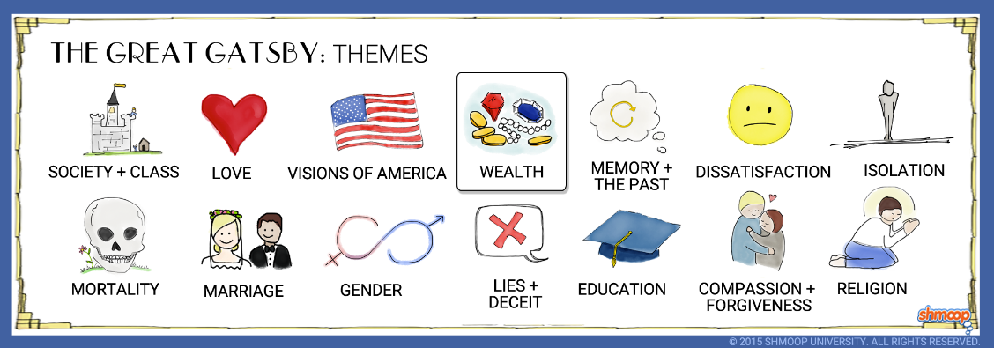
The Great Gatsby
Chapter Four & Five Questions
Directions: Choose 3 questions from Chapter FOUR and 3 questions from Chapter FIVE. Answer each using E3 format and quoted examples from the text to support your response of 8-15 sentences each. All answers must be typed.
Chapter 4
- Who is known as “the boarder”?

- Who is Meyer Wolfsheim? What details does Gatsby provide about his background?

- What is the history of Gatsby and Daisy? How does the reader find out about it?

- What is interesting about Gatsby’s opinion of Jordan?

- Why does Gatsby call Nick “old sport”?

- How do you think Nick feels when Tom comes over to talk with him while he is at lunch with Gatsby and Wolfsheim?

Chapter 5
- Why does Gatsby want to have Nick’s lawn cut?

- Why does Gatsby say he’s going to go home right before the lunch at Nick’s? Why do they end up going to Gatsby’s house later?

- What does Gatsby say about his wealth that contradicts what he had previously told Nick?

- What does Gatsby throw in front of Daisy and Nick? What does this scene tell us about Gatsby (thing about material possessions)?

- Thoroughly explain how Gatsby feels about Daisy.

