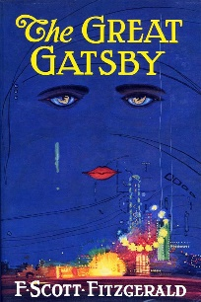
Great Gatsby
Chapter One Questions

Directions: Choose 3 questions from Chapter One. Answer each using E3 format and quoted examples from the text to support your response of 8-15 sentences each. All answers must be typed.
Chapter 1
- Who is the narrator? Where is he from? How does he describe himself? Why is he in New York?

- How does Nick know Daisy? How does he know Tom?

- What is the name of the book Tom is reading? What does this show us about him?

- Who is Jordan Baker?

- Who is Gatsby? What is Nick’s first impression of Gatsby?

