Short Case 20 Managing Relationships: Take Care of Your Nurses
Anthony R. Kovner
Betsy Cline, the patient care director of the 14-bed pediatric cardiac intensive care unit (PCICU) at Children’s Hospital, has held this post for two years. The unit has an $8 million budget. Cline has worked at Children’s Hospital for 16 years. She spends 50 percent of her time on patient safety, 20 percent on staffing and recruitment, and 20 percent with nurses in relation to their satisfaction with the work and with families in relation to their satisfaction with care. The remaining 10 percent of Cline’s time is spent on administrative duties. She says, “What I like is working with exceptional nurses who are very
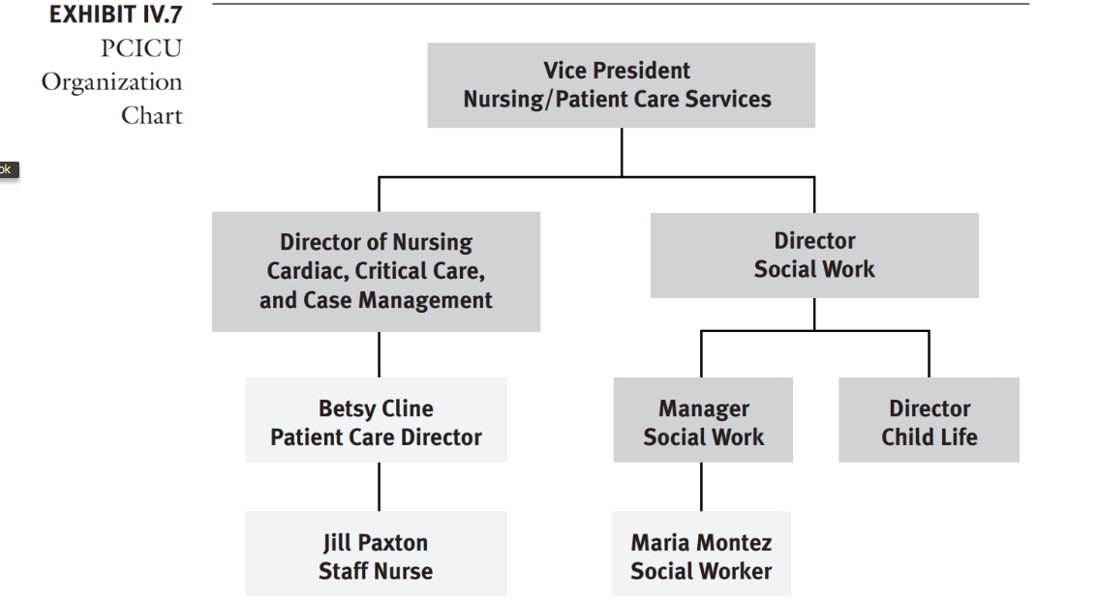

smart and do what it takes with limited resources. However, we don’t always feel empowered, despite the existence of shared governance, a structure I help to coordinate.” Exhibit IV.7 shows the PCICU organization chart.
Relationships with Nurses on the Unit
Nurses on the unit work three days a week, 12 hours a shift. Cline says, “My name is on the unit, not the medical director’s. If anything goes wrong with the unit, they blame it on nursing. Yet I’m brushed off by people with whom I have to deal outside of the unit. For example, we have a problem with machines that analyze blood gases. I spoke with the people there about the technology. This was four weeks ago. It’s a patient safety issue. I sent them e-mails. I need the work to get done. The staff don’t feel empowered if I’m not empowered. This goes for other departments as well. For example, respiratory therapy starts using a new ventilator without informing us. We have never seen this machine, nor have we been in-serviced on it. They don’t phone or e-mail. So I make the decision that we’re not going to use the machine. With surgeons, when I tell them to wash their hands, they roll their eyes. It takes tremendous energy to deal with this.”
Jill Paxton, RN, is a clinical nurse in the PCICU where she has worked for six months, having been at the hospital for nearly nine months. Paxton
spends 40 percent of her time dealing with patients and families—turning, suctioning, changing dressings; 30 percent talking with physicians—negotiat- ing plans of care and medication plans; 20 percent in medications administra- tion and conversations with the pharmacy; and 10 percent on miscellaneous duties. She has worked on the day shift for only three weeks now, but she had also been on days for three months during orientation. Paxton says she is challenged to get the core services she needs. If she has to give a 2:00 p.m. medication, and would like the medication by 1:00 p.m., she gets it by 4:00 p.m., even if she calls. She finds it difficult to coordinate services from a child life specialist—a specialist who breaks down medical terminology to children, such as “what’s about to happen to you,” and who also deals with siblings. Paxton can’t find the cardiac transplant consultant when she needs her and doesn’t have her pager number. Paxton’s main satisfactions are educating the people she’s working with, repairing children and seeing them go home, and helping the family.
Relationships with Families
Cline says, “I’m clear with them in orienting families to the unit, how we do our job. We treat families with respect. Families watch me, and mentoring of nurses is important.”
Paxton agrees that the unit generally does a good job supporting fami- lies. She says, “Families are kind and happy. There is a problem with turnover of doctors and residents, who aren’t here two days in a row. The plan of care can get lost with attendings when they change every week. Families are told different outcomes and recovery times. Families get stressed out and are often far from home. I listen to them and ask, ‘Do you have any questions?’, ‘What do you want to see done?’, and ‘Do you have any questions for the doctors?’ I ask them if they want to participate in rounds. Sometimes we just listen. When families can’t come in, they can call me every two hours because we have an in-house phone that accepts outside calls.”
Cline and Paxton feel that families are an important part of what they do, that the unit has special structures and processes to involve families, and that what they are doing is generally working. But they lack concrete ways to measure unit performance in this regard.
Relationships with Social Work
Cline says, “The hospital has a social worker who deals with heart transplant patients. This service is fragmented, and I have difficulty getting her to come to the unit. I will go to her director or to my director if I have to. I under- stand she has other responsibilities, but she needs to come to rounds, to deal with issues around getting nurses for home care. Of course, social workers can’t wave a magic wand.”
Maria Montez, the unit social worker, has worked in the PCICU for ten years. She spends 75 percent of her time on the floors with families. She works from 9:30 a.m. to 5:30 p.m., five days a week, and there is social work coverage at other hours. The kinds of issues Montez deals with are requests for a visiting nurse; medications and associated education; ordering of oxy- gen; ordering a special intervention team at home if there is a need to assess; and physical, occupational, and speech therapy. If a patient is dying, Montez discusses with nursing what they can do together when crises come up.
Montez says that she has a good relationship with Cline, and that she orients the new nurses to social work. Montez respects the work that nurses do. “We’re invited to each other’s rounds. The work is so intense, there are so many patients. We’ve reached a level of understanding; if there’s a problem, it’s not personal. It’s what we’re all going through. We discuss each of the 37 patients in the three ICUs once a week at an interdisciplinary conference.” Montez concludes, “If I could advise the hospital administrator, I would tell her to take care of your nurses.

Case Questions
1. What are the most important things that Betsy Cline can do to “take care of her nurses” who work in the PCICU?
2. What are the priorities for Jill Paxton? 3. How can nurses in the PCICU judge whether the unit is doing an
adequate job of supporting families? 4. What advice would you give to the hospital administrator to “take better
care of your nurses”?

