Post-impressionism is a term not easily defined, but Van Gogh is a transitional figure who emerges out of impressionism and signals the enormous changes to come in the twentieth century. Here we have the famous The Starry Night. It is interesting to think that so many see this as a beautiful, happy image of the world, while many art critics see it has a dark view of the world. Which do you see and why?
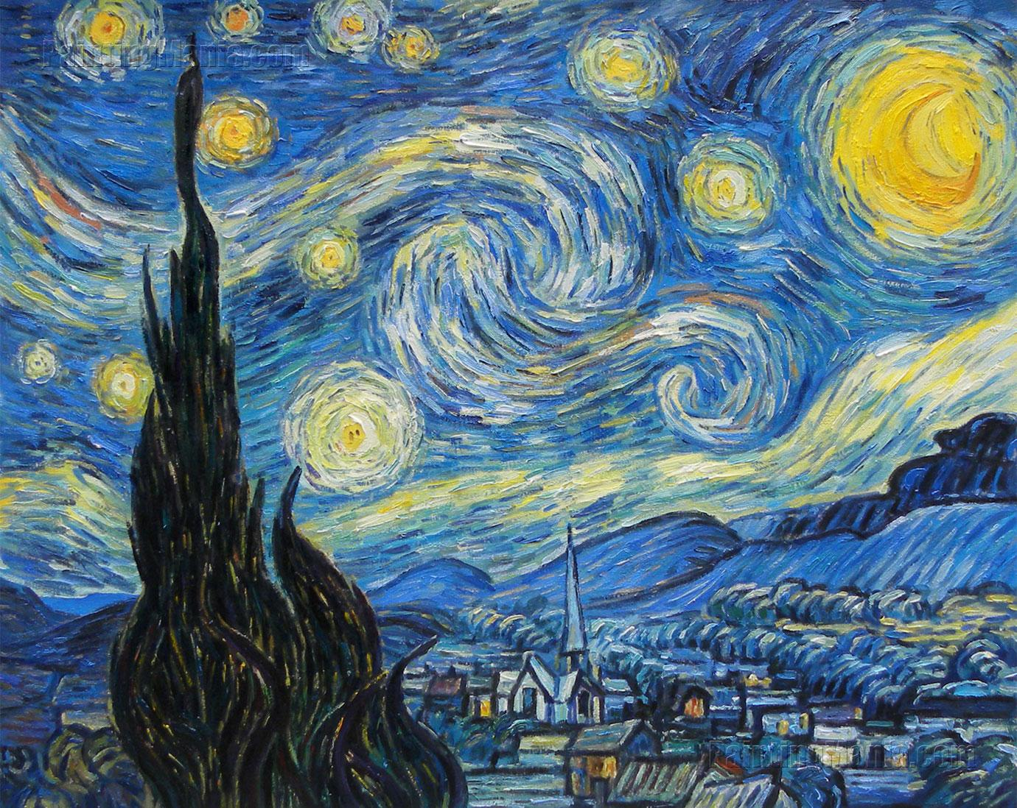
Also, find another Van Gogh which uses either color, brush stroke, subject, or symbol (think of the dead tree in the foreground as a possible example) in a similar way?

