TO: Proximity Media Teams  
SUBJECT: News Release  
DATE: June 8, 2016

Each member of your team will write a news release (1-2 pp.) announcing results from

Proximity's Summer 2016 focus group sessions. Your release should use a key finding from your focus group session, but you can also use material from other focus group sessions. You will work as a team in class to develop ideas and material for each member’s news release.

Schedule for drafts and final copy

* Post news release draft by 6:00 p.m. on June 13.
* Post comments on news release drafts before the start of class on June 15.
* Submit news release by end of the day on June 19.

### Rationale for news release

“A news release (also called a press release) is a written communication directed at the media, financial community, trade and industry analysts, investors and consumers to announce a product, partnership, acquisition, event, personnel announcement, or other newsworthy item. Editors, reporters, and journalists depend on news releases to alert them to unique products, trends and changes in the business landscape. If the journalist or analyst finds the announcement of value they may contact the company for more details and/or an interview. This contact may result in the company being mentioned in an article or broadcast. Even if a news release does not result in media pick-up, the content can still generate significant consumer interest.” ([from PR Newswire](http://www.smallbusinesspr.com/why-pr/faqs/#101061844))

**News release format**

Your news release should contain the following elements:

* main headline;
* brief summary;
* lead paragraph with a basic news account;
* social media trend topic with heading;
* business implication topic with heading.
* quotes from a Proximity spokesperson (use my name as Director of Research);
* “About Proximity” boilerplate (see news release template);
* media contact person (use your name with pseudo Proximity email address).

The news release assignment folder on Blackboard contains a news release template, a guide to writing news releases, and a sample Proximity news release.

**Proximity Finds Millennial Women   
Tweet While Watching “Pretty Little Liars”**

Focus group sessions reveal that millennials enjoy being able to interact with one another through hashtags on Twitter while watching their favorite prime time TV shows.

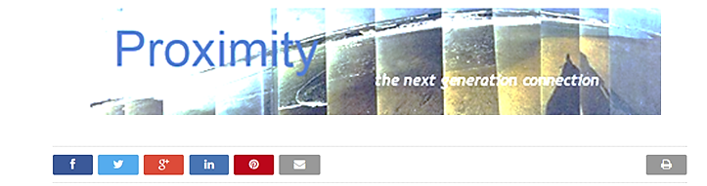

**Towson, MD,** March 22, 2015/PRNewswire **-** Proximity, a social media strategy group at Towson University, announced today results from focus groups conducted with over 300 college students regarding their use of social media. The sessions revealed that many millennials are using social networking to turn watching their favorite TV shows into an interactive experience. Although these same viewer are increasingly switching to streaming services to avoid ads, popular shows that provide hashtags on screen can induce them to watch episodes when they first air. Female participants in the focus group sessions reported tweeting while watching “Pretty Little Liars,” “The Fosters,” and “Teen Mom 2.”

"Social networking is now keeping many millennial viewers glued to broadcast TV*,*" said Paul Miers, Proximity's Director of Research.  "Advertisers can piggyback on trending hashtags to engage these viewers at a fraction of the cost of prime time ads.”

**Social TV Creates An Interactive Experience**

Texting and tweeting about a show during commercial breaks and using hash tags provided during episodes gives viewers a reason to tune in at airtime. Many students said they would be more inclined to watch a show at a later time on demand if their peers did not tweet about events during the program.

A Nielsen survey of the top ten 2014 TV series on Twitter indicates the popularity of social TV tweeting:

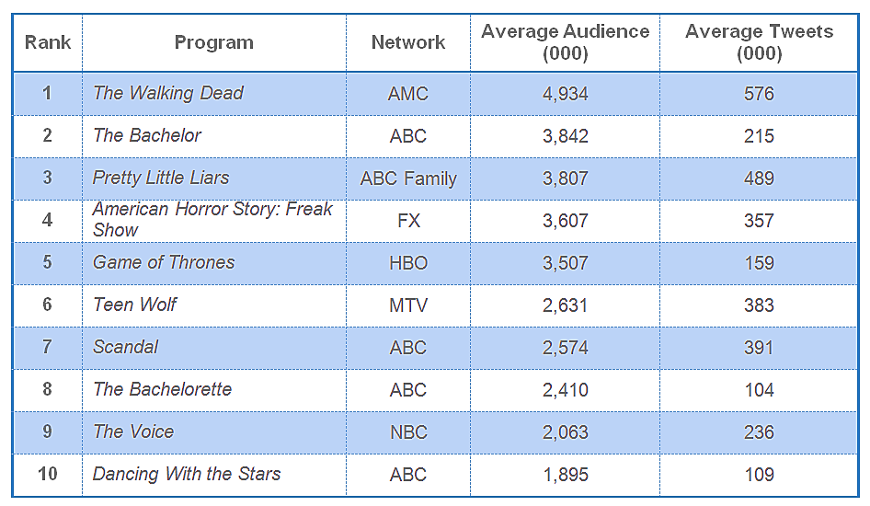  
[**Source: Nielson, Tops of 2014: Social TV**](http://www.nielsen.com/us/en/insights/news/2014/tops-of-2014-social-tv.html)

Proximity's results show that female millennials are especially likely to watch these shows when first broadcast in order to participate in the social TV experience.

**Brands Can Promote Products During Prime Time Programs**

Companies such as [Bongo](http://www.bongo.com/) have used popular hashtags to reach “Pretty Little Liars*”* viewers through Twitter.

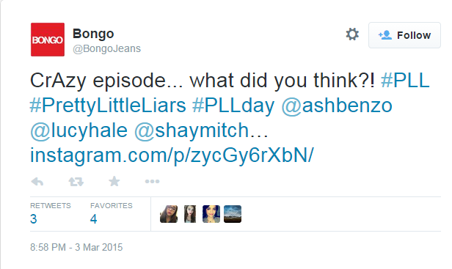

<https://twitter.com/BongoJeans/status/572939103156764675>

One Proximity focus group participant confessed that she watches "Pretty Little Liars" at airtime to avoid having the story spoiled later by social media conversations. She ignores broadcast ads but does notice branded posts on Twitter. Another participant said she enjoys being able to watch [*The Food Network*](http://www.foodnetwork.com/) during the day whenever she has time so she can she can see tweets related to the recipes. Not all shows, however, attract a critical mass of real time millennial viewers. As Miers noted, “businesses need to do careful research to determine exactly which shows are best for using social TV to market their products and services.”

**About Proximity**

Proximity is a social media strategy group at Towson University. Its analysts know how to connect with millennials using campaigns designed for the new media landscape. Proximity has immediate access to a large student population and the expertise of faculty who specialize in marketing and media research.

Proximity offers its clients a full range of services for developing and executing customized

campaigns that can reach any segment of the millennial population. It regularly conducts on line surveys and focus group sessions to keep marketers up to date on the social trends and emerging technologies that

determine how this cohort communicates and what it purchases.

Visit Proximity’s blog at <http://proximityblog.blogspot.com/> to read more about our take on the

social media revolution

**Media Contact**

_________, Associate Media Analyst

Proximity

410-704-8000

[______@proximity.com](mailto:______@proximity.com)