The United Nations International Children’s Emergency Funds (UNICEF)
Case Study

Introduction
In 1946, The United Nations General Assembly (GA) voted to establish the United Nations International Children’s Emergency Funds (UNICEF) to provide assistance to children across Europe who had been left destitute by World War II. UNICEF was a temporary emergency fund, designed to operate through 1950 mainly to address the lack of shelter and food as well as the alarming rate of child mortality and the children’s compromised security situation. The first appointed Executive Director of UNICEF, Maurice Pate, led the organization on the condition that it would provide relief to all children regardless of their nationality or creed. In 1950, Member States and UNICEF leadership pleaded for UNICEF organization to remain. Seeing UNICEF’s success in a disaster stricken community, and its potential to improve children’s lives across countries and over generations, the General Assembly in 1953 resolved to shift UNICEF from being an Emergency Fund to being a permanent Specialized Agency.
UNICEF is considered the world’s leading advocate for children. Its work is carried out in 191 countries through country programmes and National Committees. There are eight regional offices and country offices worldwide, as well as a research center in Florence, a supply operation in Copenhagen and offices in Tokyo and Brussels. UNICEF’s headquarters is located in New York.
Mandate and/or Mission Statement
UNICEF is mandated by the United Nations General Assembly to advocate for the protection of children’s rights, to help meet their basic needs and to expand their opportunities to reach their full potential. UNICEF is guided by the Convention on the Rights of the Child and strives to establish children’s rights as enduring ethical principles and international standards of behavior towards children. The organization insists that the survival, protection and development of children are universal development imperatives that are integral of human progress. UNICEF mobilizes political will and material resources to help countries ensure a “first call for children” and to build their capacity to form appropriate policies and deliver services for children and their families. It is also committed to ensure special protection for the most disadvantaged children such as, victims of war. UNICEF responds to emergencies to protect the rights of children. UNICEF makes its unique facilities for rapid response available to its partners to relive the suffering of children and those who provide their care through coordination with United Nations partners and humanitarian agencies. UNICEF’s priority is the disadvantaged children and the countries in greatest need. It’s important to note that through UNICEF’s country programmes, UNICEF promote the equal rights of women and girls and to support their full participation in the political, social, and economic development of their communities. UNICEF works with its partners towards the attainment of the sustainable human development goals adopted by the world community and the realization of the vision of peace and social progress enshrined in the Charter of the United Nations.
Governance and Membership
The governance of the organization is based on internal and external governance structures. Externally, UNICEF reports to the General Assembly (GA) through the Economic and Social Council (ECOSOC). UNICEF is one of the UN’s specialized agencies, which means that their work is reviewed annually by ECOSOC. Internally, the official governing body of UNICEF is the Executive Board and it’s responsible for providing support to, as well as supervising all activities of, UNICEF in accordance with the policy guidance of the GA and ECOSOC. In regards to membership, the membership of the Executive Board is based on equitable geographical representation and other relevant factors. Members come from each of the following UN regional groups: African states, Asian states, Eastern European states, Latin American and Caribbean states, and Western European and other states. It’s important to note the roles of the Board, which are:
- To implement the policies formulated by the Assembly and the coordination and guidance received from the Council; Receive information from and give guidance to the Executive Director on the work of UNICEF.
- To ensure that the activities and operational strategies of UNICEF are consistent with the overall policy guidance set forth by the Assembly and the Council.
- To monitor the performance of UNICEF; Approve programmes, including country programmes.
- To Decide on administrative and financial plans and budgets.
- To recommend new initiatives to the Council and, through the Council, to the assembly as necessary.
- To encourage and examine new programme initiatives
- To submit annual reports to the Council in its substantive session, which could include recommendations, where appropriate, for important of field-level coordination.
UNICEF’s Planning
Planning is critical and tied to the success or failure of a non-profit organization. There are two major types of plans:
- The strategic (long-term) plan: is a well-developed document that is designed to help the organization respond effectively to their new situations. It is also a disciplined effort to produce fundamental decisions and actions shaping the nature and direction of an organization’s activities within legal bounds.
- The annual (work) plan: is a document that lists all planned activities, the date on which they will occur or by which they will be accomplished, the resources that will require, and the person who is responsible for carrying them out. These plans are different from long-term plans in that they show how the broader objectives, priorities and targets of the strategic plan will be translated into practical activities, which will be carried out over a shorter period of time (anywhere from a week to a year). It’s important to note that there should be a complete harmony between the strategic objectives and the annual targets.
UNICEF recognizes the need for efficient planning to carry out its mission of helping the world’s children. In an organization with the breadth of UNICEF, planning is critical to maintaining success. There are different types of planning used in UNICEF and the most important types of plans they use are:
- UNICEF’s Strategic Plan
  - Years it Covers:
UNICEF’s strategic plan covers a period of four years. The newest UNICEF’s Strategic Plan is for the period of 2014-2017. The strategic plan is updated as soon as the end of the pervious strategic plan period comes to an end.
  - Strategic Planning Process:
UNICEF goes through a specific process to reach the final version of the strategic plan. Before the end of the current strategic plan, the preparation of the plan is informed by the End-of-Cycle review of the current plan presented February of the last year in the strategic plan. Then a draft is discussed during the annual session of the UNICEF Executive Board and adopted at the Second Regular Session taking place in September of the last year of the current plan.

During the End-of-Cycle (EoC) review, a review of the changing context is a key input to the planning of the next strategic plan. Moreover, the EoC review of the plan was informed by several analytic and strategic reviews including the following: 1. In-depth thematic reviews on the focus areas and humanitarian action, 2. Survey of UNICEF country offices, and 3. Survey of Member states and UNICEF National committees. The Executive Board approves the final UNICEF’s strategic plan. Below is chart summarizing the process of the newest UNICEF’s strategic plan 2014-2017:
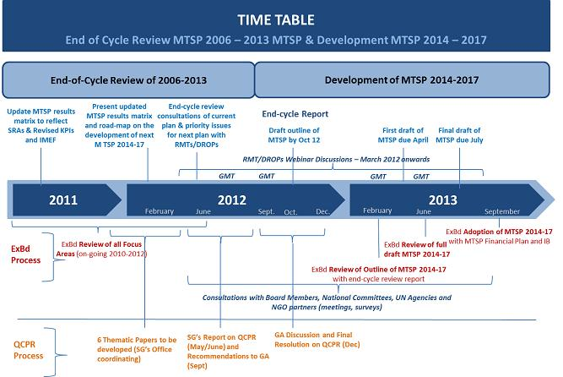
  - UNICEF’s new Strategic Plan for 2014-2017
The vision in UNICEF’s Strategic Plan for 2014-2017 is to realize the rights of all children, especially disadvantaged children. The Plan defines seven main outcomes (goals), which are:
- Health:
The goal is to reach an improved and equitable use of high-impact maternal, newborn and child health interventions from pregnancy to adolescence and promotion of healthy behaviors. The key approach will include providing equitable delivery of interventions; increasing access to lifesaving and preventive interventions, including humanitarian action; improving caregiver knowledge of high-impact interventions; strengthening health systems, including the contributing, as appropriate, to universal health coverage; improving the quality and use of data for making decisions; and ensuring better integration of health services with other services and interventions being provided to mothers, newborns and children.
- HIV and AIDS:
The goal is to reach an improved and equitable use of proven HIV prevention and treatment interventions by children, pregnant women and adolescents. The approach will be by promoting comprehensive sexuality education and on protecting the rights of excluded adolescent population who are highly affected by HIV.
- Water, sanitation, and hygiene:
The goal is to reach an improved and equitable use of safe drinking water, sanitation and healthy environments, and improved hygiene practices. UNICEF will emphasize capacity development to increase sustainable access to safe drinking water; eliminate open defection and improve access to adequate sanitation; increase hand-washing facilities in schools and health centers; and increase preparedness to respond to humanitarian situations.
- Nutrition:
The goal is to reach an improved and equitable use of nutritional support and improved nutrition and care practices. UNICEF will support delivery of vitamin and micronutrient supplementation and iodized salt; promotion of exclusive breastfeeding; and community-based prevention and management of malnutrition. Another approach would be by supporting disadvantaged and excluded families to apply good nutrition and care practices and seek comprehensive nutrition services.
- Education:
The goal is to reach an improved learning outcomes and equitable and inclusive education. The goal will be reached through supporting strengthening of systems that provide multiple and alternative pathways for disadvantaged and excluded children, including children with disabilities and girls. Another approach is by increasing the attention to early childhood development and renews its involvement in secondary education.
- Child protection:
The goal is to reach an improved and equitable prevention of and response to violence, abuse, exploitation and neglect of children. UNICEF programming will emphasize strengthening of child protection systems and support for social change for improved protection of children. The approaches will take into account the interplay between child protection systems and social norms. The efforts will be on preventing violence, exploitation, abuse and neglect, including through strengthening the protective capacities of families and communities.
- Social inclusion:
The goal is to reach an improved policy environment and systems for disadvantaged and excluded children, guided by improved knowledge and data. UNICEF will support countries to understand the patterns and drivers of exclusion and disadvantage, which includes the impact of gender inequality.
- Strategic Plan Implementation
There are seven implementation strategies, which are: capacity development; evidence generation and evidence-based policy dialogue and advocacy; partnerships; south-south and triangular cooperation; Identification and promotion of innovation; support to integration and cross-sectoral linkages; service delivery. Moreover, country programmes will determine an appropriate combination of implementation strategies that are going to be framed around the seven outcomes.
- Strategic Plan and Resource Plan
In Strategic Plan 2014-2017 it seems that resource plan is tied and relied on the Strategic Plan. A list of resources available is listed in the Strategic Plan, which shows the resources used in the previous period and the planned ones. Another important aspect is the usage of the resources plan, which shows a list of possible departments or usage of resources.
- UNICEF’s Work plans
Another type of plans UNICEF implements is work plans that are done for specific programme or projects. An example of that would be “UNICEF Rolling Work Plan 2013-4 in Odisha” the country programme aims to advance the “rights for children, adolescents and women to survival, growth, development, participation and protection by reducing inequities based on cast, ethnicity, gender, poverty, region or religion”. Work plans seem to be a breakdown of the broad goals/outcomes discussed in the strategic plan.
There are other types of planning done within the organization in regards to the organization itself. In other words, UNICEF ensures the health of the organization internally. An example of these plans is, “Internal Communication Plan”. The plan’s goal is to ensure uniformity among departments/individuals in the UNICEF organization through the access of same information. The objective and tools to reach this goal are: 1. Developing a model for communication that will increase the benefits of initiating dialogue with other UN agencies; 2. Developing effective internal communication strategies between regional offices and field offices; 3. Improving the quality of communicating precise, consistent messages to internal publics; 4. Ensuring a shared direction in communication that empowers staff with the appropriate authority, resources, and tools enabling them to assume responsibility and be accountable for fulfilling their duties; 5. Ensuring the effectiveness of all departments through coordinating interdepartmental communications; 6. Ensuring the executive director, the executive board, and other stakeholders; 7. Clarifying the message and vision of the organization, disseminate information using the organizational hierarchy, and utilizing internal mass media through an effective communication process.
UNICEF’s Programming
UNICEF’s core global programs are: Education, Emergency Relief, Health & Immunization, HIV/AIDS, Nutrition, Protection, and Water & Sanitation. UNICEF’s programming is guided by agreed UN Development Group normative principles, which are: Human Rights, Gender Equality, and Environmental Sustainability. In addition, UNICEF’s programming in humanitarian contexts is guided by Convention on the Rights of the Child (CRC) and International Humanitarian Law. The Executive Board is the governing body of UNICEF and it provides intergovernmental support and oversight to the organization. The Executive Board reviews UNICEF activities and approves its policies, country programmes and budgets. The Executive Board makes different decisions in regards to UNICEF programming, they:
- Review and approve the Medium Term Strategic Plan (MTSP) and Integrated Budget.
- Review and approve Country Programme Documents (CPDs), these documents are critical to the approval and funding of any programs or projects of the UNICEF. These documents are reviewed and commented on by the Board then is updated and submitted for final approval. The original CPD is originally submitted in the language of the country the programme is for but the final version is in English. The country programme document contains the following elements:
- Programme rationale
- Programme priorities and partnerships
- Programme and risk management
- Monitoring and evaluation
- Review and approve selected policies, plans and framework.
The UNICEF country programme priorities are based on the following:
- National plans and priorities
- Situation analysis of children
- Comparative advantage of UNICEF vis-à-vis partners
- Financial and human resource availability
UNICEF’s Budgeting
Nonprofit organizations wrestle continually with trying to maintain and improve their operations, especially during today’s uncertain economy. There are various types of budgeting system types such as, Line item; Zero-based; Performance; Program; Composite or hybrid. UNICEF is committed to performance-based budgeting (also named, results-based budgeting (RBB)). Under this type of system the organization identifies the results it wants to achieve, determines the resources needed for those results, and then allocates them. Moreover, this will help ensure that the organization’s processes, resources, and services are directed at strategically important results. It’s important to note that the Executive Boards of United Nations Procurement Division (UNPD), United Nations Population Fund (UNFPA) and UNICEF work together to present a “road map” that will improve linkages between resources and results, and also improve and create harmonization in the presentation of the biennial support budget for a period of a year. The Board is also responsible to provide a single, integrated budget that includes both the programme and institutional budgets for UNICEF.
Even though, Performance Based Budget is what UNICEF uses there has been a proposed initiative of using “social budgeting”. According to Forham University social budgeting is defined as a process by which society’s goals and priorities, as well as the rights for the entire population are better reflected throughout the budgeting process. In other words, UNICEF would apply a child-focused budgeting that would seek to make the overall government budget more responsive to children’s rights. UNICEF would benefit from this type of budgeting because their child-focused budget proggrames will be on a national scale and funded sustainably as part of a medium-term budget framework. The major benefit would be UNICEF simply funded standalone or smaller-scale projects.
UNICEF’s Budget Execution
The budget execution in UNICEF is reliant on the budget plans, which play an important role in budget execution. UNICEF prepares budgets for regular resources (RR) and other resources (OR) Regular resources are the most flexible form of resources and they include income from voluntary annual contributions form governments, un-earmarked funds contributed by National Committees and the public. Also net income from greeting card sales. OR on the other hand have restrictions and are allocated to programme assistance. OR are mostly received from governments and private sector. Trust funds are important to the UNICEF and they are received from governments and through inter-organizational arrangements, and are mostly used for procurement services. Even though, trust funds are important but budgets are not prepared for them. Below is a table showing the resources available to UNICEF between the years 2010 to 2013:
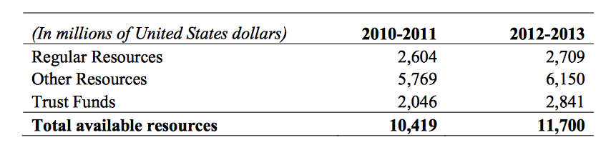
UNICEF organization budgets reports/plans are the following:
- Institutional budget: it includes the estimated costs of development effectiveness, United Nations development coordination, management, and special purpose activities and outlined in the Institutional Budget. The Executive Board on a biennial basis approves this document. UNICEF is proposing a $2,094.5 million for 2014-2017: with $1,155.1 million funding from RR, $823.0 million from cost recovery from OR, and $116.4 million from OR.
- Programme budget: it’s a collective term for UNICEF budgets other the the institutional budget. This budgets are approved by the Executive Board in Country Programme Documents and the Advocacy, Programme Development and Intercountry Programme Document for the implementation of programme activities and achievement of programmatic results and funded by RR and OR.
- Integrated budget: is a combined budgeting of both programme and institutional budgets.
UNICEF’s general approach to monitoring its spending is through their tested system. The system of checks and balances that ensure proper use of funds, including regular internal and external audits. Spending reports are an important aspect of the organization and are available to access on their website. Another way they monitor spending is by regular field visits done by staff to monitor spending and progress and payments to allow for assessments of prior spending. Annual reports of country offices include budget utilization and achievements of key results. The annual reports were limited to monitoring country offices spending and not global level. The reporting is annually done and they are done through written reports. It doesn’t seem that UNICEF have any mid-term or quarterly reporting for the spending.
UNICEF’s Accounting
UNICEF had prepared their financial reporting in accordance with United Nations Systems Accounting Standards (UNSAS) since 1993. After a General Assembly resolution, member states requested UN organizations to adopt International Public Sector Financial Reporting Standards (IPSAS), full accruals accounting and Cash accounting. The reason behind the need to change the accounting system was to enhance the quality of organizational-level financial reporting. IPSAS are credible, high-quality, independently produced accounting standards, underpinned by a strong due process and supported by governments, professional accounting bodies, and international organizations. These standards are specifically tailored to the public sector and integral to UN management reform. IPSAS requires financial statements to be more relevant and timely. UNICEF interestingly, has gone through a long process of transition before implementing IPSAS to ensure that they reach the standards of IPSAS. Below is graph of the process of implementation before the transition completed in 2012:
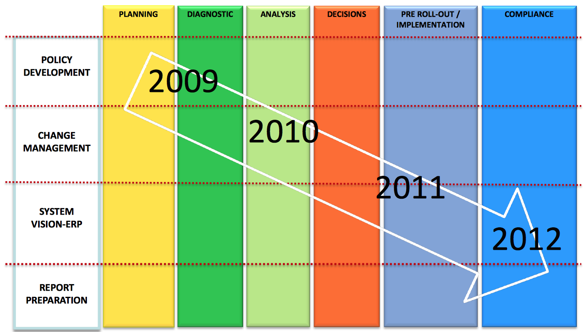
The 2012 financial statement represent the first set of UNICEF financial statements prepared in accordance with IPSAS. It’s an important achievement and it enables UNICEF to:
- Assess the accountability for all the resources it controls as well as the management and deployment of those resource;
- Enable the identification of funding requirements for asset maintenance and replacement and all liabilities; and
- Make better decisions about providing resources to UNICEF.
It is important to note that financial measure may or may not be presented on an IPSAS basis as these financial measures are not required to be disclosed by IPSAS and do not form part of the financial statements. However, the basis of presentation used for these financial measures is disclosed along with each table.
Even though, UNICEF is a nonprofit organization they do recognize the importance of investing in a new accounting system. Their investment in IPSAS represents a process of change and it improves programmatic and operational management practices throughout the organization.
There are significant differences between the old accounting systems UNICEF used and are using now. Below is a table representing the major differences between UNSAS and IPSAS:
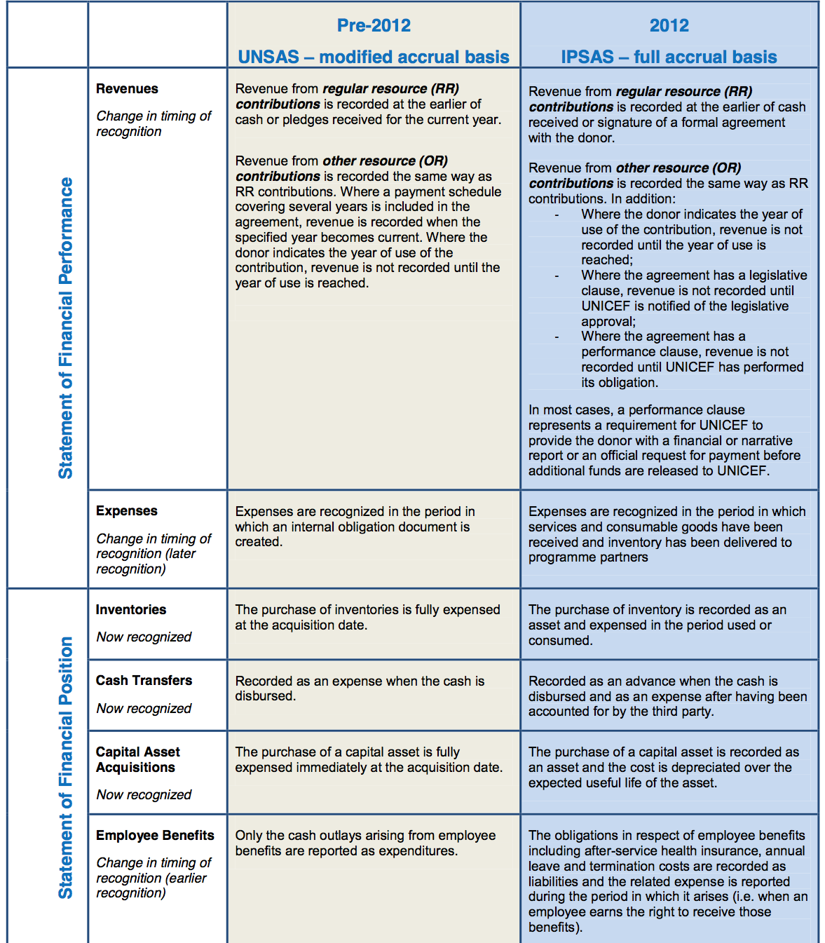

As seen from the table UNICEF lacked so many aspects when its accounting system was based on UNSAS. It seems that this new system will help the organization and improve their performance.
UNICEF’s Financial Management
Effective financial management is an ongoing process that features a cycle of good management habits. Below are the components of the UNICEF’s financial management cycle:
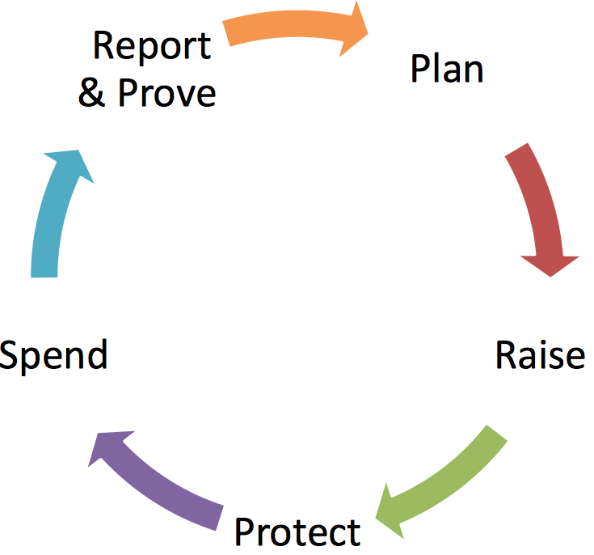

UNICEF’s financial management cycle is:
- Planning: UNICEF provides plans prior to the start year (2014), which are the Medium Term strategic plan and Institutional Budget. Starting the new start year (2014), the strategic plan and integrated budget are established.
- Raising Money: There are three types of financial resources, which are: RR, OR, and Trust funds. The total revenue for the year 2012 was $3,958 million.
Below is a breakdown of the 2012 UNICEF revenue based on source and funding:
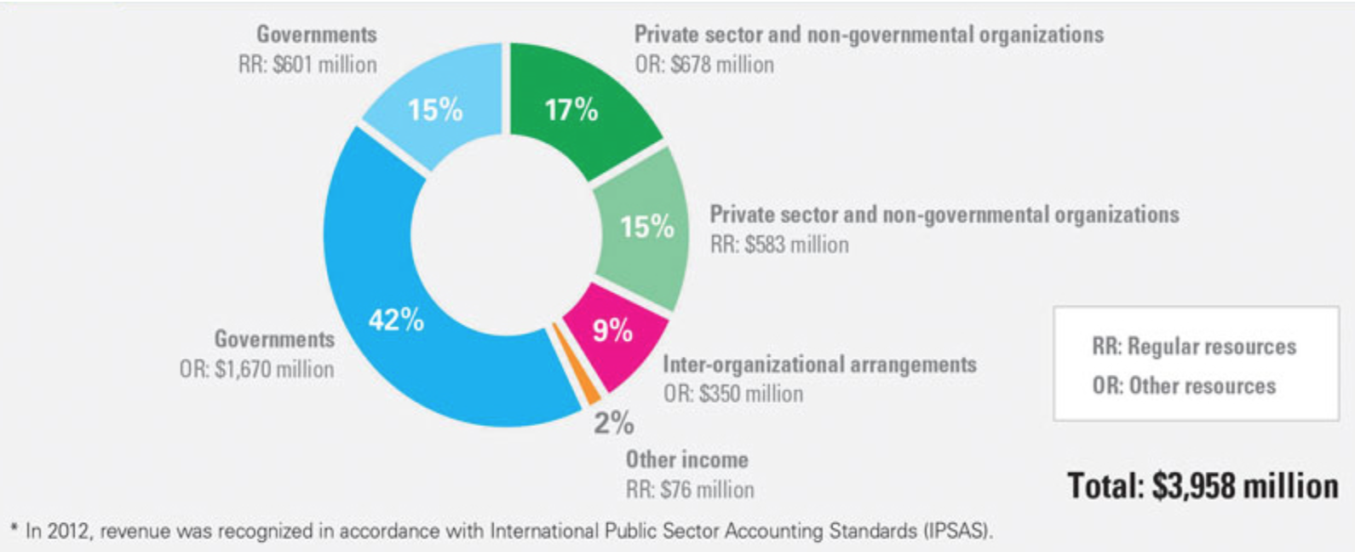

- Protect: this is a representation of accountabilities, risk and controls within UNICEF.
- Spend: Here the management will be in regards to ensuring that funds are spend and revenue collected according to the financial plan and according to the norms and standards of UNICEF.
- Report and Prove: UNICEF reports on expenditures and responds to audits. In regards to reporting to stakeholders is done through:
  - UNICEF Financial Statements: a collective organizational financial health and annual financial performance reports are provided to the Executive Board. These financial statements are based on IPSAS standards.
  - Reporting to donors on the use of OR contributions: Here UNICEF provides financial performance for individual donor agreements.
  - Organizational Documents: UNICEF reports to external stakeholders on performance and including financial information. These reports include Executive Director’s Annual Report, UNICEF Annual Report, and Reports on RR.

It’s important to note that UNICEF uses Bridge Fund, which is a revolving loan. The basic premise of the Bridge Fund is that it’s a more institutional method to fund gaps in pledges made by donors and cash received. There are different types of social investors that enable UNICEF Bridge Fund to borrow or leverage money. Grant-makers form the foundation of the Bridge Fund. They enable the Bridge Fund to borrow up to 3.5 times the grant amount in social investment loans. Another type of social investors are lenders. By lending the Bridge Fund cash for up to 5 years, they enable goods to bought rapidly. UNICEF’s Bridge Fund will aim to raise $14 million in grants and $50 million in loans. By leveraging and revolving investor support, UNICEF’s Bridge Fund will multiply both the effect of its dollars and the organization’s capacity to save lives. For example, a single net worth grant of $1.4 million will enable the Bridge Fund to borrow, or leverage $5 million, or 3.5 time as much capital. So if the capital bridges just two transactions per year, the net worth investor has already achieved 7 times the impact of the original investment. Moreover, after 5 years, a grant maker can achieve up to 35 times the impact of his or her original investment. UNICEF’s Bridge Fund is considered a separate entity that is equivalent to a wholly own subsidiary in the business world. The funds here are managed and accounted for distinctly from the U.S. Fund.
UNICEF’s Financial Reporting
The Board of Auditors Report on the financial statements is a critical way to report on UNICEF’s finances. The UNICEF submits its financial report, accompanied by 10 statements, 3 schedules, and 2 annexes. Statements 1 to 4 are presented in line with the formats agreed by the UN System Chief Executives Board for Coordination as a step towards harmonizing the accounts of agencies in the UN system. Moreover, the financial report summarizes the financial results of UNICEF activities during the last term. However, with the new IPSAS standards the Executive Director prepare an annual set of financial statements. These financial statements are prepared for the financial period in accordance with the following Regulations and Rules:
- Principle Accounts Report
  - The report on the UNICEF account must be presented in United States dollars.
  - The reports should reflect financial transactions on an accrual basis in accordance with IPSAS.
- Subsidiary Account Report
  - The Comptroller is responsible for the policies with respect to the financial operations of UNICEF. The accounting records should be maintained by the Comptroller and also institute all financial systems and procedures, including those in respect of offices away from headquarters.
- Currency of Accounts
  - The report on UNICEF Account will be submitted by the Executive Director, no later than 31 March following the end of each financial period, to the Board of Auditors for examination.
- Certification of Report of the UNICEF Account
  - The Executive Director shall transmit the report on the UNICEF Account to the members of the Executive Board in accordance with the rules of procedure of the Executive Board.
- Other statements
  - In addition to the UNICEF Account, the Comptroller provides the Board of Auditors information/reports on: ex-gratia payments; on inventory, property, plant, and equipment and intangible assets; on the value of losses of cash, stores, and other assets written off; and such other information that the Board of Auditors may request.
It’s important to note that UNICEF organization use both Internal and External Audits. The Office of Internal Audit and Investigations (OIAI) internal audit function provides independent and objective assurance and advisory services designed to add value and improve the operations of UNICEF. OIAI conducts different types of internal audits, which includes: audits of country offices, regional offices, headquarter divisions and thematic areas. The OIAI also provide summary reports that shows the cross-cutting issues identified from different county office audits. UNICEF is subject to external audit exclusively by the United Nations Board of Auditors (UNBoA) is accordance with the UNICEF financial regulations that Executive Board of UNICEF has established. OIAI states that it works with full transparency to the UNBoA. The UNBoA undertakes its audits of UNICED accordance with its own risk model and audit plan.
UNICEF’s Performance Management
Performance management is an essential to the success of an organization but it’s difficult to implement a suitable performance management model. There are recurring challenges that face nonprofits when implementing or choosing a suitable performance management model, which are: the culture in nonprofits, the role of a voluntary board, stretch resources and time, and problems with traditional performance management models. Another aspect I personally believe why UNICEF is facing issues in regards to performance management is the nature of the organization itself. A multinational organization with various numbers of offices all over the world makes it harder to implement an effective performance management tool. There are five phases of performance management process, which are: planning, implementing, measuring and monitoring, reviewing and reporting, learning and adapting. Even though, the progress on UNICEF’s evaluation function is recognized, there are many concerns about management response and follow-up to evaluations. UNICEF is putting an extended monitoring and reporting platform (VISION), which will provide an integrated performance and results reporting at country as well as the global programme level. VISION system, fully launched in January 2012, it allows UNICEF offices at all levels to develop and input data on different types and levels of results. It also links together budgeting data and key results so that country offices can input their budget information under key UNICEF results area rather than program expenditure activities. It’s a fact that a strong performance monitoring is a vital element to achieve UNICEF’s programme excellence and accountability. At the operational level, good monitoring data are also indispensable for good planning, reporting and fundraising purpose. Moreover, a timely monitoring helps UNICEF manage risks such as implementation risks, financial risks, and accountability risks.
It’s important to note the objectives of monitoring and evaluation in UNICEF, which are:
- To improve management of programmes, projects and supporting activities and to ensure optimum use of funds and other resources;
- To learn from experience as so to improve the relevance, methods and outcomes of cooperative programmes;
- To strengthen the capacity of co-operating government agencies, non-governmental organizations (NGOs) and local communities to monitor and evaluate;
- To meet the requirements of donor to see whether their resources are being used effectively, efficiently and for agreed upon objectives;
- To improve information to enhance advocacy for policies, programmes and resources that improve the condition of women and children.
To achieve the first purpose of UNICEF’s monitoring and evaluation objective there is a need to improve management through bettering monitoring and evaluation throughout the programming cycle and providing data to help in decision-making process. The second objective can only be achieved if procedures are set up to disseminate findings to decision-makers and to use them to corrective action. To strengthen national capacity, UNICEF must work with responsible officials and programme staff and involve supporting institutional strengthening. The fourth objective relates to fundraising and often depends on occasional external evaluations done by teams of specialists. Finally, advocacy for improved policies and programmes and mobilization of greater personal commitment and financial support require credible information about progress, problems and potential derived from mentioning and evaluation.
UNICEF’s Risk Management
Risk Management is defined as: a process of identifying and assessing risk and establishing measures or controls to bring risks within the organizational risk tolerance. UNICEF’s risk management assessment is conducted as part of the annual planning process. In the annual planning process key risks are identified, assessed and responded to in a manner to ensure that residual risk is brought within the risk tolerance accepted by UNICEF. However, major risks should be reported to management on a periodic basis. It regards to major risks that cannot be adequately treated must be escalated, and brought to the notice of UNICEF managers with sufficient authority to deal with the risk and take appropriate decisions.
Part of the UNICEF’s accountability framework is identification and treatment of risk and it’s the responsibility of all managers and staff. Below is a list of major personals’ roles and responsibilities:
- Executive Director: the director is accountable to the Executive Board for the development and achievement of UNICEF strategy and objectives, which includes the overall management of risks.
- Senior Staff Risk Committee: the members of UNICEF Global Management Team discuss the key risks and assignment of significant issues to appropriate parties. The role of the Senior Staff Risk Committee is to provide direction in risk management activities within UNICEF.
- Heads of Offices: Head of Offices are: representatives, regional directors, and directors of HQ division and offices. They are responsible for the overall management of risks related to programme and office operations.
- Policymakers: They are the Heads of Offices, they are responsible for promulgating or proposing for promulgation organizational policies and procedure.
- Risk Management Secretariat: Responsible for monitoring the effectiveness of risk management and related processes in UNICEF, facilitating implementation of these across UNICEF, and prepare reports on issues and trends in overall risk management in UNICEF.
- Risk Liaisons: They are focal points for risk management in UNICEF offices. They have deep knowledge of risk management challenges affecting their office.
- All Staff: every UNICEF staff member is responsible for managing the risks that affect the achievement of objectives related to their area of work, within their delegated authority.
- Office of Internal Audit: The office provides independent assurance to the Executive Director on risk management practices within the organization.
Risk reporting is critical when managing risk. The management of risk must be reviewed and reported for the following reasons:
- To monitor whether or not the risk profile is changing
- To gain assurance that risk management is effective and to determine whether further action is necessary.
Annually, a Risk and Control Self-Assessment is conducted at Divisional, Regional, and Country Office level. This assessment is facilitated by the Risk Liaisons and reported to the respective Heads of Office. The results are also reported to the Risk Management Secretariat, who reviews a sample of risk profiles and matrices to monitor the effectiveness of risk management practices and the emergence of new risks. It’s important to note that the Risk Management Secretariat uses the risk profiles to update the Risk and Control Library and UNICEF’s Risk Profile. UNICEF is able to evaluate the effectiveness of their risk management efforts through:
- UNICEF’s Risk Profile: evaluating the changes over time in the profile will reflect the risks UNICEF is taking and their significance based on how risks are managed.
- The ongoing communication: the ongoing communication between the Risk Management Secretariat, Risk Liaisons, Policymakers and other risk experts in refining risk tolerance definitions.
- The Reports and Assessment: the quality of risk assessment and reporting will reflect whether risk management is effective or not.

UNICEF’s Business Continuity
UNICEF’s organization acknowledges business continuity as an institutional priority. All UNICEF headquarters locations and regional and country offices have a business continuity plan and the overall objective for UNICEF is to have business continuity institutionalized as a core functional plan of all offices globally. UNICEF’s Business Continuity Unit (BCU) is established within the Office of Emergency Programmes (EMOPS), it comprises a chief, manager, and an administrative assistant. The accelerated BCU workplan has been developed in 2007 and agreed with a focus on four major objectives, which are:
- Completion of business continuity management plan for New York and other headquarter offices by the end of 2007;
- Establishment of an alternate disaster recovery centre outside of New York for purposes of storing UNICEF information technology by the end of 2009;
- Completion of a business continuity training package and training for all regional and country offices;
- Establishment of coordination arrangements for all inter-agency partnerships on business continuity;

It seems that UNICEF business continuity is still in the development process.

Conclusions and Recommendations
UNICEF organization is a leading organization that has been working to help children all over the world. There are many strengths, progress, and weaknesses that UNICEF organization has now a day. Below I list the various strengths, progress, and weaknesses they have based on my examination of the organization:
- Strengths:
  - Planning: in the planning process of the strategic plan it seems that one of UNICEF’s strengths would lay on the intense process of MTSP’s development stages. Having different responsible personnel or departments drafting, giving feedback and also maintain that certain updates is in my opinion essential. The process seems to ensure that the organization strategic plan is implemented and not just put in a shelf. Even though, the strategic plan is heavily relied on in the organization work plans are also strength of UNICEF. Having work plans specifically done for a programme or a project but also maintain that linkage with the strategic plan is important. It was really interesting to read about how they provide Internal Communication plans within the organization, which is a reflection of how UNICEF acknowledges the importance of ongoing communication in their organization.
  - Accounting: The implementation of IPSAS accounting system. The type of process UNICEF has gone through to implement the new system seems to reflect the strength of planning and understanding the risks of change.
  - Risk Management: UNICEF seemed to have a very effective risk management even with the organization’s issues with reporting. Recognizing the different definitions that have a relation to risk was interesting to see in their risk management report. The differentiation between risk, threat, and other definition is critical.
- Progress:
  - Budgeting: the initiative of using “social budgeting”, might have a great outcome to UNICEF in the long run. It will also help better their funding and possibly reporting.
  - Accounting: UNICEF’s change of accounting system might need some time before it effectively work and for the organization to prove the system works.
  - Financial Management: It seems that UNICEF method of using Bridge Fund is so far working well and it’s a great way to reach their goals effectively. There are still minimums of examples on the cases UNICEF uses Bridge Fund so it’s still progressing.
  - Financial reporting and reporting in general: UNICEF’s financial reporting is considered effective but their reporting to the public is still in progress. UNICEF is trying to be transparent by providing as much reports as possible but it’s still a work in progress.
  - Performance Management: The VISION system is a great way UNICEF is implementing will help in providing an integrated performance and results reporting at both country and global programme level. The reason why I listed this in both progress and weakness is the lack of any efficient reports stating the effectiveness or failure of this system to help in performance management.
  - Business Continuity: There wasn’t enough evidence of how they implement business continuity plans. But the basic structure and implementation plans seemed to be strong.
- Weaknesses:
  - Planning and programming: Even though the planning process is considered strength but the time it takes can affect the organization negatively. In other words, programme-planning process can take too long and sometimes programs become obsolete too quickly.
  - Budgeting: The type of budgeting UNICEF uses is the results based budgeting. The key issues of using this type of budgeting are: there will be a need to increase focus on outcome, not only inputs and outputs; and there is a limitation of performance measurement information.
  - Performance Management: this is considered a major weakness UNICEF has in their organization. Even though, UNICEF recognize evaluation and monitoring but they don’t have a strong tool.
UNICEF’s organization is a multinational one and with a big organization there are usually some flaws that might take time to fix. However, I recommend that UNICEF consider adding an extra type of planning process for programs that are time sensitive. That might help them be more efficient but also maintain their strong planning process and implementation. In regards to budgeting I highly recommend to use a combined budgeting, combining both Zero-based budging and their current results budgeting or maybe customized their own budgeting system that will be used for their unique organization. Performance management is a major concern and even though UNICEF is trying to implement new systems that will help in reporting, which will lead to better monitoring. I recommend UNICEF to invest and concentrate on reporting processes and also reporting to the public. Transparency in reports will not only better monitoring and performance management but will also help in regards to funding. When people are able to see where their money goes and how it is used through reports that will build trust and will rise funding.

References

United Nations Educational, Scientific and Cultural Organization. (n.d.). Guide to Archives of International Organizations: UNICEF. Retrieved from http://www.unesco.org/archives/sio/Eng/presentation_print.php?idOrg=1033

Our History. (n.d.). About UNICEF: Who We Are. UNICEF. Retrieved from http://www.unicef.org/about/who/index_history.html

UNICEF’s Mission Statement. (n.d.). About UNICEF: Who We Are. UNICEF. Retrieved from http://www.unicef.org/about/who/index_mission.html

FAQ. (n.d.). “About UNICEF: Who We Are”. UNICEF. Retrieved from http://www.unicef.org/about/who/index_faq.html

United Nations Children’s Fund. (n.d.). United Nations System: Chief Executives Board for Coordination. Retrieved from http://www.unsceb.org/content/unicef

Family Planning Heat Module: Developing and Using Work Plans. (n.d.). LabSpace. Retrieved from http://labspace.open.ac.uk/mod/oucontent/view.php?id=451851&section=10.4.1

Bryson, J. (1988). A Strategic Planning Process for Public and Non-Profit Organizations . Long Range Planning, 21, 73-81. Retrieved from http://docushare.usc.edu/docushare/dsweb/Get/Document-8775/bryson+-+strategic+planning+for+non-profits.pdf

Strategic Plan 2014-2017. (n.d.). Strategic Plan 2014-2017. UNICEF. Retrieved from http://www.unicef.org/strategicplan/

“The UNICEF Strategic Plan, 2014-2017”. (2013). United Nations: Economic and Social Council. Retrieved from http://www.unicef.org/about/execboard/files/2013-21-UNICEF_Strategic_Plan-ODS-English.pdf

“UNICEF Rolling Work Plan 2013-14 In Odisha”. (2012). Government of Odisha. Retrieved from http://www.odisha.gov.in/samachar/2013/Jan/data/12-01-2012/NewsUNICEF.pdf

“Internal Communication Plan”. (n.d.). UNICEF. Retrieved from http://onmyodo.com/kate_labriola/unicef_internal_communications_plan.pdf

UNICEF Executive Board: Home. (2014). UNICEF Executive Board. UNICEF. Retrieved from http://www.unicef.org/about/execboard/

Overview of Programming Process. (n.d.). UNICEF. Retrieved from http://www.unicef.org/about/execboard/files/Jeffrey_OMalley-Orientation_Executive_Board-15Jan2013.pdf

“Modification to Procedures for Consideration and Approval of Country Programme Documentation”. (2013). United Nations: Economic and Social Council. Retrieved from http://www.unicef.org/about/execboard/files/2014-PL1-Modification_to_CPDs-ODS-English.pdf

“Report on an Audit of the Budgeting Process in UNICEF”. (2012). Office of Internal Audit and Investigations (OIAI). UNICEF. Retrieved from http://www.unicef.org/auditandinvestigation/files/oiai_2012_budgeting_process.pdf

Channon, J. (2012). “Putting Children at the Heart of Budgets: How UNICEF is Pioneering Child-Focused Budgeting”. Oxford Policy Management. Retrieved from http://www.opml.co.uk/sites/opml/files/Putting%20children%20at%20the%20heart%20of%20budgets%20-%20How%20UNICEF%20is%20pioneering%20child-focused%20budgeting%20-%20OPM%20Briefing%20Note%20August%202012_1.pdf

Gore, Radhika. (2009). “A review of UNICEF’s Social Budgeting Initiatives”. UNICEF Policy and Practice. Columbia University. Retrieved from http://www.fordham.edu/images/academics/programs/iped/unicef_sb_06-2009.pdf

“UNICEF Integrated Budget, 2014-2017”. (2013). United Nations Children’s Fund: Executive Board. UNICEF. Retrieved from http://www.unicef.org/about/execboard/files/2013-ABL4-UNICEF_integrated_budget-11Jul2013.pdf

“UNICEF Moves to IPSAS”. (n.d.). UNICEF. Retrieved from http://www.unicef.org/parmo/files/UNICEF_moves_to_IPSAS.pdf

“Update on the Implementation of IPSAS”. (2012). UNICEF. Retrieved from http://www.unicef.org/about/execboard/files/Implementation_of_IPSAS-Item_12-20Jan2012.pdf

“Financial Management”. Financial Management: An Overview and Field Guide for District Management Teams. Retrieved from http://www.who.int/management/Finances4FinancialManagement.pdf

Sullivan, Patrick. (2014). “UNICEF ‘Bridges’ Times from Pledge to Action”. The NonProfit Times. Retrieved from http://www.thenonprofittimes.com/news-articles/unicef-bridges-time-from-pledge-to-action-2/

“UNICEF Bridge Fund”. UNICEF. Retrieved from http://www.unicefusa.org/sites/default/files/assets/pdf/bridge-fund-slideshow.pdf
“Internal Audit”. (2012). The Office of Internal Audit and Investigations (OIAI). UNICEF. Retrieved from http://www.unicef.org/auditandinvestigation/index_65753.html#TYPE_OF_INTERNAL_AUDITS

“UNICEF Financial Regulations and Rules”. (2011). United Nations: Economic and Social Council. UNICEF. Retrieved from http://www.unicef.org/about/execboard/files/2011-ABL8_Regulations_and_Rules-ODS-English.pdf

“A UNICEF Guide for Monitoring and Evaluation”. UNICEF. Retrieved from http://preval.org/documentos/00473.pdf

“The Art of Performance Management, Nonprofit Style”. Trends & Issues. Retrieved from http://www.hrcouncil.ca/documents/LMI_performance_management.pdf

“Review of UNICEF’s Development Effectiveness: Final Report 2009-2011”. (2013). Retrieved from http://www.oecd.org/dac/evaluation/UNICEF%20DE%20Review%20Report%20final%20May%2015.pdf

“Recruitment of an International Consultant for 3 Months”. (n.d.) UNICEF. Retrieved from http://reliefweb.int/sites/reliefweb.int/files/resources/TOR%20HPMsystem%20%26%20mapping_0.pdf

“UNICEF Risk Management Policy”. (n.d.). UNICEF.

“Implementation of Executive Board Decision 2007/4 on Crisis Management and Business Continuity Capacity”. (2007). United Nations: Economic and Social Council. UNICEF. Retrived from http://www.unicef.org/about/execboard/files/07-ABL11-crisis_mgt.pdf

