United Nations Children’s Fund (UNICEF)

Who is UNICEF?
The United Nations Children’s Fund (UNICEF) is the main UN organization defending, promoting and protecting children’s rights. It also works towards protecting the world’s most disadvantaged children. The United Nations Children’s Fund was created in 1946 to provide aid to European children affected by World War II and the acronym stood for “United Nations International Children’s Emergency Fund”. In 1953 it became a permanent part of the UN, and the UN General Assembly extended UNICEF’s mandate indefinitely. UNICEF has saved more children's lives than any other humanitarian organization, is working toward a day when ZERO children die from preventable causes.
UNICEF believes that children have the
- Right to Adequate Nutrition,
- Right to Education,
- Right to Health,
- Right to Participate,
- Right to Protection, and
- Right to Clean Water.

Stated Purpose
“to inform people of the needs of children in developing countries, create an awareness of the diversity of human cultures, of the commonality of human needs and interests and of the responsibility to share in the world's resources and benefits, solicit and receive funds and other property for the purposes stated herein, participate in coordinating planning with voluntary agencies engaged in child relief, and otherwise improve the well-being of children in the world.”

Mission Statement
UNICEF is mandated by the United Nations General Assembly to advocate for the protection of children's rights, to help meet their basic needs and to expand their opportunities to reach their full potential.
UNICEF is guided by the Convention on the Rights of the Child and strives to establish children's rights as enduring ethical principles and international standards of behaviour towards children.
UNICEF insists that the survival, protection and development of children are universal development imperatives that are integral to human progress.
UNICEF mobilizes political will and material resources to help countries, particularly developing countries, ensure a "first call for children" and to build their capacity to form appropriate policies and deliver services for children and their families.
UNICEF is committed to ensuring special protection for the most disadvantaged children - victims of war, disasters, extreme poverty, all forms of violence and exploitation and those with disabilities.
UNICEF responds in emergencies to protect the rights of children. In coordination with United Nations partners and humanitarian agencies, UNICEF makes its unique facilities for rapid response available to its partners to relieve the suffering of children and those who provide their care.
UNICEF is non-partisan and its cooperation is free of discrimination. In everything it does, the most disadvantaged children and the countries in greatest need have priority.
UNICEF aims, through its country programmes, to promote the equal rights of women and girls and to support their full participation in the political, social, and economic development of their communities.
UNICEF works with all its partners towards the attainment of the sustainable human development goals adopted by the world community and the realization of the vision of peace and social progress enshrined in the Charter of the United Nations.

UNICEF Executive board
The Executive Board is the governing body of UNICEF; it provides intergovernmental support and oversight for the organization, in accordance with the overall policy guidance of the United Nations General Assembly and the Economic and Social Council.
The executive board reviews UNICEF activities and approves its policies, country programmes and budgets. It comprises 36 members, representing the five regional groups of Member States at the United Nations. Its work is coordinated by the Bureau, comprising the President and four Vice-Presidents, each officer representing one of the five regional groups.
The Executive Board meets three times each calendar year, in a first regular session (January/February), annual session (May/June) and second regular session (September). Executive Board sessions are held at the United Nations headquarters in New York.
The Office of the Secretary of the Executive Board supports and services the Executive Board. It is responsible for maintaining an effective relationship between the Executive Board and the UNICEF secretariat, and helps to organize the field visits of the Executive Board.
The Office also provides editorial and technical services for all documentation related to Executive Board sessions and meetings, decisions, reports of sessions and the country programme documents repository. A selection of key documents related to the work of the Executive Board can be found under resources.
All programs, planning, budgets and crucial organizational activities are reviewed and approved by the executive board.
Planning, Strategic Planning and Resource Allocation
“The Strategic Plan contributes to realization of the rights of all children by emphasizing equity. Focusing on the most disadvantaged and excluded children, families and communities accelerates progress towards fulfillment of the rights of all children and reduces disparities
The strategic plan comprises of seven programme outcomes and three organizational effectiveness and efficiency results which are contained in a single results framework for UNICEF. The integrated results and resources framework identifies how total resources available to UNICEF will be allocated to these outcomes and results. Below is a list of the seven expected outcomes.

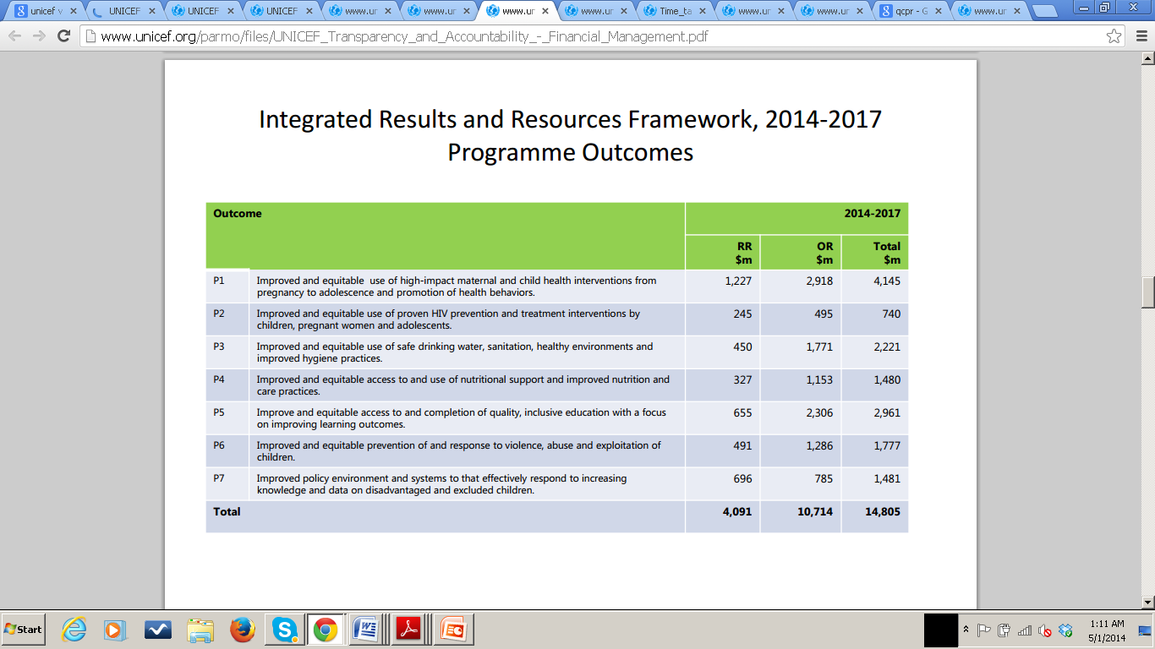
UNICEF’s strategic planning philosophy is based on its mission statement, the Convention on the Rights of the Child, the Millennium Summit Declaration of the General Assembly and the Declaration and Plan of Action of A World Fit for Children, adopted by the General Assembly. Its current strategic planning is in a form of a medium-term strategic plan (MTSP) which extends from 2014 to 2017 and formerly extended from 2006-2013.
UNICEFs MTSP provides the strategic context for both the institutional budget and the integrated budget. The guiding principles of the MTSP are as follows
(a) Working with partners and within UNICEF to accelerate results and impact for children, with an equity focus for assuring achievement of the Millennium Development Goals;
(b) Ensuring that UNICEF work at all levels is informed by data, evidence, current knowledge, good practice, the lessons of evaluation and international experience;
(c) Striving for efficiencies, cost reductions, value for money and excellence in UNICEF management and operations within the framework of the organizational strategic plan, and monitoring and assessing its performance on an ongoing basis;
(d) Bringing a human rights perspective and striving to mainstream gender issues in all UNICEF work for children;
(e) Promoting, advocating for and supporting children’s rights in all situations, including humanitarian action, transition and in fragile states.

Integrated Results and Resources Framework connects the Strategic Plan to the Integrated Budget and identifies how total resources will be allocated to programme outcomes and organizational effectiveness and efficiency. The Medium term strategic plan for UNICEF has several focus areas which include:
1) Young child survival and development
2) Basic education and gender equality
3) HIV AIDS and children
4) Child protection from violence, exploitation and abuse
5) Policy advocacy and partnerships for children’s rights
6) Humanitarian action.

The current strategic plan incorporates the findings of the 2012 end of cycle review of the UNICEF medium-term strategic plan, 2006-2013 and the lessons learned from this review are then applied into the strategic plan for the next cycle 2014-2017. The chart below describes the time table between the end of cycle MTSP 2006-13 review and the development of the MTSP for 2014-17.

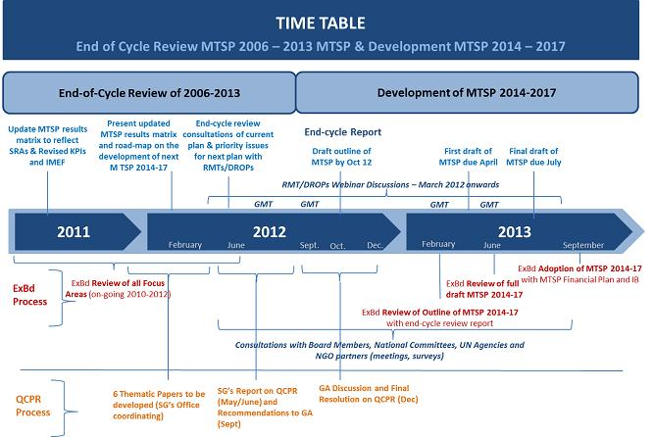

UNICEF has an integrated resource plan which is over a 4 year span and is also part of the MTSP. This plan is revised and reviewed on a rolling basis and annually submitted to the board for approval. The IRP is one of the three key budget tables and is included in the presentation of budgetary information. The integrated resource plan has replaced the financial plan because they share similar information and are both over the same 4 years financial period.
UNICEF submits a financial plan to the Executive Board through three routes: a country programme document is presented to and approved by the Executive Board at the beginning of each programme cycle; an institutional budget is presented every two years; and the advocacy, programme development and inter-country programme carried out by

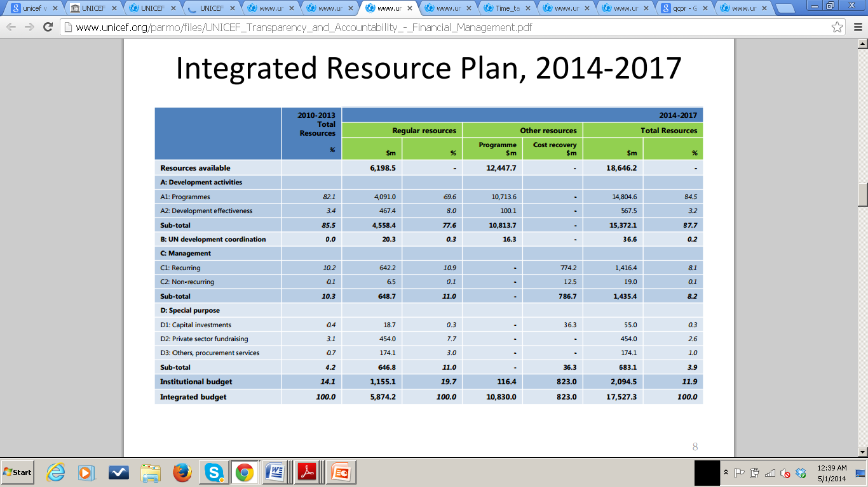
Below is statement on its strategic plan found on the UNICEF website
“The strategic plan includes a strengthened focus on humanitarian action, including enhanced dedicated capacity for effective preparedness for response, response and early recovery, to save lives and protect rights, as defined in the Core Commitments for Children in Humanitarian Action, as well as to address underlying causes of vulnerability to disasters, fragility and conflict through responses to humanitarian crises and through regular programmes”
Resources for the organizational effectiveness and efficiency results are allocated in accordance with the UNICEFs methodology and results-based budgeting and approved by the executive board. Resources are allocated to output delivering activity organizational units and these units are grouped into functional clusters, which provide the link between results and resources. Development effectiveness activities are more closely associated with the programme outcomes and delivery modalities of each of the agencies. Resources for development effectiveness within UNICEF are allocated to three functional areas 1) technical excellence in policy and programmes (2) technical excellence in humanitarian action (3) and technical excellence in procurement and management of supplies
UNICEF’s Public sector alliance and mobilization office (PARMO) is responsible for the organizations overall resource mobilization from public sector donors and is also responsible for the management of the overall relationship with them. UNICEFs Income consists of regular resources, other resources (regular) and other resources (emergency). Funds from the voluntary annual contributions of Governments, intergovernmental agencies and non-governmental organizations, the income received through the UNICEF Private Fundraising and Partnerships Division, non-earmarked funds contributed by the public and other income are included as regular resources. Other resources are funds contributed to UNICEF by Governments, intergovernmental organizations, non-governmental organizations and the United Nations system for specific purposes within the programmes approved by the UNICEF Executive Board. Other resources include those contributed for emergency operations. Income is recorded on the basis of funds or pledges received for the current year. Funds received for future years for purposes specified by donors are considered deferred income and recorded as “contributions received in advance”. Contributions income received from National Committees and field offices for other resources are recorded on a cash basis.
Planning and Resource allocation Recommendations
UNICEF needs to formulate stricter Programme plans with objectives in certain country offices and establish its programme of work with a view to meeting those objectives. This effective programme plan will enable an UNICEF to set appropriate goals and put in place effective plans to achieve them. These processes should also enable it to measure outcomes, determine whether it is using its resources effectively and hold people to account for the effective use of those resources.

Budgeting and Budget Execution
The Division of Policy and Strategy (DPS) and the Division of Financial Management
(DFAM) are the key players UNICEFs in the budgeting process. UNICEF uses a form of budgeting which they refer to as a “Result based budget” which can be said to be a mix of a performance/program based budget. Using this RBB process, the organization identifies the results it wants to achieve, determines the resources it needs to achieve those results, and then allocates those resources appropriately. This form of budgeting should help ensure that the organization’s processes, resources and services are directed at results that are important to its strategy.
UNICEF’s institutional Budget is over a two year duration and also included in the integrated budget results and resources framework. The Integrated budget is a very integral part of the UNICEF strategic plan which contains all budgetary provisions to complement the strategic plan.
UNICEF submits an integrated budget every year to the Executive board which includes all of its budgetary provisions to complement the next strategic plan. The Integrated budget is an integral part of UNICEF strategic plan and is considered along with its annex.
The UNICEF budget includes a programme budget and a support budget. The programme budget provides funds required for the implementation of programmes for women and children approved by the Executive Board. The support budget includes all costs that are not directly attributable to a particular programme or project, but are necessary to maintain the Fund’s presence in a country, as well as the management and administrative costs of headquarters.

Budget Analysis and Recommendations
UNICEFs RSB is required to include key elements, like the activities that will be undertaken, the expected results and what will be achieved, how to measure achievements against input and financial resources requested or the amount of resources required. When all these key information is present, only then can the executive board consider the budget complete and justified, but the organization has failed time and time again in its effort to present a justified budget to the executive board.
UNICEF exceeds it budget and most of the time this is due to the unforeseen problems or emergencies in most of the countries the organization deals with. I recommend that the organization sticks to a strict program based budget and allocate resources according to its annual and biennual programmes. This way I can keep better track of its resource orincome allocation and expenditure to for the programmes specific purposes. it should also have a support budget so that funds and resources can be allocated if expenditure is exceeded due to unforeseen emergencies and circumstances. it needs to make sure that achievement of expected results and it result based budgeting data collection are monitored adequately in country and field offices.

Financial Management
UNICEF’s financial management is overseen by its department of financial management (DFAM). Its role is to safeguard financial resources entrusted to UNICEF for the benefit of children by maintaining and improving financial and administrative management systems and procedures to ensure efficient, cost effective and transparent utilization of these resources.

The DFAM is responsible and accountable for:
Provide financial forecasts for organizational strategic planning;
Lead global budget planning, preparation and monitoring process
Manage financial assets, including cash and banking arrangements
Maintain and improve financial and administrative management systems, policies and procedures
Record, summarize, analyze and interpret financial information in the accounting records, and report information to various users

Below is an illustrative diagram of how the UNICEF financial management cycle works
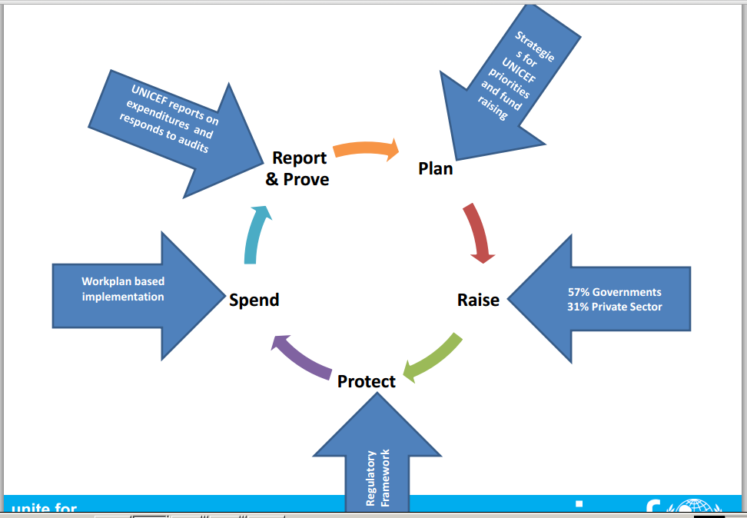

UNICEF goes through both internal and external auditing. Internal audit which involves the Office of Internal Audit and Investigations (OIAI), Independent assurance and advisory services. This internal audit helps evaluates governance, risk and management and control processes and provides annual report on activities and findings provided to Executive Board. The external audit involves the UN Board of Auditors (BoA) which provides independent opinion on UNICEFs organizational financial statements. The BoA provides observations on procedures, controls and general management practices and is the only entity that can audit UNICEF.

Risk Management
UNICEF has Risk management policy, whose main objective is to embed a systematic and consistent approach to identifying, assessing, and managing risks across UNICEF using a common risk language. All individuals, staff, departments, divisions, regional offices, country offices, headquarter offices are responsible for performing risk management within the organization.
The Public Sector Alliances and Resource Mobilization Office (PARMO) performs a comprehensive risk and control assessment for the organization on all country and regional offices.PARMO is the main risk owner for public sector resource mobilization and agreed to conduct annual reviews of risks related to public sector resource mobilization, including those that cut across multiple offices, have wider impact on PARMO, and/or require global corporate action or policy change.
UNICEFs risk management philosophy and principles are as follows
- Risk management is everyones business
- Accept no unnecessary risk
- Accept risk when benefits outweigh costs
- Anticipate and manage risk by planning
- Recognize opportunities
- Take decisions promptly
- Consider risks individually and in the aggregate
- Make risk management decisions at the right level
- Embedded risk management (into the existing organizational business process)

Implementing this policy will help UNICEF:
- Facilitate risk-informed decisions when setting objectives, selecting and managing the most appropriate course of action, and evaluating results;
- Maintain forward-looking rather than reactive risk management by encouraging well planned and well managed risk-taking;
- Facilitate a change in organizational culture to enhance risk management practices; and
- Provide assurance to stakeholders that UNICEF's objectives would be met, key risks would be better managed, and results would be demonstrated

Risk Management Analysis and Recommendation
UNICEF risk management policy and methodology is a good one because every individual and level is held accountable for accessing the different risks that may affect them.

Financial Reporting
Reports and audits are done quarterly, annually and biannually by the office of internal audits and investigations (OIAI), and are submitted to the executive board.
Budget performance reporting is a vital part of budget management. By the end of the budget cycle, the administration should provide a formal performance report to its governing body (the Executive Board) indicating the utilization of budget resources, explaining significant variances between the original budget and actual expenditure, and indicating what has been achieved as a result of the utilization of resources.
Every year, the Executive Director of UNICEF submits to the Executive Board an annual report, which presents the results and analysis of programme progress and achievements in each focus area of the UNICEF medium-term strategic plan, as well as organizational performance
On a quarterly basis, country offices are required to report to headquarters and regional offices the status of outstanding direct cash transfers, including those outstanding for more than six months.
Financial Reporting is done on all UNICEFs management controls and is reported to the board.

Accounting
There isn’t much information out there about UNICEFs accounting. UNICEF has adopted the International Public Sector Accounting standards and uses revised cost categories in its budget.
UNICEF income for the biennium totaled $7,355 million. Income comprised $2,005 million under regular resources, $3,364 million under other resources (regular) and $1,986 million under other resources (emergency). The breakdown of UNICEF income by source is: 59 per cent ($4,305 million) from Governments and intergovernmental agencies; 31 per cent ($2,276 million) from fundraising campaigns, the sale of greeting cards and gifts, non-governmental organizations and individual donations; 9 per cent ($664 million) from inter-organizational arrangements; and 1 per cent ($110 million) from miscellaneous sources, including interest income and net currency exchange adjustments and gains on foreign currency transactions.

Performance Management
Performance reporting is the mechanism by which an organization monitors progress towards the achievement of its objectives, and thus is essential if the governing body and the public are to gain a comprehensive understanding of the achievements of an organization and the efficiency and effectiveness demonstrated in the delivery of its mandate.
There are performance monitoring system and indicators in place that allows the organization measure and track the outcomes from the monitoring and data collection systems annually.
UNICEF has a Global Evaluation Reports Oversight System (GEROS) in place which It provides for independent assessment and rating of reports on country, regional and global evaluations; feedback on the quality of reports to offices; and compilation of performance information.
Performance management analysis and Recommendations
Inconsistent performance reporting on programme activities is one of the major problems that plague UNICEF. The organization needs to put a better performance reporting and management mechanism in place for reporting and explaining the variance between the original budget and actual expenditure, utilization of resources and the fulfillment of expected results to the executive board. Indicators need to be set in place and used for performance reporting on programme activities

Business Continuity Plan
UNICEF is aware of issues and risks that arise during times of negative environmental turbulence and plans on tackling those problems by instituting appropriate Business Continuity Management programmes within the organization. UNICEF has a sound Strategic issue management system that is constantly reviewed and aligned with the changing global as well local operating environment. Business Continuity planning is well embedded UNICEFs planning process and organizational culture, and the organization also has a business continuity management system in place. UNICEF uses this Business continuity planning as a strategic issue management tool for addressing surprise issues that have impact on the long term survival and resilience of the organization in the face of unforeseen circumstances that are likely to impact on its ability to survive and to continue serving its purpose both in the short and long term.

References

"UNICEF :: Mission & History | Guide to Archives of International Organizations." UNICEF :: Mission & History | Guide to Archives of International Organizations. N.p., n.d. Web. 01 May 2014.
"Home." UNICEF. N.p., n.d. Web. 01 May 2014
Report O N an Audit of the Budgeting Process in UNICEF. N.p.: unicef.org, Oct. 2012. PDF.
UNICEF Integrated Budget, 2014 - 2017. N.p.: unicef.org, 11 July 2013. PDF.
UNICEF Financial Management. N.p.: unicef.org, 10 Oct. 2013. PDF
Overview of the Strategic Focus of the MTSP 2014 - 2017. New York: Unicef.org, 22 Mar. 2013. PDF.
Financial Report and Audited Financial Statements. N.p.: Unicef.org, 31 Dec. 2011. PDF.
Internal Audit of the Public Sector Alliances and Resource Mobilization Office (PARMO). N.p.: Unicef.org, Dec. 2013. PDF
UNICEF Integrated Budget, 2014-2017. N.p.: Unicef.org, 11 July 2013. PDF
UNICEF. The UNICEF Strategic Plan, 2014-2017. N.p.: Unicef.org, 11 July 2013. PDF.

