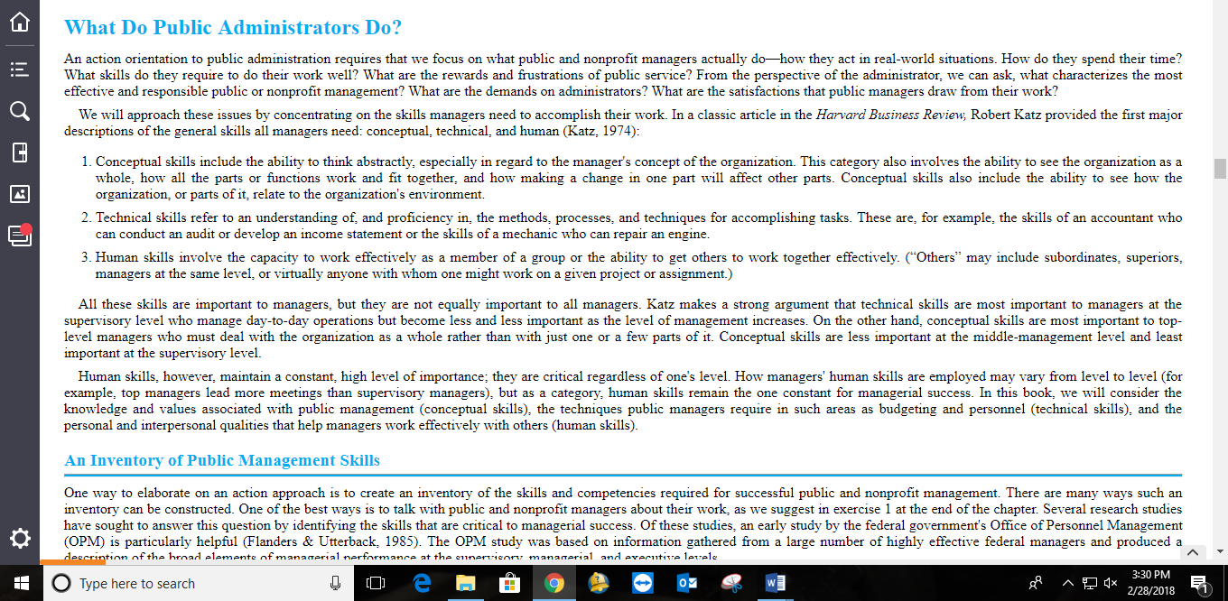

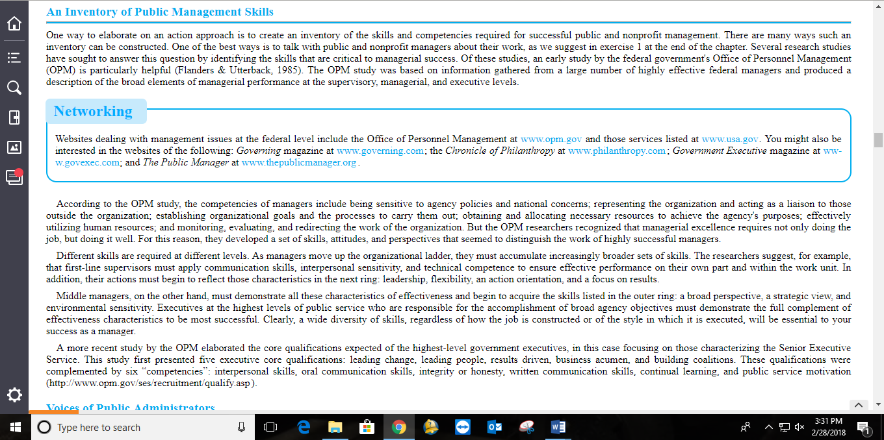

Denhardt, R. B., Denhardt, J. V., & Blanc, T. A. (2014). Public administration: An action orientation (7th ed.). Belmont, CA: Thompson – Wadsworth – Cengage Learning.

