PSYC 110M
Instructions for Research Paper
Overview
This term you will be writing a research paper on a particular topic relating to human psychology. You will choose your own topic, but you need to get it approved by me, unless you choose one of the topics suggested at the end of this document.
I suggest you choose a topic you know nothing about and have little interest in. You may be surprised at how much interest you develop in the process of doing your research. In fact, learning about topics you know nothing about and perhaps don’t care about is at the heart of getting an education.
I have posted a lot of information on how to write a research paper, and we will discuss the process in class. If you don’t know how to write a research paper, I guarantee you will by the time this course is over, as long as you pay attention to all the materials provided.
Instructions for Research
- You may use the MCC online library or any academic online library, or any walk-in library such as the Boston Library. Look for recently-published books by recognized experts, peer-reviewed journal articles, and other academic sources.
- You may use the Internet, but you must restrict your sources to sites that end in .edu, .gov, or .org. If you feel a .com website qualifies under those criteria, check with me to get permission to use it (e.g., TED.com is always acceptable). Above all, you must use sources that are accurate, up-to-date, unbiased, and written by a recognized expert.
- You must use at least five (5) sources. YouTube talks are acceptable, as long as the speaker is an academically recognized expert on the topic (e.g., a known scientist or psychology professor). If you are not sure about the speaker’s credentials, research that individual. If I challenge your research choices, you will have to find new ones.
- Avoid taking the majority of your information from a single source and only briefly mentioning your other sources in your paper. If necessary, find more sources. It is important to have multiple sources of information.
- Wikis are NOT acceptable research sources, although the list of original sources they include at the bottom of each article generally are. You must always use only original sources for research papers.
- Your textbook is also not a resource. You should always use original sources for your papers. Textbook authors are simply reporting research that others have done—and sometimes they’re simply quoting other textbooks. And sometimes they’re wrong. Go to the original source.
- Popular magazines like Psychology today are not acceptable resources, as articles are either not written by the original source of the information or are just excerpts from the original.
- If you absolutely cannot access the original source, but another reliable source has cited it, you may cite it as an indirect source. The APA rule is to exclude the indirect source (called the "original source" below) from your Reference list and include only the work you have in-hand (the "secondary source"):
Name the original source in your signal phrase. List the secondary source in your Reference list and include the secondary source in the parentheses, with the page number.
Johnson argued that . . . (as cited in Smith, 2003, p. 102).
- You may not cite your previous academic papers, even if you got A’s on them, because neither you nor your instructor is an expert on the subject matter.
- Interviews with topic experts are acceptable and recommended where possible.
- You are an expert on your own experience and may use that under certain circumstances. For example, if you write a paper on the psychological impact of workplace shootings and were the victim of one, you can tell your story as an example to support your point.

Instructions for Format

- APA style required (include a title page and abstract):
OWL: https://owl.english.purdue.edu/owl/resource/560/01/
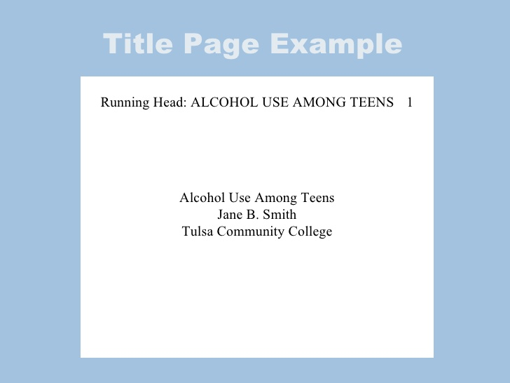
- A non-generic title that makes your topic clear is required.
- Microsoft Word is required for submission. If you don’t have it, type your final paper on a computer that does.
- Five to seven pages, not including the title page, abstract, or References page (papers shorter than five pages will be graded down by 10 points, and papers three pages or less will not be graded). “Padding” (irrelevant information), visuals, and repetitiveness will not be included in your page count.
- Double-space throughout. Do not use triple or quadruple spaces. Remove the “add space before paragraph” and “add space after paragraph” options from your settings.
- Standard 11- or 12-pt font throughout—Times New Roman, Calibri, etc. No fancy or “handwriting” fonts, and please, no super-large fonts on your title page.
- One-inch margin on all sides.
- A running head and pages numbered according to APA regulations (upper right-hand corner of page)
- Pictures and graphs (credited directly under the visual) should be included where helpful to making your point. If you use these, make sure that your written text still amounts to at least five pages.
Instructions for Content
- Write an introductory paragraph that provides some background information and ends with your thesis statement. Supporting details and examples do not belong in your introduction.
- Write a strong thesis statement that takes a position on your topic. Generally, your thesis statement will be the answer to your research question. A thesis statement is one that takes a position or states an opinion. It is not an announcement of what you are going to write about. Generally, it is the answer to your research question.
- Use appropriate paragraph structure, with a topic sentence and detailed supporting material. Make sure each topic sentence supports the thesis statement. If it doesn’t, you can eliminate the entire paragraph.
- Minimize use of direct quotations. If you can paraphrase, do so, and usually you can. Use a direct quotation only if paraphrasing would destroy the statement’s meaning or impact. If you do use direct quotations, include no more than two or three and keep them to no more than three lines.
- Include a reasonable conclusion that pulls your paper together for the reader. It can be a brief summary of your thesis and supporting points, although that is the least interesting kind of conclusion. More interesting options are a call to action, your personal reactions to what you’ve learned, or a projection of your findings into the future.

Final Note: Students often struggle with the issue of length in papers. There are three ways to get to the required length:

- Provide details in each paragraph. Detailed paragraphs are more interesting and more informative than general, superficial ones, and they yield a longer paper.
- Provide specific examples of each point; examples help the reader understand your point, they make your paper more interesting, and they yield a longer paper.
- Add additional relevant information that you think should be addressed.
Late Policy: Late papers will not be accepted. No exceptions! You have an entire semester to get the paper done. Start now.

