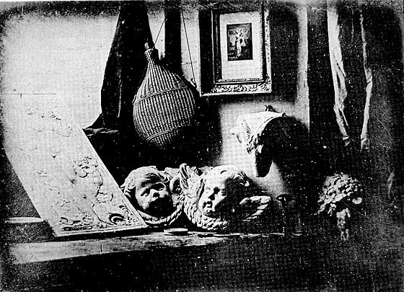

louis jacques mendes the artist's studio 1837

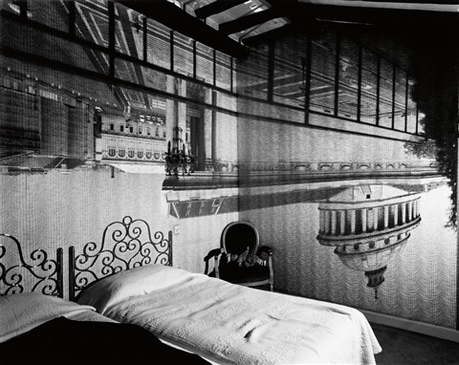
Abelardo Morell Camera Obscura of The Pantheon in the Hotel des Grands Homes
, 1999
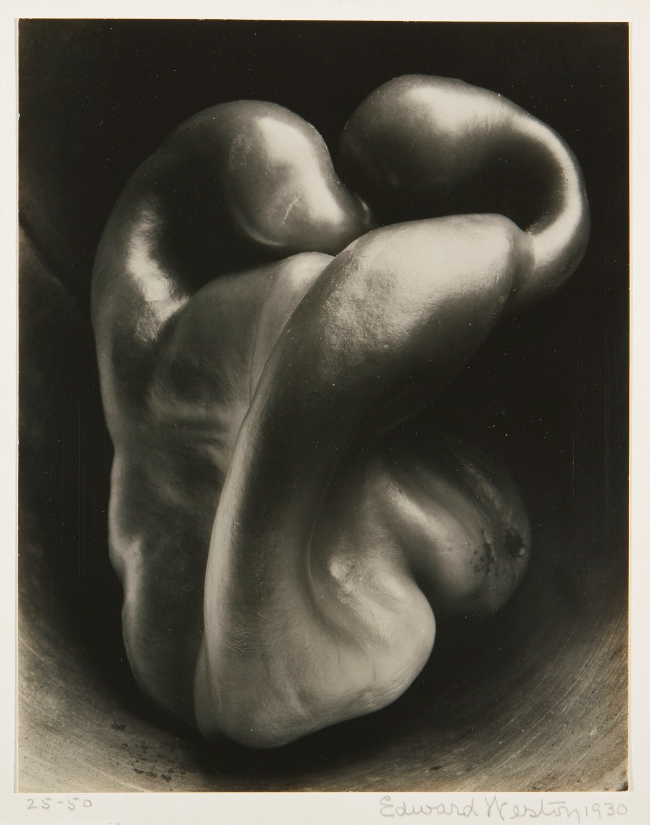
Edward Weston, Pepper N0. 30, 1930

