Response 1

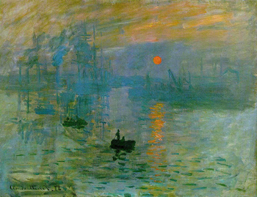

*Claude Monet’s Impression, Sunrise (1872)* is considered one of the most classic symbols of the impressionist movement that has transformed French painting during that second half of the nineteenth century. *Impressionism Sunrise* was also considered the painting that gave birth to the impressionist movement and regarded as his single most famous painting. This oil on canvas is located at Musée Marmottan Monet, in Paris.

*Impression, Sunrise*, depicts Le Havre’s harbor in the morning fog. Monet paid close attention to capturing light and natural forms. One of the key elements and characteristic of Monet’s technique is the use of short and quick brush strokes. Monet captures a particular light effect of the early dawn, created with an orange and blue-violet contrast. This illustrates the interaction of color and sunlight capturing the viewer’s attention.

One cultural influence that affected his work was the Franco-Prussian War, which lasted from 1870-1871. France ultimately lost the war, and had to relinquish the Alsace-Lorraine territory to Prussia. This damaged the morale of both government and society. Immediate reconstruction and rebuilding of a nation were underway. Monet was part of the revitalization of pride and spirit, which was conveyed through his paintings of the time. *Sunrise* strongly emphasizes France’s determination to rebuild and recover from the devastation of the war and post war renewal. Conflict has been the root of drama and a motivating force behind creative expression and Monet’s Sunrise reflects the culture in which it was created.

Janet

Response 2

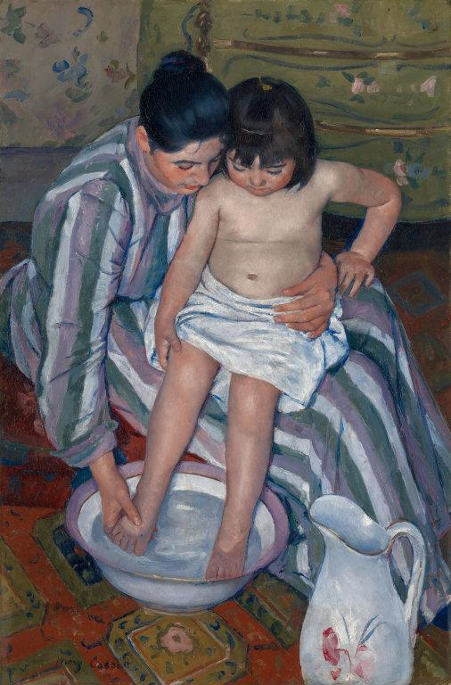

Title: *The Child's Bath*

Artist: Mary Cassatt

Year: 1893

Medium: Oil on Canvas

Location: Art Institute of Chicago, Chicago

The artist Mary Cassatt became the only American to be apart of Impressionism artists in Paris. Her work often featured women and children in every day acts such as *The Child's Bath.* The pair are made to be the focus of the painting, with more defined brushstrokes and bright colors that make the skin seem to almost glow, while the background is less structured and has more patterns. The years around 1893 were a time women were starting to make more of an appearance in the workplace with men. Some women, however, were still playing the role of housewife to take care of home and the children. This painting was an example of that, showing the viewers the inner domestic setting of a woman at home, and the relationship between mother and children. The bond is demonstrated by their closely positioned faces, the child's hand on her knee, and the protective hold she has around the child's waist.

"Mary Cassatt Biography, Art, and Analysis of Works." *The Art Story*. N.p., n.d. Web. 26 Jan. 2017. <http://www.theartstory.org/artist-cassatt-mary.htm>.