Volume 12
Issue 1
March 2014

Performance Appraisal at Telespazio: Aligning Strategic Goals to
People Development

Case1 prepared by Professors Silvia PROFILI,2 Alessia SAMMARRA,3 Laura INNOCENTI4
and Gabriele GABRIELLI5

Part A

“Dear colleague,

The Telespazio Performance Appraisal is one of the primary tools for human resource development
and management, and its correct use is one of your main responsibilities.

Our organization sets important challenges at the transnational level, leveraging on personnel
motivation. Optimal use of the appraisal system is extremely important when it comes to achieving
this. For these reasons, this year, I am looking forward to receiving your full commitment to the
management of the process, which is divided into two phases:

- Phase 1: evaluations related to the previous year must be finished by no later than April l5th, 2011.

- Phase 2: you are asked to define the 2011 objectives for your subordinates by no later than
April 30th, 2011.

Regarding Phase 1, I have to stress the importance of the evaluation, which must be based on fair and
realistic criteria, while also respecting deadlines.

I look forward to receiving your full commitment to the appraisal process.”

It was January 2011 when Telespazio’s CEO, Carlo Gualdaroni, sent this letter to all of the
company’s managers in order to strengthen their commitment to the appraisal program.
Gualdaroni considered the Performance Management System to be crucial to the organizational
change process undertaken by the company. As a matter of fact, the top management team had

____________
1 The authors wish to thank the Telespazio HR team, guided by Giorgio Dettori, for its continuous support. Particular thanks go
to Marta Di Santo, who is in charge of the Organizational Development, Management and Training Function, for her input and
enthusiastic involvement. Without her support, this case study would not have been possible. Special thanks also go to Stefania
Tomassi, who heads the Development Function, for her valuable contributions to the writing of this case.
2 Silvia Profili is an Associate Professor of Management at the European University of Rome, Italy.
3 Alessia Sammarra is an Associate Professor of Organization Theory and HR Management at the University of L’Aquila, Italy.
4 Laura Innocenti is an Adjunct Professor of Organizational Behavior and Human Resources Management at the LUISS Guido
Carli University, Italy.
5 Gabriele Gabrielli is an Adjunct Professor of Human Resources Management at the LUISS Guido Carli University, Italy.
© HEC Montréal 2014
All rights reserved for all countries. Any translation or alteration in any form whatsoever is prohibited.
The International Journal of Case Studies in Management is published on-line (http://www.hec.ca/en/case_centre/ijcsm/), ISSN 1911-2599.
This case is intended to be used as the framework for an educational discussion and does not imply any judgement on the
administrative situation presented. Deposited under number 9 30 2013 010 with the HEC Montréal Case Centre, 3000, chemin de
la Côte-Sainte-Catherine, Montréal (Québec) Canada H3T 2A7.

been renewed and a new organizational matrix model had been introduced in the fall of 2010.
This re-organization also involved the HR Function. With the change in top management, the
entire HR Management and Development System had been redesigned by the new Organizational Development, Management and Training Function. Marta di Santo was in charge of this, and it had been validated by the senior management team. The CEO, Carlo Gualdaroni, stated: “For the very first time, all of the components of the HR System (Development, Organization, HR Management and Training) fall under a single coordinating structure in the HR Department; this can only provide a new momentum to Telespazio, which will be even more market-driven,
international and based on a matrix model” (Figure 1).

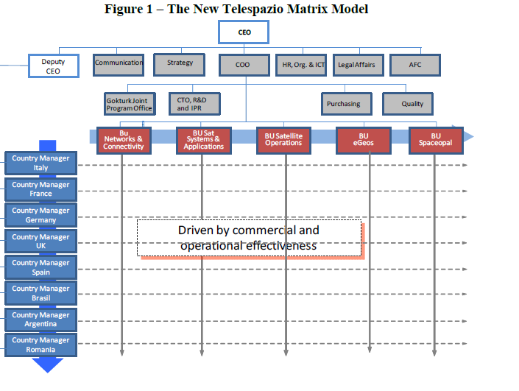
The company had become increasingly present on foreign markets, which required a more
articulated structure to manage its global dimension. For this reason, Telespazio undertook a
major reshaping of the group model, adopting a matrix approach in order to produce a
transnational organization that focused on both geographic markets and business lines.
The new organizational model was characterized by:
- Double reporting, both regional and business, with a strong controlling model.
- Responsibilities allocated on a dual basis (central and local).
- Simultaneous control of market and business strategies.
- The opportunity to take advantage of synergies.

This new model had several advantages, but also introduced a new challenge, especially related
to HR management, because of the dual line of authority.
.
This organizational model was complicated by the fact that in the last decade, Telespazio had
focused on project teams in an attempt to deal with the constant and rapid innovation required by
the business environment. For example, the company was involved in major international space
programs, including: Galileo, EGNOS, GMES, COSMO-SkyMed, SICRAL and Göktürk. These
programs involved employees from different business units and departments, who would be
temporarily assigned to a project on a full-time basis.

The appraisal system could play a strategic role for this organizational change. However, the HR
Department had to make important decisions about how to manage the ambiguity and potential
conflict inherent in the matrix model. Should the responsibility for employees’ evaluations be
shared between two managers, with different views and competencies, or should the
responsibility be allocated to a single supervisor (the Business Unit Manager or the Country
Manager)?

Mr. Dettori, Director of Human Resources, was aware that the time had come to review the
appraisal system, taking into account the complexity of this new organizational model.

Telespazio: From Its Origins to Its Development into a Leading Global
Company in the Space Industry
Telespazio, a space services company, headquartered in Rome (Italy), has roots dating back to
1961, when Italcable and RAI founded the business under the auspices of the CNR (National
Research Council) and the Ministry of Posts and Telecommunications.

From the very beginning, the heart of the firm’s activities was telecommunications using artificial satellites, and it quickly partnered with NASA. The creation of the company opened the horizons of space to Italy, and enabled the country to take part in experiments with new forms of
telecommunication.

In just a few years, Telespazio expanded by way of its successful technological developments,
achieving important goals that marked the history of telecommunications, such as the live
television broadcast of the moon landing on July 20, 1969, which was made possible by the
parabolic antennas at Fucino, the Space Centre inaugurated by Telespazio in 1967. The Fucino
Space Centre was, at that time, one of only four such stations on the continent (the others being
Plemeur Bodou in France, Goonhilly in the UK and Raisting in West Germany) that were capable of receiving TV signals via satellite from anywhere in the world.

Over the course of 50 years, Telespazio quickly became a point of reference in the space
industry, expanding its operations from the design and development of space systems to the
management of launch services and in-orbit satellite control, and from Earth observation services,
integrated communications, satellite navigation and localization to scientific programs.

The company’s growth and diversification was accompanied by important changes in its
governance structure through subsequent mergers and acquisitions. The most important transition occurred in 2002, when Telespazio became part of the Finmeccanica Group, the leading Italian manufacturer of high technology, which was ranked among the top 10 global players in the aerospace, defense and security industries.

In 2007, Telespazio, along with Thales Alenia Space, was transformed into a joint venture
between Finmeccanica (67%) and the French company Thales (33%) as a result of the new Space Alliance signed by these two giants of the European aerospace industry.

In 2010, Telespazio was ranked among the leading global companies in satellite management and Earth observation, satellite navigation, integrated connectivity and added value services.
With437 million Euros in annual revenues and approximately 2,500 people employed in 25 sites
worldwide, the company managed a network of four space centres, including the Fucino Space
Centre, the world’s largest civilian teleport (Figure 2). In Europe, the company was now present
in France, Germany, the United Kingdom, Spain, Hungary and Romania. Worldwide, Telespazio
operated in the U.S. via Telespazio North America and had consolidated its presence in South
America with Telespazio Brazil and Telespazio Argentina.

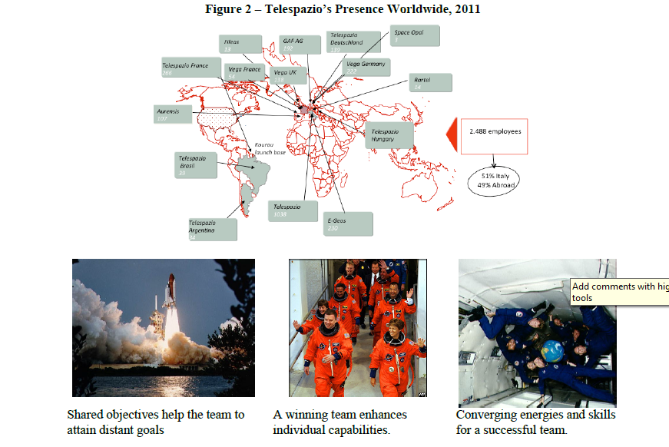

Performance Appraisal at Telespazio (PAT)

A performance appraisal system (PAT) was designed in 2005 to align employees’ efforts with the organizational and the Group’s challenging goals, both locally and in the international arena. The system was conceived as a means to support decisions regarding employee management, such as rewards, compensation, career advancement, mobility, and training. Its aim was to promote the following values:

- Transparency
- Sharing
- Joint definition of objectives
- Reference to observable behaviors
- Focus on roles and competencies

The evaluation system covers all employees and managers, with the only exception being
executives, who are part of the Finmeccanica management review process.

The last, but by no means least important advantage of this system is the fact that it is totally
paperless.

What is assessed?

The aim of the system is twofold: (1) to ensure that the company achieves positive results, and
(2) to promote the professional development of employees. Accordingly, it focuses on two
aspects of employee performance: goals/objectives and competencies/skills (Figure 3).
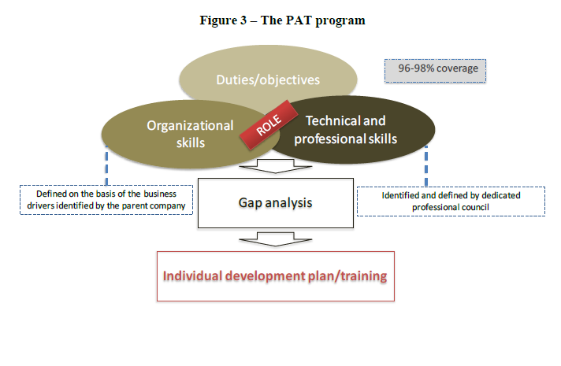
Duties/objectives
Technical and
professional skills
Organizational
Goals/objectives

The identification of objectives is a crucial phase, as it is considered to be the basis on which
each employee focusses his/her efforts throughout the year.

Each objective should: be related to an individual department’s budget plan, be coherent with the
activities planned for an employee’s team, and cover an employee’s development needs. Along
with business related objectives, attention should also be paid to the definition of goals that are
geared towards an employee’s professional development, such as the attainment of an advanced
proficiency in English, or the acquisition of the technical knowledge needed to operate a specific
application.

Importantly, in order to ensure joint ownership of, and involvement in, this process, the system
allows middle managers, professionals and specialists to set their own objectives and enter them
directly into the system. Their supervisor can then modify them or add new ones with the
approval of the employee.

Objectives should be set and assessed as far as possible on the basis of measurable factors, such
as facts, deadlines and figures. For the system to be effective, it is important to not only achieve
results, but to reach them in the right way. An objective accomplished using inappropriate or
inconsistent conduct is considered to be more harmful to the organization than an unmet goal.
The achievement of each objective is then evaluated through an appropriate rating scale with
three levels:
For middle managers, professionals and specialists,
1. Not achieved
2. Achieved
3. Exceeded
and, for employees and operators,
1. To be improved
2. Standard
3. Outstanding

Skills and competencies

All of the skills and competencies related to each organizational role have been identified and
included in the Competency Management System, and each manager is asked to communicate
with his/her staff about their role. This enables a thorough communication of the organization’s
expectations for each role in terms of skills and competencies.
The Competency Management System includes both organizational and technical/professional
skills, which are derived from the business drivers. Organizational skills include behaviors and
methods adopted by an employee to deal with specific situations and achieve set objectives.
Examples of organizational skills for middle managers, professionals and specialists include:
‘Value creation’ and ‘Market and Customer orientation’ (Figure 4).

Figure 4 – Organizational Skills for Middle Managers, Professionals and Specialists
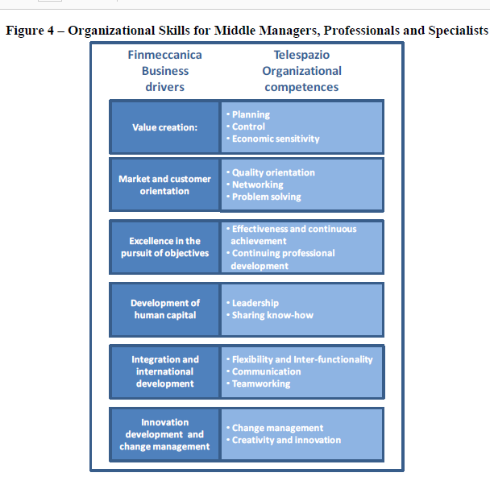
Examples of organizational skills for employees and operators include: ‘Flexibility and
Interfunctionality’ and ‘Customer Service orientation’ (Figure 5). Technical and professional
skills refer to specific knowledge and competencies required for a particular role.

Moreover, each manager can add specific skills or professional experience to the role-specific
skills, selecting them to be included in the list of competencies in the Competency Management
System. These additional skills are not assessed, but can provide useful information on an
employee’s experience.

For the system to be really effective, managers are asked to focus on performance and the
behavior exhibited by an employee during the assessment period. They are also required to base
the evaluation of competencies/skills on the observation of concrete facts, adopting a three-level
scale: to be improved, standard, outstanding.
Value creation:
Mark et and customer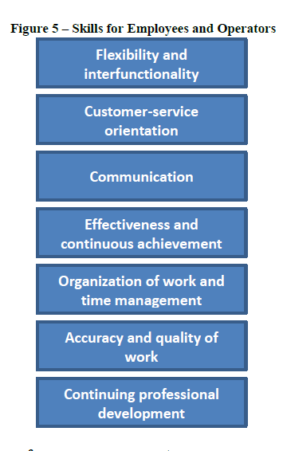international
development
Basic steps for effective performance management

The appraisal process must be completed by the first quarter of each new year, as employees
must have enough time to plan the activities required to meet their objectives. To set the goals
half way through the year or, even worse, at the end, is considered to be ineffectual or, in many
cases, harmful.

The interview as the core of the appraisal process

The evaluation process has several steps, which are described in Figure 6. The interview is the
key part of the process. Indeed, it is so central to the process that it should be regarded as the
performance appraisal. Accordingly, particular attention must be paid to preparing for the
interview; both managers and employees need to carefully gather all of the information available
to support their discussions with concrete evidence. During the meeting, the manager should
focus on the results achieved and the gaps between the expected level of skills for the role and
those exhibited by the employees. The manager must see the interview as an opportunity to both
fully explore areas of performance and skills that require improvement and define the appropriate
training.

For his/her part, the employee should make a list of his/her achievements and skills, and is also
invited to suggest training activities that could be useful for improving weaknesses. Employees should not regard the meeting as an ‘exam’, but as a relevant and constructive opportunity to get
feedback on both strengths and areas that could be improved.

According to the HR development team, the PAT system should be used as a management tool,
and is designed to motivate and develop employees, rather than simply ‘reward’ or ‘punish’
them. In this regard, negative feedback is also relevant, as it should encourage employees to
recognize their weaknesses, face their problems and take appropriate action to improve their
skills.

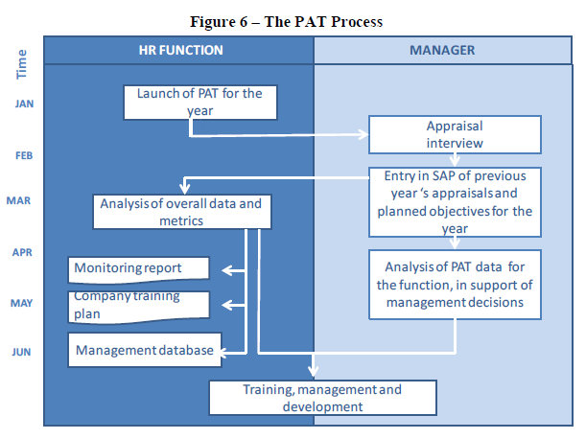

A paperless appraisal

The appraisal process is completely electronic. In order to ensure standardized and comparable
analyses, all of the information about employee objectives and skills are gathered on specific
forms made available by SAP-HR (Figure 7), one for middle managers, professionals and
specialists, and another for employees/operators.

The forms also serve to collect all of the data related to training needs and improve the
information available with which to evaluate the company’s quality and return on investment in
training. The SAP system collects the information required to prepare specific training plans for
each individual that are coherent with the company’s strategies. The effectiveness of an
employee’s training, in terms of the impact on work performance, during the year is evaluated by
the manager and included.

Employees are expected to take an active part in the performance evaluation, writing their
comments in the appropriate section, which includes several questions aimed at encouraging
them to explain their points of view on key aspects of the appraisal. Both managers and
employees are asked to complete this section. If the sections are blank, the appraisal process is
considered incomplete and the system does not accept it.

The adoption of the SAP tool enables the HR Function and all managers to have real-time access
to specific and aggregate data that is valuable for managing and developing employees.

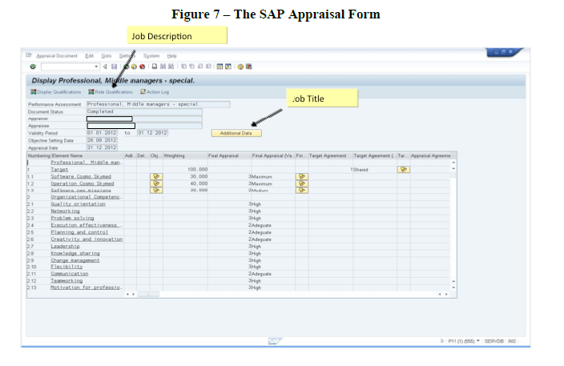

Overall appraisal

The evaluation of objectives and competencies flows into an overall assessment of employees
and uses a three-level scale: to be improved, standard and outstanding. The system itself, on the
basis of all of the information obtained, suggests the most appropriate level. The supervisor can
modify this value if an employee’s professional track record suggests a different evaluation.

Who is in charge of the appraisal?

The performance appraisal at Telespazio is based on the views of one evaluator, the direct
supervisor. Evaluation is a primary responsibility of each manager, which ensures the appropriate visibility of results by the management level immediately above. An exception to this rule occurs when employees are assigned to project teams on a regular basis, with a mix of line and project responsibilities. In these cases, the performance appraisal is completed by both the Project Manager and the Line Manager. More specifically, the definition of the objectives for each new year is the Project Manager’s role, as he/she is responsible for the project’s budget and timing. While the Line Manager is responsible for the performance interview, as this is the core of the appraisal process. This approach has two objectives: (1) the attainment of the team’s project goals and (2) ensuring the employee’s long-term professional growth (Figure 8).

The planning and coordination of the entire appraisal process is the responsibility of the HR Department, which is also in charge of analyzing and preparing monitoring reports on the overall results
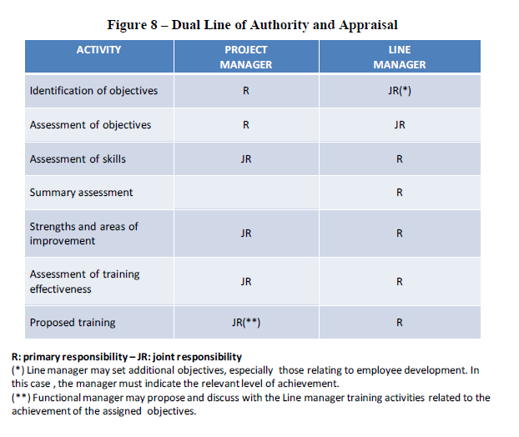
Supporting implementation of PAT through ongoing communication

Each year, several means of communication are used to ensure that important information and the values associated with the program go out to all employees. Indeed, both the managers who are in charge of evaluating their staff and the workers who will be appraised must be fully aware of the rules of the game. As stated by the HR team: “transparency and equity are essential to
guaranteeing that the program is successfully implemented.”

At the start of each year, the CEO sends out a letter as a way of engaging all of the company’s
managers in the process. This letter is accompanied by the setting-up of a Management Forum for all of the managers involved in the appraisal process, and by a more detailed communication
from the Director of Human Resources, Giorgio Dettori, to all employees. Moreover, a section of
the company’s intranet is dedicated to a PAT description and timeline. There also exists a PAT
brochure which explains the evaluation objectives and process.

Assessing the PAT system

On April 14th, 2011, Mr. Dettori and Ms. Di Santo met the HR staff to determine the program for
the upcoming Management Forum, the annual workshop where the Human Resources
Department presents the overall results of the performance appraisal process to Telespazio’s
management. The Development Unit had prepared a detailed presentation for the meeting in
which it planned to highlight both the positive aspects of the PAT program as well as critical
issues, with the aim of making recommendations with respect to potential changes.

Marta Di Santo said: “After six full years since PAT’s introduction, we have several reasons to
be satisfied. We have gone from a context in which it was necessary to demonstrate the value of a formal performance appraisal process, to an organizational environment that has finally
understood its importance. Today, most supervisors acknowledge that PAT is a useful tool that
allows them to manage structured feedback with their subordinates. Moreover, employees have
begun to appreciate PAT as a tool that ensures a transparent and consensual evaluation process.”

Stefania Tomassi added: “Initially we had to ‘chase down’ supervisors to get them to complete
PAT; now, employees themselves pressure their boss to complete the evaluation process. I
realized that we were finally able to bring about a real cultural change when the trade unions
came to ask for our intervention with respect to the supervisors who were not completing the
appraisal process, as they thought that this wasn’t in line with the best practices set by the
company.”

Marta Di Santo continued her presentation by illustrating the results of the competence gap
analysis for all of Telespazio’s organizational roles (Exhibit 1). As she noted, the PAT program
provides valuable data when it comes to assessing average competency levels and evaluating
their appropriateness against role requirements. These data were crucial for planning targeted
training programs.

Although these results were considered to be extremely positive, Ms. Di Santo did have some
concerns about the program:
- The timing of the performance appraisal process. Although the PAT process was deemed
an essential responsibility for managers, delays against the planned schedule were still a
problem; pressing budget deadlines took precedence over performance appraisal.
- Equity and selectivity. Although the company made significant investments in targeted
training and coaching for assessors, the analysis of the data generated from the Human
Resources Management System showed that the rating distributions were often biased
towards positive performance and uneven between different business units and
departments (Exhibit 2).
- Some remarks were made regarding the system’s alleged rigidity.

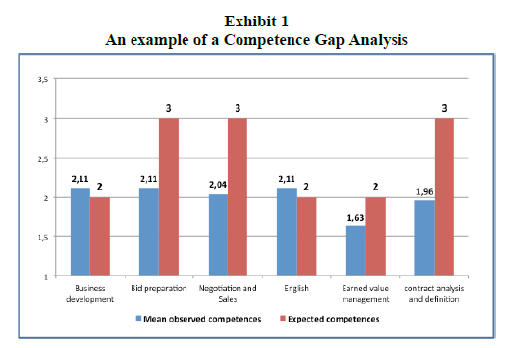
Mr. Dettori considered the equity and selectivity issue to be the most critical: “After several years devoted to developing a culture of appraisal, I don’t see many steps forward in the ranking
distribution.” Marta Di Santo added: “Most ratings are inflated, others are not
differentiated…some managers award superior ratings to all of their staff!” Mr. Dettori
continued: “These kinds of appraisal risk having a demotivating effect on those employees who
have been correctly evaluated by their boss, and who come out below the average. Last year, we
were in the same situation and decided that more effort was required in terms of communication
and training. But this wasn’t enough! It’s time to make some changes. Our managers have to be
aware that differentiation among their employees is essential to the system’s effectiveness. We
have to evaluate carefully every possible action that goes in this direction. The revision of PAT
should also address the important organizational change we’re facing. The new organizational
model needs to be assimilated by our colleagues; they still need to feel confident with this new
way of working. We must attain a stronger integration of our operations across the world and
adjust to a multicultural context. The worldwide implementation of the performance appraisal
program will be crucial to communicating the new organizational requirements and sustaining the process of global integration.”
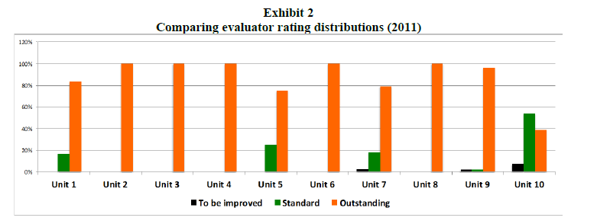
Part B

T-PAD. The revised appraisal program

At the end of April 2011, the HR development team decided on how to improve the PAT
program. The major revisions included:
• Revised rating categories: the old numerical, three-level rating scale for the evaluation of
both objectives and competencies was replaced by a new four-level rating scale that is
consistent with the one used for the overall evaluation. This expansion was made at the
request of a number of different evaluators, who expressed the need to have a better
opportunity to differentiate between different performance levels. Figures 9 and 10 set out
the new four-level rating scale introduced for both targets and competencies.
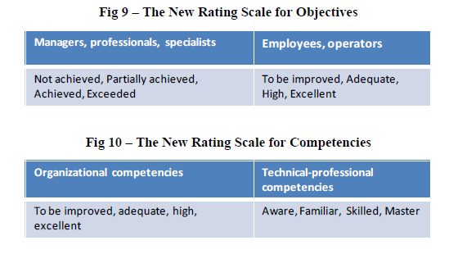
• More selectivity in the appraisal process: all company managers were advised that in every
department/function, the number of employees with an outstanding performance should not
exceed 15% of the overall number of people working in the unit.

• Assessment of new competencies: two competencies were added to support the
implementation of the new model (i.e., international orientation and business orientation).

These revisions were communicated to all managers and employees through an email sent by the
CEO during the launch phase of the new appraisal process for 2012. Furthermore, a meeting with
all supervisors was planned, with the objectives being to share the previous year’s evaluation
results and to explain how to handle the new program. The revised PAT, now named T-PAD
(Telespazio Performance Appraisal for Development), was illustrated in an article published on
the intranet. A new brochure was also distributed to all employees.

As 50% of Telespazio’s employees work outside Italy, the goal set for the 2012-2014 period was
to ‘export’ the Roles and Competencies System and the updated T-PAD to all of the countries
where the company’s subsidiaries operated. The HR team defined the schedule of the operational
plan for the introduction of the T-PAD program to the company’s sites abroad. The pilot country
would be Telespazio Argentina in 2012, with the objective being to extend the appraisal program
to all of the other foreign subsidiaries by the end of 2014.

The situation in 2012

On September 24th, 2012, Mr. Dettori met the HR team to take stock of the situation and asked
Marta Di Santo to report on the goals achieved during the year. Ms. Di Santo started her
presentation by illustrating the partial results of the 2012 rating distribution among different
organizational units (Exhibit 3): “I think we’ve made some steps forward. The introduction of a
four-level scale together with the supervisors’ training and coaching activities have paid off. Four
evaluators used the outstanding level for less than 20% of their staff and no one rated his/her
entire staff as outstanding. The assessments now definitely have a more normal distribution
compared to those from 2011. The best cases are represented by units 7, 8 and 10, where the
managers used the entire rating scale. But we are still some ways from having a really selective
evaluation approach.”
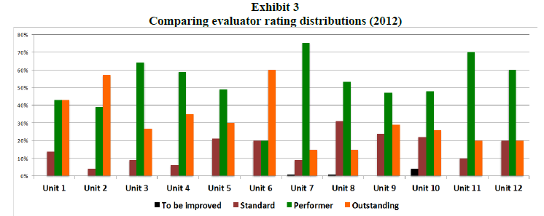

According to Ms. Di Santo, the T-PAD had other positive outcomes: “These figures are very
important, but we need to go beyond them. We’ve been able to bring about a real cultural shift
among our line managers. Most of them are now fully aware that the T-PAD is a powerful tool
with which to manage their staff effectively and achieve their unit’s goals. All the decisions
regarding employee development (training and career advancement) and economic incentives are
taken exclusively on the basis of the evaluation results.” Stefania Tomassi added: “Last week I
met Francesco Rossi, who has recently been appointed as Operations Manager of the Network
Division, and he told me: ‘It’s a good thing we have the T-PAD! Thanks to this system, I had the
chance to conduct structured interviews with my new staff and to get to know each of them in
greater depth. Moreover, the SAP forms allowed me to easily reconstruct the personal history of
each employee... until a few days ago, I didn’t even know them, but today I feel like I’ve been
working with them for the last 20 years!’ He was very enthusiastic about the appraisal system and its potential.”

Ms. Di Santo took the floor again: “We all know that the most important task set by our team in
2012, in line with the company’s expectations, is the extension of the T-PAD to all of the foreign
subsidiaries by the end of 2014. The program’s worldwide extension will be crucial to sustaining
the company’s global integration. We started this year by implementing the system in Telespazio
Argentina, the pilot country, and we didn’t have any problems; we worked well with the local HR Department. The local HR Manager, Camila Beliera, was conscious that the subsidiary really
needed a structured appraisal system and worked hard to bring all 10 of the local supervisors
onboard, making them aware of the appraisal system’s strategic role. Moreover, I know Camila,
as she used to work for a big Italian company in Rome and we have the same people management philosophy...working with her was easy.”

Stefania Tomassi added: “By the end of September 2013, we have to complete the
implementation process in Germany and France. These countries’ subsidiaries have very different managerial systems and leadership styles... Telespazio France has nearly 400 employees, a very strong national culture and a well-established local evaluation system. This will make the transfer of our T-PAD not easy at all...I don’t think that French managers will simply accept our program!”

The HR team was aware that the international implementation needed to be carefully planned.

2014-03-06

© HEC Montréal 16

