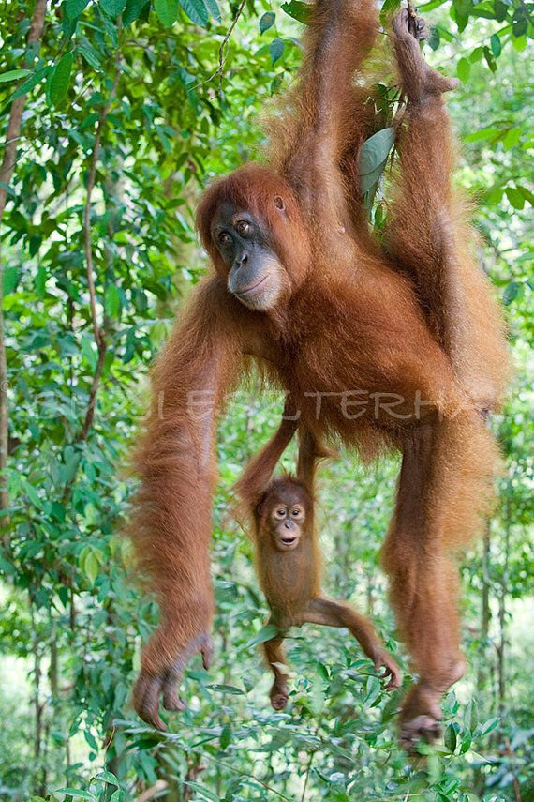
Primate hand features
Nails, opposable thumbs, friction ridges and grasping reflexes in young primates are anatomical features that have been selected for within the primate lineage. Your task is to explore and explain how primate hand features enhance fitness.
Make sure you answer all of the following questions for full points.

  - What does the arboreal hypothesis generally suggest about the unique traits primate possess on their hand?
  - Explain how primate hand features increase fitness and give one examples. When writing about your example name the hand feature that you have chosen and explain clearly why it increase fitness in a tree environment.
  - Conjecture what would happen if a primate infant did not possess your chosen primate hand features.

