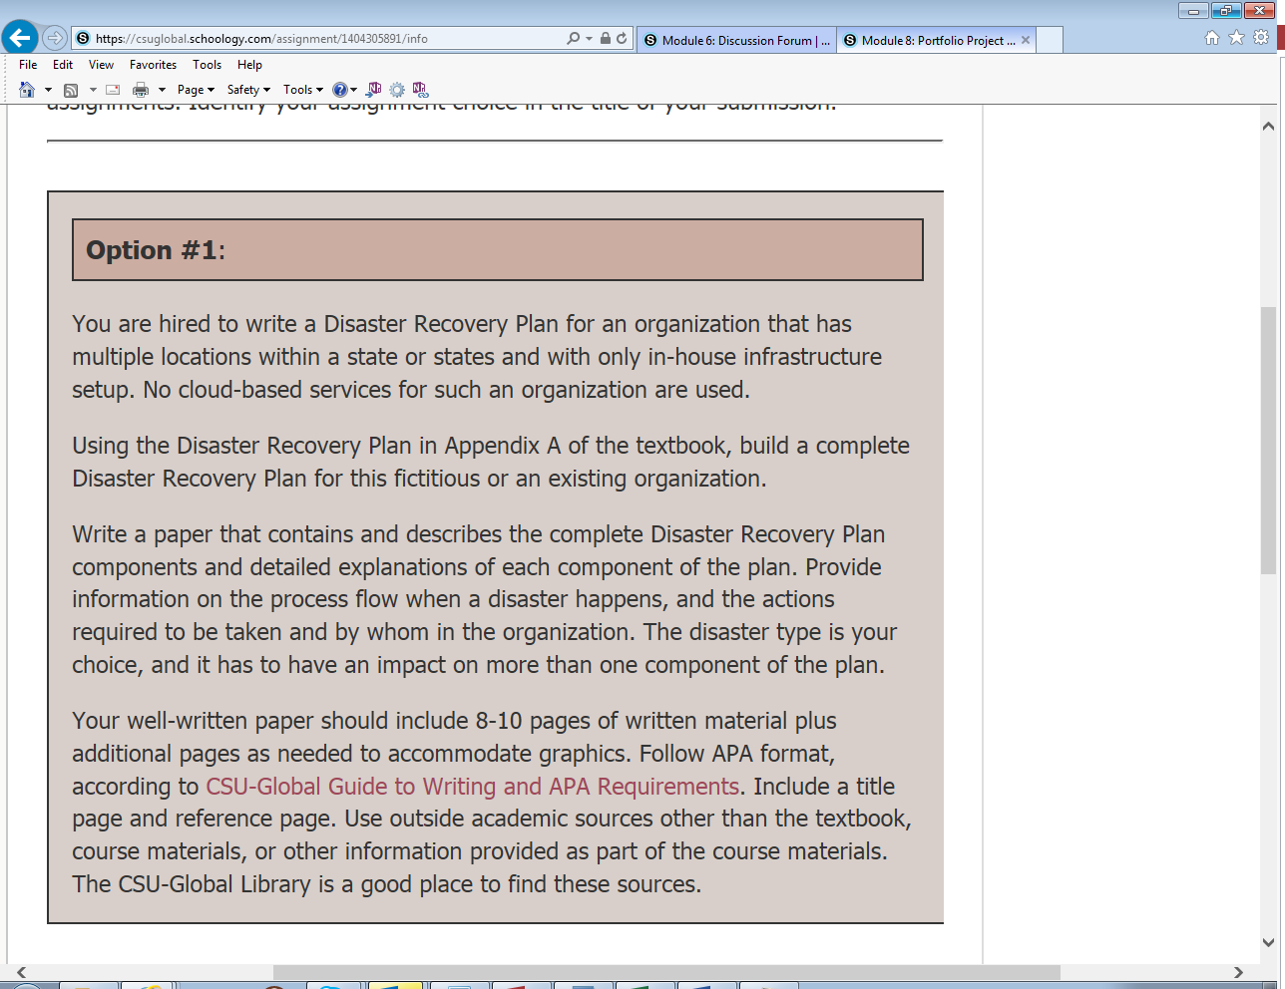

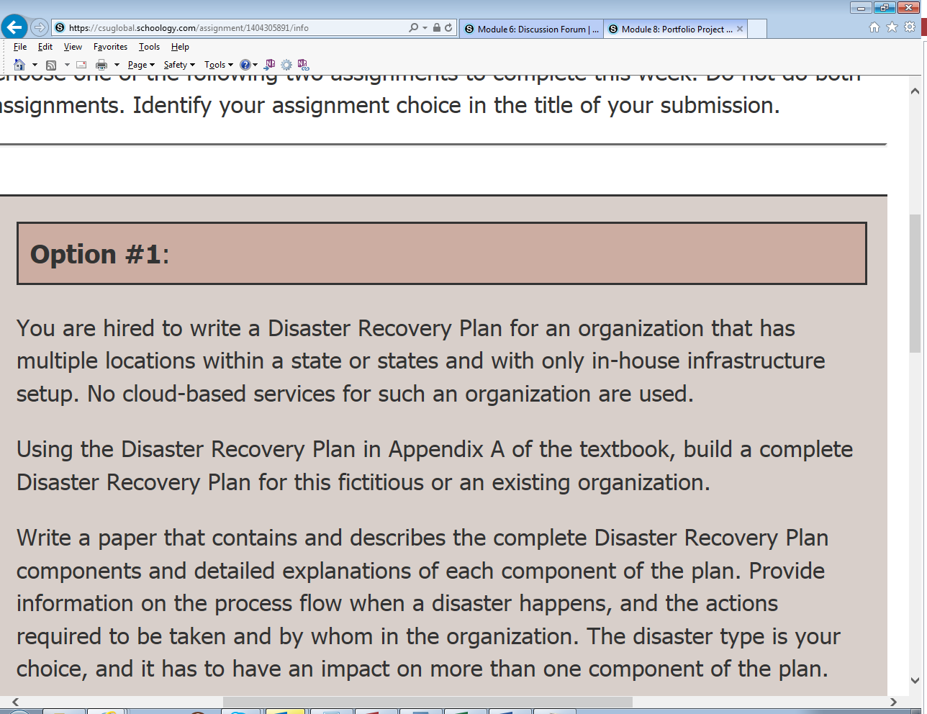

Paper must be 9 pages in length, including a reference page
Must include in-text citation
Must be in APA format

