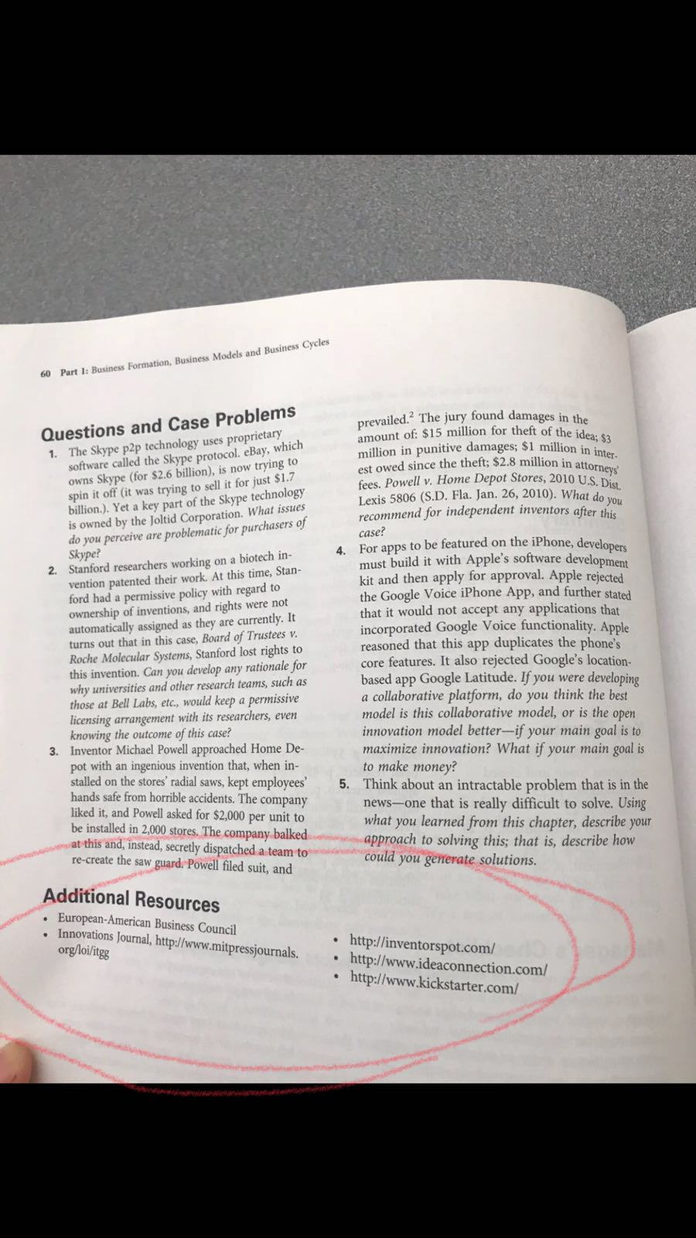
Questions and Case Problems

Each question should be at 2 or more paragraphs long and supported (and cited) with information from the text and other other outside resources.

Complete questions #2 and #3 at the end of the chapter.

Note: Use the links under Additional Resources to assist you in formulating your answers.

