How to Compare and Contrast Two Poems
Adapted from: How to Write a Poetry Analysis Essay Comparing and Contrasting Two Poems
by Johnny Kilhefner

Throughout your career as a student you'll have to write several kinds of essays. One of these is the compare and contrast essay. Literature students, for instance, must write compare and contrast essays on two specific works of literature -- in this case, poetry. Such essays analyze the similarities and differences between two literary works to encourage critical thinking.

Step 1
Choose an idea or theme to focus the essay on, such as love, nature or death. Literary movements have certain characteristics that make it easy to pinpoint two poems with similar ideas or themes. For example, compare Miguel Hernandez's and Pablu Neruda's accounts of love.
Step 2
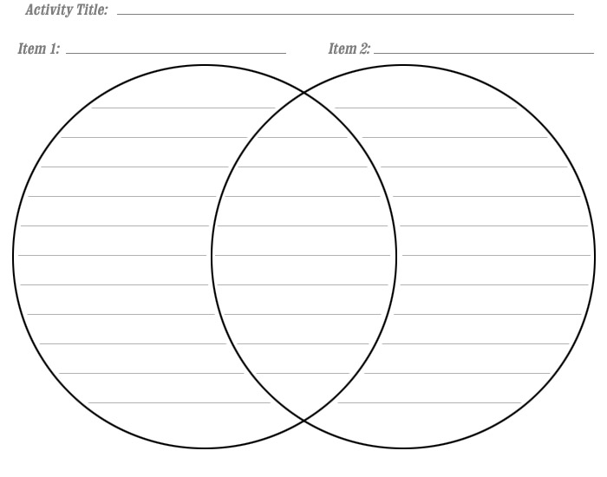
Make a Venn diagram by drawing two overlapping circles -- one for each poem by the two authors. Write the similarities in the overlapping section of the circle, such as similarities in form, technique or ideas. In the individual spaces of the two circles write characteristics independent of each other. When making the diagram, consider what each poem is about. Are they part of the same literary movement? What is the focus of each poem? What is the author's tone? Is the poem broad or narrow in scope?

Step 3
Work on the thesis of your essay. Your thesis will organize the thoughts swirling in your head so your essay has direction for not only the reader but also for you. Consider the expectations of the essay. For instance, why are you writing this paper on these poems? Why should people care? To this end, consider the content of your class. Your thesis should not merely announce the comparison to the two poems but also your method of doing so.
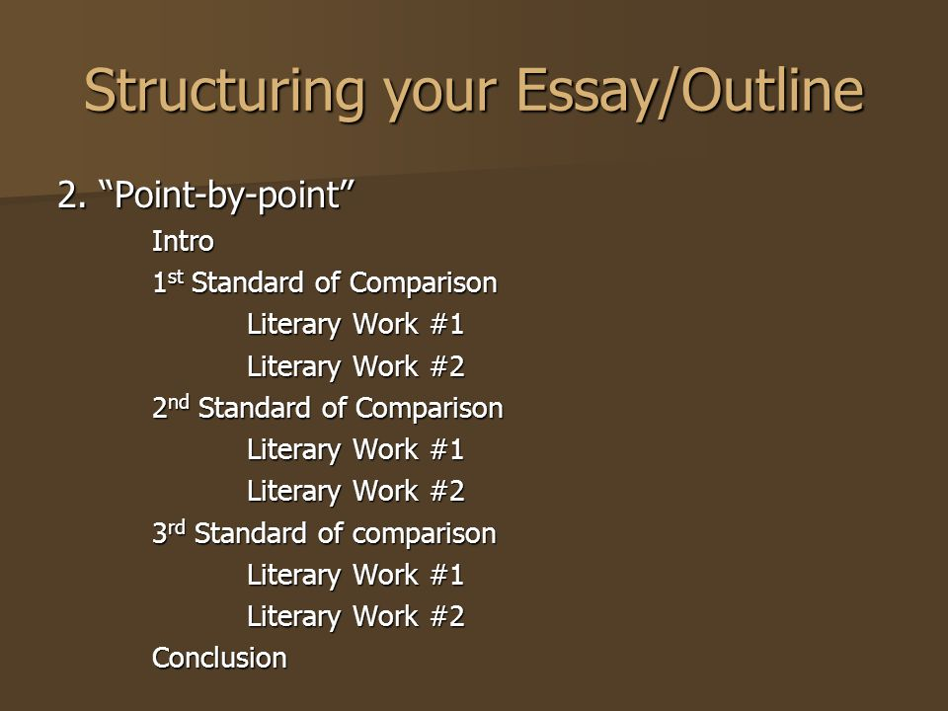
Step 4
Organize your paper point-by-point. Discuss one point of a particular poem and transition into a similar or contrasting point of the second poem back and forth.
Step 5
Outline the essay according to the format you are using. Write the main point of each paragraph followed by a list of subpoints to emphasize or exemplify your main point.
Step 6
Write the introduction of the essay. Move from the general (poetry) to the specific (the poems). Your first two sentences should tell the reader the "what" and "why" of the essay. Include your thesis near the end of the paragraph but before the transition into the body.
Step 7
Draft each body paragraph according to your outline. Start each paragraph with a topic sentence telling the reader the main point you are discussing. Use examples from the poems to make your points stronger. Use transitional phrases to help the reader comprehend the flow of ideas. Some transitional devices include: like, similar to, also, unlike, similarly, in the same way, compared to, likewise, again, on the contrary, however, although, yet and conversely.
Step 8
Conclude the essay with a brief summary of the main idea or ideas. Make a conclusion based on the two poems' similarities and differences. End with a restatement of the thesis and a final thought on the essay that leaves readers thinking long after they finish reading.

