Dec. 17, 2017 2:36 p.m. ET
Te-Ping Chen

Will They Search for That? Chinese Learn Art of Hooking Americans on Amazon
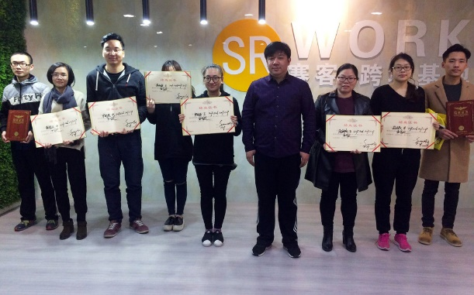
Tao Xin and students with graduation certificates after a class in perfecting an Amazon product listing PHOTO: TE-PING CHEN/THE WALL

Dec. 17, 2017 2:36 p.m. ET
YIWU, China—On the third floor of a nondescript office building in this eastern Chinese city, Huang Wenyan is hoping to sell satin headbands to Americans for Christmas, if she can crack the Amazon code.
Ms. Huang frowns through her maroon glasses at the home page of her Amazon shop, Candygirl, trying to find the apt product description.
“Look,” says Tao Xin, an instructor in a daylong training session for would-be Amazon sellers. He points at Ms. Huang’s elaborate product listing, which describes the size of her headbands (36 centimeters) and their shape (circle). “No one will search that,” Mr. Tao says, as some among the two dozen student-sellers crowd around.
“Covered headbands?” Ms. Huang suggests. Mr. Tao, who goes by the nickname “Uncle Sam,” which he chose in tribute to the U.S. icon, shakes his head.
After a few more tries to see what Amazon’s autocomplete reveals as the most common search terms, the class arrives at the right one: “Girls’ headbands!”
Tao Xin, a.k.a. "Uncle Sam," instructs students who want to sell to Americans on Amazon Te-Ping Chen/The Wall Street Journal
China has been exporting goods to the U.S. for decades. Now Chinese entrepreneurs want to sell directly to Americans, and Amazon is giving them a way to do so. But American shoppers and their favorite e-commerce site aren’t so easy to figure out.
Picking the right product is the first challenge. Ms. Huang says she ended up with loads of unsold fidget spinners earlier this year after she mistimed the craze.
Navigating language barriers to find the right search keywords also is crucial; describing Santa hats as “traditional” didn’t work for one of Mr. Tao’s students.
And Americans can be demanding; a seller of Christmas tiaras had to add more glue to keep her products’ fake jewels from falling off after customer complaints.
“I don’t understand what Americans want,” says Huang Xiaoting, another classmate, who is trying to sell camping tents at Christmastime.
Businesses like Mr. Tao’s SR Work are trying to help. In the past year, Mr. Tao has held around 100 Amazon training sessions. Hundreds of other courses have cropped up. In the southern export and tech hub of Shenzhen, the Monkey King E-Commerce School offers to help students achieve their “cross-border e-commerce dreams.”
“The pictures must speak!” Mr. Tao exhorts his students in a classroom decorated with giant Facebook, Amazon and Google logos. “You need to think about how they’ll use your product,” he says, gesturing at Ms. Huang. “Can you get 100 people at a party wearing your headbands? That would look good in a photo.”
Half a billion Chinese shop online. Cities teem with delivery men on scooters, and margins in the competitive e-commerce sector are thin. For Chinese businesses, the American consumer is prized quarry, seen as less price-conscious and freer-spending than Chinese shoppers.
Chinese sellers have flocked to Amazon, which holds regular conferences in China to promote its platform, explaining the logistics and support services it offers. Business-intelligence group Marketplace Pulse estimates that Amazon has roughly one million active sellers and that one-third are from China, 250,000 having joined this year.
An Amazon spokeswoman said the company has sellers from more than 130 countries but wouldn’t comment on sellers by region.
Along with rising production costs, the influx of so many Chinese sellers is a challenge for Qingdao Ray Trading Co. Business manager Yao Wei says profit margins have dropped from around 40% in 2014 to closer to 20% today for the maker of pillowcases, including one featuring a saxophone-playing Santa, a common way Mr. Claus is depicted in China.
Qingdao Ray Trading Co.'s pillowcases for sale on Amazon
Mr. Yao isn’t sure why Santa is paired with a sax. “It may be to represent a very cheerful mood,” he says.
Shenzhen-based Agoal sold about $50,000 worth of products on Amazon last month, including a Wi-Fi-equipped smart plug, says sales manager Zhou Jialing. With several hundred Chinese sellers offering products similar to their plug, Ms. Zhou says she is looking for other products that might appeal to Americans, such as measuring tapes or other tools.
“The cost of labor in America is high, so they have to do more things themselves,” she reasons.
She also considered dog accessories; she heard Americans like to dress like their pets.
Mr. Tao, a.k.a. Uncle Sam, previously worked for an online Chinese retail startup that targeted the global market. Having worked with international customers, he began selling jewelry and women’s apparel on Amazon in 2011.
Yiwu offers a natural customer base for him. The area’s factories and businesses supply toys and more than half of the world’s Christmas decorations, according to Chinese state media. Many of his students have small factories producing for foreign brands and now want to cut out the middleman.
Among those attending Mr. Tao’s class last month, some were selling apparel, others LED lamps or outdoor gear.
In the run-up to December, Liu Yantao, 28, spent $15,000 on Christmas baubles, hats and novelty items such as reindeer ears. On a recent day in Yiwu, he stood in a rented office with walls covered with inspirational slogans and a whiteboard with scribbled-over Amazon headlines he has tried to perfect.
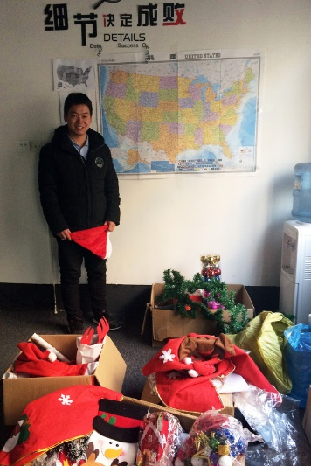
Liu Yantao with the Christmas products he hopes to sell on Amazon Te-Ping Chen/The Wall Street Journal
“We don’t have this Christmas culture,” he says. Still, with the help of training and online tips (he hears identical family pajamas are popular), “I’m learning.”
Mr. Tao brings the class to a close after a 13-hour day, and one by one calls students to the front of the room to collect their graduation certificates. He reminds students the path of the entrepreneur isn’t easy. Mr. Tao suggests they read inspirational books and listen to podcasts to improve their minds.
“Go home, get some rest,” he tells them, as they file out into the night. “Tomorrow will be better. Merry Christmas.”
—Zhang Chunying contributed to this article.
Write to Te-Ping Chen at te-ping.chen@wsj.com
1. What challenges do Chinese entrepreneurs who want to sell products to Americans face?
2. How do Tao Xin's classes help Chinese entrepreneurs?
3. How does language create a barrier when marketing to international customers?
4. What are the advantages and disadvantages to firms when they market their products differently in international markets?

