Changing the Discussion Settings in LEO

The following instructions show how you should set up your discussion settings in LEO.

- You should click on discussions.

- Then you want to click on settings.

- The interface looks like this
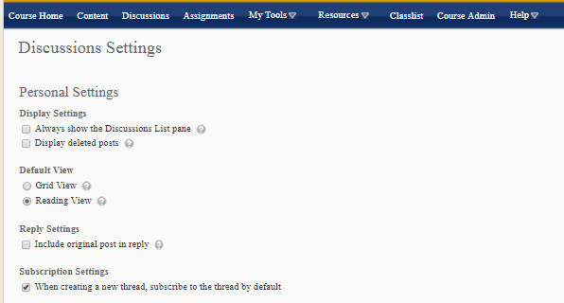

- The next step is to change some settings. Look at this next picture.
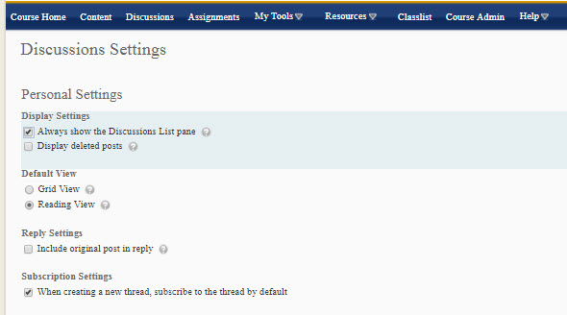

- Did you see what we just changed? Good!

- Want to know the next step? Here it is!

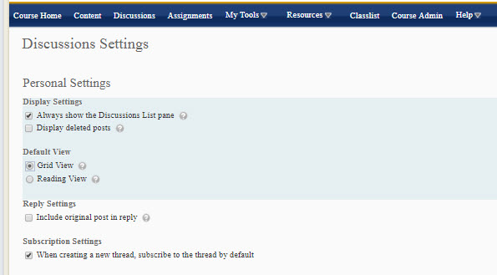

- I hope you see that two settings have now been changed. Examine the pictures closely to see what has been changed. It’s important.

- Clicking save will save these settings.
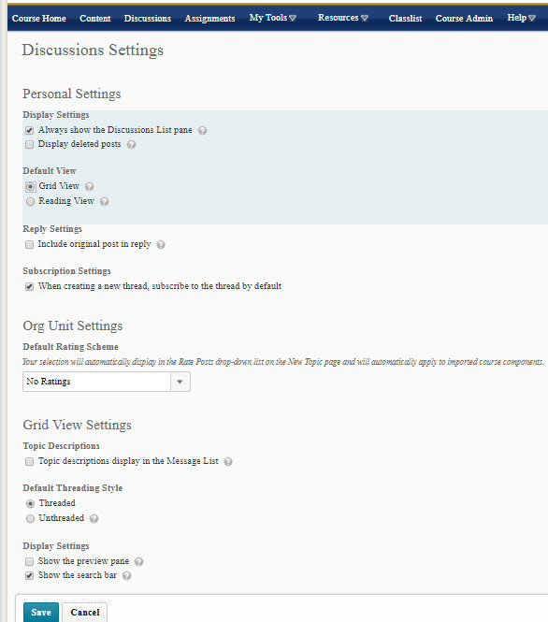

- Now, click on any particular discussion, and you will see how the changes change the interface.

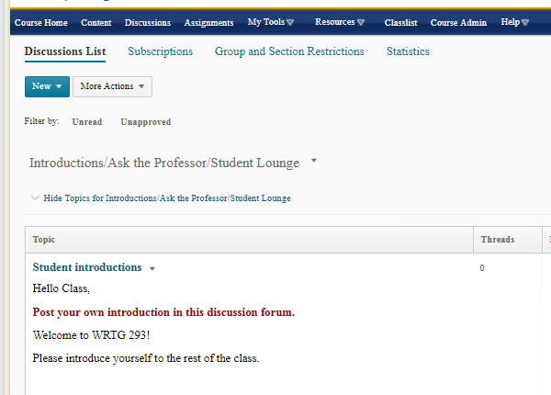

- Take a look. Cool, eh?!?

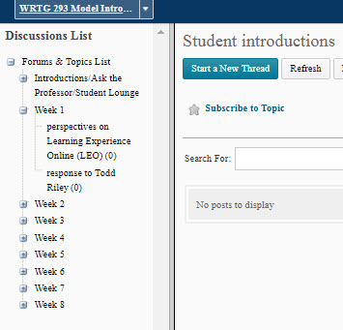

- And more cool features are shown in the next picture.
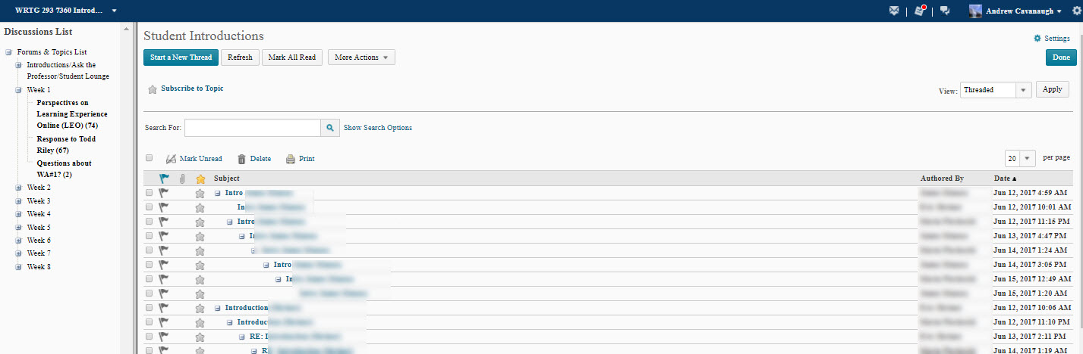

I hope this helps.

