**Would This Company Benefit from Expansion?**

**CAPCOM CO. LTD**

CAPCOM is a company whose principle is to be a creator of entertainment culture. Its history is deeply rooted in creating video games, whether it be for home or arcade entertainment. (CAPCOM Mission Statement, 2018) The company initially started as a Japanese arcade game distributor and creator in the late 1970s and rose to success with the launch of its first arcade game in 1984, “1942”. This paved the way for CAPCOM to tackle more ambitious video game development in the future, releasing popular titles such as Mega Man, Street Fighter, and Ghosts and Goblins for the Nintendo Entertainment System. These titles allowed CAPCOM to expand its presence to the United States, Europe, and other parts of Asia. (Business Insights, 2022) To this day, CAPCOM remains almost solely a video game developer.

CAPCOM has remained to be a profitable company since its inception in 1979 due to its ability to develop quality video games despite the fast-changing technological landscape. It has triumphed over its competitors such as Konami, SEGA, and Square Enix by engaging in management that sets its focus five years ahead, using a matrix that compares figures to net sales, and quickly identifying and addressing problems.

CAPCOM has proposed expanding its current game lineup to mobile platforms for further growth. While this may sound good on paper, consumers aren’t interested in having new video games, limited to the hardware capabilities of their cell phones. It would be ideal for CAPCOM to take advantage of the current “game streaming” mentality that companies such as NVIDIA and Google are doing. The future of entertainment has been proven to be streaming your entertainment via the internet in recent years. Imagine if CAPCOM created their own streaming service for all their gaming titles to be accessed instantly by just opening an app on their computer or gaming console.

**Planning**

|  |  |
| --- | --- |
| **Strengths**:  Social and financial stability  A consolidated platform for releasing future games | **Opportunities**:  Room for expansion to new markets  Increase customer base and meet customer expectations  Growth in the profitability of the company |
| **Weakness**:  Customers can no longer own future games since the streaming service will be monthly.  The company may appear desperate for new customers. | **Threats**:  High competition in the sector  Other companies are creating a better streaming platform in retaliation |

The popularity of video games is steadily rising, and there are expected to be over three billion gamers by 2023 (Cabeza-Ramirez, 2022). CAPCOM has proven already that their player base has only grown over the years. With the introduction of a game streaming service, CAPCOM will see an opportunity for an increased customer base. Entertainment mediums such as video games have already transitioned from physical to digital, beginning in the late 90s and early 2000s. Customers want the ability to have what they want when they want it. Therefore on-demand video game streaming would be the logical next step for CAPCOM.

**Production and Logistics**

This new platform’s production can be based on what companies such as PlayStation and NVIDIA have already created. CAPCOM would need to establish network servers for games to be streamed efficiently without losing quality. Luckily for CAPCOM, they already have subsidiaries established all around the world. It would be cheaper for them to build a team from employees that already work for the company rather than hiring brand-new ones. This team would be required to port all CAPCOM’s older titles to a digital format, create an ad campaign, and create a template for the application.

**Growth Impact**

Google and NVIDIA offer game streaming as both limited free service and a paid premium service (Carrascosa, 2022). CAPCOM could become a strong competitor to both companies by offering more options. For example, they could offer a monthly, quarterly, or annual subscription service. They could charge $10 monthly, $25 quarterly, or $60 annually to incentivize customers to commit to a quarterly or yearly subscription to save a few monthly dollars. CAPCOM is already a 902 million dollar per year company. CAPCOM sold 30,100,000 units priced at $60 in FY21 amounting to $1.8 billion (CAPCOM, 2022). Assuming these units represent people purchasing the new annual subscription, CAPCOM could see its profits double to $3.6 billion.

**Expected Launch**

CAPCOM could expect this product to launch at the beginning of FY23, but the longer they wait to release this, the more profit they can expect to miss out on. There is still enough time in this fiscal year to work on this, advertise it to the public, and work out all the issues with it before it launches. A problem they may face would be that all their titles aren’t compatible with on-demand streaming. For example, a new game running an intense graphics engine may not be able to stream efficiently depending on the customer’s bandwidth. To combat this problem, CAPCOM could allow these games to be downloaded to the customer’s console but require a subscription and an internet connection to play these titles.

Another problem could be that some titles are not compatible with the customer’s console. A customer playing a Nintendo Switch may not find the streaming service very friendly with their console due to their hardware limitations, only allowing them to play less graphically demanding titles. A solution would be to offer different versions of the streaming service based on what console it is on. PS5s, Xbox Series X, and PC would get the full version. At the same time, Nintendo Switch users get a reduced price due to a reduced content library.

**Organizing and Staffing**

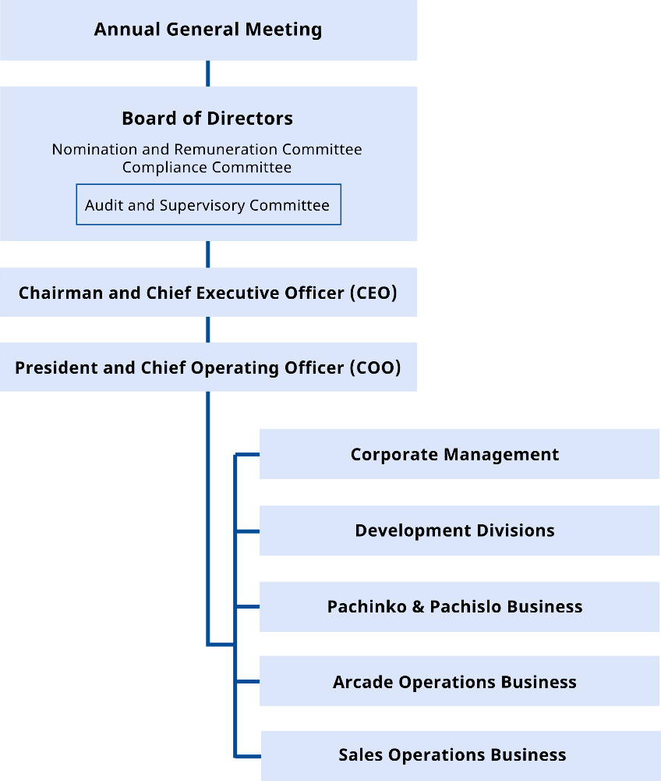

**Graphic Designer**

The company would use their former graphic designer department team to provide a suitable outlook for their new product. They will not need to hire a new graphic designer since the new product will be based on the already existing idea generated by the company.

**Marketing Manager**

The marketing manager will collect the views of the public and the customers on the new product. He will then provide a solid report on the possibility of marketing a profit or loss based on the market trend if the new product is adopted.

**Social Media Manager**

The social media manager will ensure that the vies of customers on various platforms of CAPCOM company are captured in detail before the program’s launch. It will foster all the necessary adjustments that will be very useful in developing the new product.

**Resources**

In the last report of the company, it saw an increase of 35% in its annual profit (Game Industry, 2022). Therefore, the company is very stable in its resources and hence does not need to acquire more outside sources to expand and launch the new gaming platform. The recently released games by the company include monster hunter, resident evil, and many more. In addition to that, the company has estimated a net sale of around nine hundred dollars for the end of the financial year 2022. It is clear that the company is on a good track and planning very well prior to the launch of the new project. Therefore, it explains why there is no need to get funds from outside sources.

**Cost and Profits**

The company will at least spend around $ 1 billion to see its dream come true. The cost is based on paying the graphic designers, programmers, audio testers, quality assurance department, and the tools that will be needed for the gaming platform (Juego Studio, 2021). It is projected to realize an annual profit of around $ 3.6 billion (CAPCOM, 22).

**Leadership Style and New Ideas**

A democratic leadership such as the one CAPCOM has employed very important in launching new ideas and seeing them through (Arizona Global Campus, 2022). An excellent idea that would see CAPCOM emerge to new ages is going in the direction of Microsoft and the likes of Google by streaming games. This would mean less money would be used to make the hard copy games through CDs. It would also be convenient in that it can reach many people. The control point, in this case, is that streaming games would earn more profit since they would easily get everybody worldwide (Foster, 2016).

The company can survey to establish roughly the marketing department and social media managers. This is an important way for the company to evaluate the performance of the service. This will also be important in understanding the user experience and expected user turnout. It is also important to analyze the market competition to know how it affects the company’s profit turnout (Sun & Claypool, 2022).

The best way for the company to get feedback on service is by creating an online community. Online communities are important in giving feedback on the general outlook and experience of the service being offered. This is an important step through which feedback is possible. Additionally, the company can occasionally conduct surveys to understand the gaming environment and some of their preferences (SmartSurvey, 2022).

The best approach to address failures or poor performances in a system introduced or the product entails several steps. The first step is listening to the public concerning the product. The second step is to assess the issue raised. Third, the company can best understand a product’s functioning by evaluating the product to understand the problems that the user has raised. It is also important for the company to offer solutions to the fans based on the solutions that the users have suggested. Finally, after delivering the answer, it is important to follow up with the users (Takeuchi & Quelch, 2022).

**Conclusion**

In summary, CAPCOM would benefit from expansion for several reasons. First, since its beginning in 1979, it has remained profitable by developing quality video games regardless of technological changes. Expanding its game lineup to access more customers is guaranteed to lead to more benefits. Secondly, CAPCOM knows its strengths, weaknesses, threats and opportunities, allowing it to strategically overcome any potential drawbacks to its development. For example, since the company knows that its threat is its competitors creating between streaming platforms, its next logical step is to expand to more quality streaming platforms to broaden its customer base. Thirdly, CAPCOM has established subsidiaries globally, indicating that it would not need to deploy too much funding in establishing streaming network servers or hiring new personnel. The only potential funding would be training its existing employees on converting its analog titles into digital format and creating ad campaigns and application templates. This will lead to more profit at reduced costs. Lastly, CAPCOM has stable resources which have contributed to annual profits over the years. Therefore, expanding will guarantee the company more profits without the need to input new resources. Based on the success of the games that CAPCOM has recently released, such as resident evil and monster hunter, it has estimated further improvement in its profits by the end of the 2022 financial year. Thus, even before the launch of its new products, CAPCOM has a good team that has maintained its success through planning and funding. The expansion will propel it to expect more profits and success based on its workers' effectiveness and the democratic leadership style that the company follows.

**References**

Arizona Global Campus, A. (2022). 4 Leadership Styles in Business: Leadership Style Quiz | UAGC | University of Arizona Global Campus. UAGC | University of Arizona Global Campus. Retrieved 3 July 2022, from <https://www.uagc.edu/blog/4-leadership-styles-in-business>.

Carrascosa, M. (2022, April 15). *Cloud-gaming: Analysis of Google Stadia traffic*. Retrieved June 12, 2022, from <https://www-sciencedirect-com.ezproxy.libproxy.db.erau.edu/science/article/pii/S0094576502001704?via%3Dihub>

“Capcom Company Ltd.” *International Directory of Company Histories*. Ed. Jay P. Pederson. Vol. 83. Detroit, MI: St. James Press, 2007. *Business Insights: Essentials*. Web. 28 May 2022.

“Capcom Company Ltd” *CEO Commitment*. Kenzo Tsujimoto. Integrated Report, 2018.

Cabeza-Ramirez, J. (n.d.). *Exploring the connection between playing video games and watching video game streaming: Relationships with potential problematic uses*. ScienceDirect.com | Science, health and medical journals, full text articles and books. Retrieved June 12, 2022, from https://www.sciencedirect.com/

Foster, L. (2016). Effects of Video Game Streaming on Consumer Attitudes and Behaviors (Master of Arts in Professional Communication). East Tennessee State University.

Juegostudio, (2022). *Everything you need to know about AAA game development costs*. Juegostudio.com. Retrieved 3 July 2022, from https://www.juegostudio.com/blog/everything-you-need-to-know-about-aaa-game-development-costs.

Partis, D. (2022). *Capcom revenue jumps 35% to $774m*. GamesIndustry.biz. Retrieved 3 July 2022, from <https://www.gamesindustry.biz/articles/2022-01-26-capcom-sees-35-percent-revenue-increase-to-usd774m>.

Sun, J., & Claypool, M. (2022). Evaluating Streaming and Latency Compensation in a Cloud-based Game. Web.cs.wpi.edu. Retrieved 3 July 2022, from https://web.cs.wpi.edu/~claypool/papers/drizzle/paper.pdf.

SmartSurvey, S. (2022). 10 Advantages of Online Surveys - SmartSurvey. SmartSurvey. Retrieved 3 July 2022, from https://www.smartsurvey.co.uk/articles/10-advantages-of-online-surveys.

Takeuchi, H., & Quelch, J. (2022). Quality Is More Than Making a Good Product. Harvard Business Review. Retrieved 3 July 2022, from https://hbr.org/1983/07/quality-is-more-than-making-a-good-product

Tsujimoto, K. (2018). *Six Elements Required for the Sustainable Enhancement of Corporate Value*. capcom.co.jp. Retrieved 3 July 2022, from [https://www.capcom.co.jp/ir/english/data/oar/2018/growth/ceo.html#:~:text=Accordingly%2C%20Capcom’s%20basic%20philosophy%20is,the%20world’s%20most%20entertaining%20games](https://www.capcom.co.jp/ir/english/data/oar/2018/growth/ceo.html#:~:text=Accordingly%2C%20Capcom's%20basic%20philosophy%20is,the%20world's%20most%20entertaining%20games).

<https://bi-gale-com.ezproxy.libproxy.db.erau.edu/essentials/article/GALE%7CI2501310905/c801f9b19ffbec943bef8ef55103ea6b?u=embry>

.