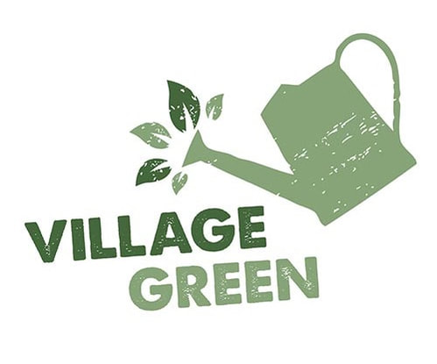

The Village Green Movement: Organisational Design Emerging from Crisis

Case Study: Organisational Design Consulting Proposal

MGTS3601

Semester 1, 2022

Credit to Jessica Fields for her research and development of much of this case. While loosely based on a real organisation, many details have been disguised to protect their confidentiality .

# **Case Study: Assignment Context**

The Village Green Movement (VGM) case following sets the scene for your individual Case Study assignment. While you will take on the role of “Jessica”, an employee of VGM, you will regard the Village Green Movement as a “client”, as you would if you were providing this proposal from an external consulting firm.

Your submission will be structured as a series of consulting proposals but will also include evidence, models and frameworks from academic literature to explain and justify aspects of your analysis and recommendations, based on the information you have available to you.

A template is provided with guidance on the required sections. The word limit for each proposal is 1250 words, including the Executive Summary but excluding references and appendices.  Appendices must be referenced in-text, presented in order of that reference, and clearly necessary for you to present your recommendations.

In order to support your analysis, you must use a minimum of ten (10) good quality, peer reviewed journal articles to support your arguments.  At least five (5) of these must be drawn from the MGTS3601 reading list provided. For this assignment, references to the Nadler Tushman chapters or articles from McKinsey or Harvard Business Publishing will count as peer-reviewed articles. You may also draw on other good quality sources as appropriate but avoid references to textbooks or lecture notes.

All sources must be cited correctly and included in a reference list according to the Academy of Management Journal (AMJ) or Vancouver referencing style.

Please note that aside from the quality of the references, what is most important is how you use the evidence from these sources to justify your analysis.

I highly recommend that you submit a final draft and review your TurnitIn report at least 24 hours before the assignment due date to ensure that you have not inadvertently failed to comply with the academic integrity policy. Note that if you do submit an early draft, Turnitin will not allow you to submit a revised version after the submission deadline.

The key criteria for this assessment are as follows.

1. Well targeted Executive Summary (2 marks)
2. Thoughtful introduction of the report (5 marks)
3. Comprehensive Diagnosis (9 marks)
4. Practical conclusion with recommendations / outline of steps to be taken (5 marks)
5. Discerning choice of literature and frameworks (6 marks)
6. Professional, business focused communication (3 marks)

Total: 30 marks

See the full rubric for more details

# **Case: Village Green Movement: Emerging from Crisis**

Dominic Steel, Lead Pastor of the Village Green Movement (VGM) and Pastor of the Melbourne West church, settled into his office chair, gathering his final thoughts before beginning the latest Zoom meeting for the Corona Virus Task Force. This year hadn’t been what he expected, but nearly every person in the country could say the same. On this Friday in October 2020, Melbourne was still in lockdown, although conditions had eased in the rest of Australia. Still, Dominic missed being able to counsel people one-on-one, preach to a live audience, and gather together with his staff team. Because of COVID-19, governments, organisations, and individuals across the world had been forced to pivot, making fundamental changes to the way they functioned and accomplished goals.

His Facetime app on his phone chimed. He answered it to see the smiling face of Jessica, from the Communications team. Jessica had been doing amazing work during this difficult period with COVID. He had great faith in her abilities, which is why he had invited her to the meeting about to start. He hoped that she would be able to bring some fresh insights to the problem he had.

“Hey Dominic”, she said. “I’m glad I could catch you before the meeting started as I would like you to meet my lecturer from Uni that I mentioned, Dr Delilah Samson.” A different face appeared on the screen. An older woman with dark curly hair waved. “Lovely to meet you Dominic, I have heard so much about you from Jessica. It seems you have been a wonderful mentor and guide for her!

Jessica had asked Dominic if she could bring Delilah into this meeting as well. They were working on a project together as part of Jessica’s studies and Jessica felt that Delilah’s guidance here would be of great value, both to her and to the issue that Dominic needed to address. Taking back the phone, Jessica continued… “Dominic, I just wanted you to meet Delilah before the Zoom with the others, so you can introduce her to make sure no one feels awkward about us being on the call. We will hang up now, and dial in to the Zoom shortly.” “Sure thing” he responded.

Dominic hung up, found the Zoom app on his laptop and prepared to lead his team in discussion of the new, long-term oriented, post-COVID plan for VGM, he reflected on just how much had changed since he’d first really thought about COVID-19 in mid-March of 2020:

**The Village Green Movement**

The Village Green Movement began in 2007, as one church located in Melbourne’s docklands. VGM describes itself as “one movement of men and women gathered across six churches, in three cities, united around the mission to ‘know Jesus and make Jesus known.’ Under this mission, VGM has 6 strategic priorities: “raise gospel leaders, plant new churches, invest in unity, health and growth, build gospel gatherings, grow communities of life, love and mission, and equip the next generation”. To achieve these strategic priorities, VGM follows four guiding principles: “gospel confidence, unity and trust, cultural engagement, and innovation and excellence”.

As of late 2020, VGM consists of 7 churches: Melbourne, Melbourne West, Melbourne East, Brisbane, Ballarat, Surf Coast, and Sunshine Coast. Each of these churches functions semi-independently, running under the leadership of the local lead pastor, and governed by a central leadership team and a shared board of directors, but otherwise operating locally. Additionally, each church is served by the central communications and operations team. Beyond the 7 churches, VGM also has an aid-based arm, Many Rooms, which serves the underprivileged in each church’s local community.

Prior to COVID-19, the VGM structure was:

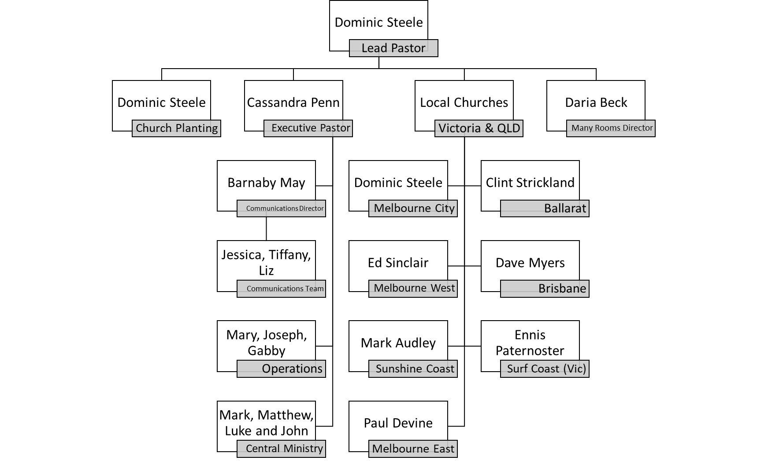

For VGM pastors, in-person ministry was everything. All church staff, from kids coordinators to Many Rooms workers, valued being able to meet the people they served, and the idea of ‘doing church’ away from people seemed almost counter to the organisational ministry. COVID, however, would make this nearly impossible.

**COVID-19**

First detected in Wuhan, China in late 2019, COVID-19 spread rapidly across the globe, with the World Health Organization (WHO) labelling it a pandemic by March 2020. By October 2020, 40 million COVID cases and 1.1 million COVID-related deaths had been reported globally, with Australia reporting roughly 27,000 cases and 905 deaths in total.

Australia’s first COVID case was reported in late January 2020, and by March 20th the Australian Government made the decision to close national borders to non-residents. By April, Australians were living under increased restrictions, practicing social distancing, limiting visitors in their homes, and stocking up on toilet paper, pasta, and canned goods.

These restrictions were not limited to individuals. Organisations too were under pressure to do their part to limit the spread of COVID-19. As restrictions increased, many organisations moved towards a predominately work-from-home model, though not all companies had the capacity to pivot in this direction. Likewise, event sizes were limited, with allowable group sizes decreasing rapidly.

For the Village Green Movement, both event and workplace restrictions limited the ability for the organisation to function ‘business as usual’. The weekday shift was easier, with VGM employees moving from central church offices into individual home offices. The greatest impact was felt on Sunday mornings, as 100-person event limits meant VGM churches could no longer run Sunday church services, impacting adult, youth, and child programming. For VGM, these restrictions posed a clear challenge to their strategic goals: how could they help parishioners learn, and feel connected into community, if they couldn’t meet in person?

**The Crisis Response**

COVID-19 didn’t begin to seriously impact VGM’s plans until late March, but Dominic Steele had been tracking COVID’s development since the beginning of the year. Clued in by parishioners with family connections to China, Dominic was aware that COVID was going to be deeply impactful, and if he was right, VGM would need to brace itself for some pretty significant changes.

Each VGM church sought to excel in two areas: Sunday services and midweek small group gatherings. Sunday service sizes ranged from 50-500 people across the 7 churches, and pockets of 10-20 people met each week for midweek gatherings across VGM’s five cities. As talks of isolation and social-distancing picked up, VGM leaders knew they needed to prepare for a day when in-person gatherings would be prohibited.

Dominic had established a coronavirus task force, consisting of leaders from across the organisation: himself, Cassandra Penn, executive director, Dave Myers, pastor of VGM Brisbane, Daria Beck, director of Many Rooms, and Barnaby May, central communications director. Together this coronavirus taskforce sought to lead the organisation through the pandemic, however long it might last. Some leaders believed things would blow over quickly, and some expected the organisation to still be feeling the impact six months later, but nobody expected COVID-19 to be a world-changing pandemic.

Initially the task force came together to issue guidance on social distancing and health policies for in-person meetings, but after a government directive in mid-March that limited gatherings to 500 people, and then days later to 100 people, the task force shifted their focus to moving the entire organisation digitally. Moving rapidly, the task force decided on Sunday evening, March 15th, to pool resources for one digital service, starting the following Sunday, March 22nd. Lead Pastors were informed of the changes that evening, and the rest of the VGM staff was informed during an all-staff zoom meeting on Monday, March 16th.

Though the entire VGM staff had worked together for a few events, like the all-church conference in October 2019, and had gathered together for a yearly staff conference and annual Christmas party in Melbourne, non-director staff members rarely worked with staff from other churches. For VGM, keeping ministry locally-based was a high priority. Now, however, seven semi-independent staff teams were pooling their collective resources to produce one Sunday service, one mid-week gathering guide, and one set of child and youth programming.

The Coronavirus taskforce argued that this move towards one collective service allowed each VGM church, and the organisation as a whole, to continue to accomplish their six strategic priorities while keeping their four guiding principles, particularly innovation and excellence, at the forefront. Dominic had his doubts…could the team shift, in the span of a week, to 7 different digital services? It seemed simply too much to ask of the VGM staff team, especially if they wanted to produce quality resources in line with their strategic goals.

To accomplish this shift, VGM needed to redeploy their staff, assigning them new tasks in the digital sphere. Church employees would still have work tasks related to their local church, but they would also now have tasks connected in with the digital ministry, an operation VGM named Village Green Digital (VGD). Dominic assigned the lead pastors of the five well-established VGM churches (Melbourne, Melbourne East. Melbourne West, Brisbane, and Ballarat) to an area of church ministry. The pastors of the newer churches, Ennis and Mark, would keep their focus local. Cassandra and the Central Ministry, Communications and Operations teams would need to work across all locations, even more than they did already. This restructuring is shown below:

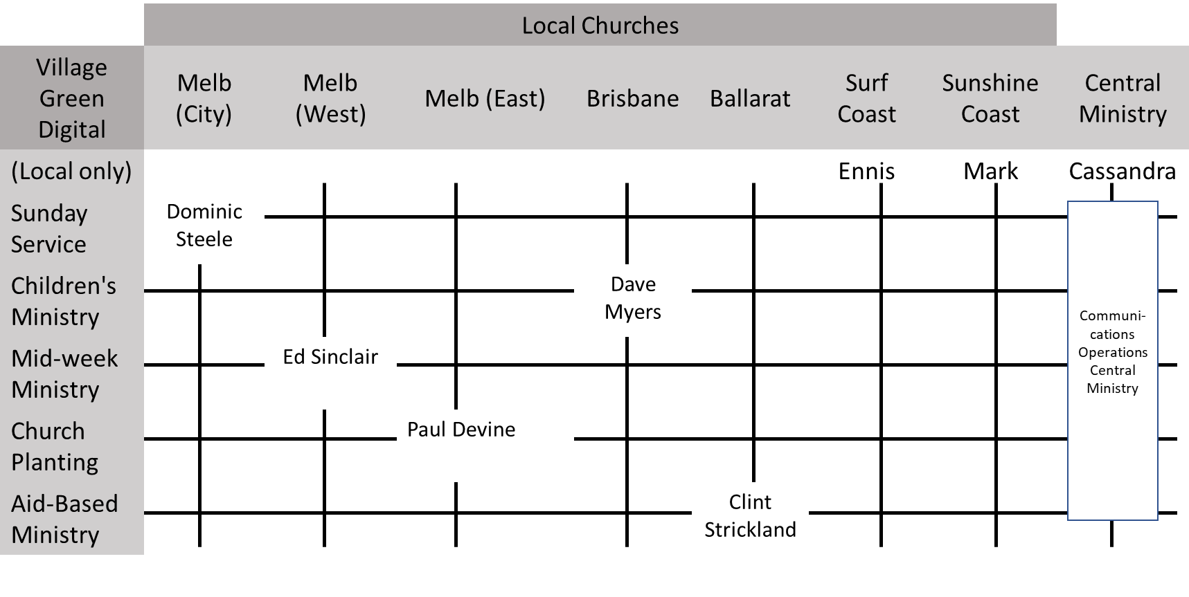

In addition to leading their local ministries, each lead pastor now led a staff team of employees whose local role was in a specific area of ministry. For example, all children’s coordinators now fell under the leadership of Dave Myers, Brisbane lead pastor and now responsible for Children’s Ministry, in addition to being under the leadership of their local lead pastor. The support of Church Planting, which involved developing new church locations by training a new pastor and helping to fund the church until it was financially self-sufficient, fell to Paul Devine. This new matrix model meant that local staff teams were working together and collaborating on collective resources. Because the ability to do locally-based ministry was diminished, staff were able to allocate a greater portion of their time to the collective digital efforts to develop and deliver new digital resources for everyone.

Though the structural shift happened rapidly, the effects were long-lasting. For the next six months, the VGM team put together a single weekly Sunday service delivered on-line, rotating through local pastors and worship teams. They also produced guides for the weekly digital mid-week gatherings, a weekly children’s YouTube show, as well as a weekly gathering of some sort at each local church. Attendance at these weekly gatherings was high, higher than the collective attendance of the VGM churches prior to COVID. In addition to meeting the needs of VGM stakeholders, VGM Digital was providing resources to those outside of their network. For many staff members, this was an exciting move towards VGM’s broad strategic goals of health and growth, as well as a potential move towards planting new churches. For others, however, this move towards greater collaboration caused fear that local ministry would lose priority, which ran counter to VGM’s purpose of being one movement of many individual churches.

**The Leadership Team Meeting**

Dominic began his Zoom meeting by introducing Jessica and Delilah and explaining that they were attending to help the leadership team with thinking through their next steps as an organisation. He then reminded the lead pastors of all that Village Green Digital (VGD) had accomplished over the past few months: an initial spike in stakeholder participation, the creation of a global platform, parishioner connection in the midst of a pandemic, and greater unity across the VGM staff team. When he opened the discussion for their input, he listened thoughtfully to the concerns raised by each local pastor: the increased workload on the Brisbane, Sunshine Coast, and Surf Coast teams as COVID restrictions eased enough to allow them to resume in-person gatherings. In Melbourne, local pastors were noticing decreased digital attendance as parishioners experienced zoom fatigue. For staff in the churches particularly, Dominic heard of fears that VGM was losing its local emphasis.

As ideas continued to be tossed around, Dave Myers piped up. While he sympathised with the Melbourne staff teams, he argued that he simply couldn’t keep contributing to the digital services in the same way. His local ministry in Brisbane needed to take priority, and Dave believed that the rest of the pastors should agree. Dave believed VGM had to shift again – he could no longer lead in Brisbane and in children’s ministry, as part of the VGD, and as restrictions eased, he believed the same would be true for the rest of the lead pastors.

Others, however, were optimistic. Many of the Melbourne pastors on the call, still months away from meeting in person, argued that this digital ministry was sustainable, and even necessary. They noted that they were able to reach new parishioners that preferred the digital ministry approach. The VGM staff had developed valuable technological resources, such as the popular YouTube channel and increased their own technical know-how during COVID. However, they needed staff from all the churches in order to make VGD work. Couldn’t Dave, and the rest of the Queensland staff, see how important this was to keeping the movement functioning and growing?

Privately, Dominic was wondering if they actually had the resources to staff this new “digital church”. If they needed more people, how could they fund them? He noticed that Ennis and Mark were very quiet. Were they worried but not saying anything because of being newer to the organisation? Or was it the impact of Zoom fatigue right here in the leadership meeting? Perhaps he needed to think of ways to ensure everyone contributed to these important meetings, despite the challenges of technology.

**What next?**

It appeared VGM was at a crossroads. Their pivot to digital ministry, and the restructuring of the staff to a matrix-style organisational design, had helped them to successfully survive, and thrive, during a pandemic that had forced many churches and business to shut their doors. They had been able to retain all of their staff during the crisis, but it was clear that the staff team was now stretched thin. When staff teams returned to in-person ministry, they would need to significantly reduce the time they dedicated to VGD.

As a purpose-driven non-profit, VGM’s goals were entirely people focused, and while it was clear that their structural shift had helped them continue to focus on their strategy during COVID, this structure may no longer be able to meet their needs.

As the chatter died down, Dominic reassured all of his colleagues that, just as they had shown the resilience of their organisation in responding to the crisis of COVID-19, they would find the right path to move forward to the future. He focused on Jessica and Delilah in the sea of faces on the Zoom screen in front of him.

“Now you have heard the views from across the leadership team, we would be keen to hear your thoughts on what we should do next.” Jessica stayed silent for a moment. Delilah cleared her throat and offered “Thanks so much for welcoming us to this meeting. We have heard a lot from you about the current challenges you face. However, Jessica and I would like some time to gather a little more information and then come back to you with a proposal for some next steps”. She scanned the faces on Zoom. “If you would be comfortable with that approach, what about we reconvene with you in about two weeks?”

“That sounds great”, said Dominic. “Can I ask everyone to help Jessica and Delilah if they reach out to you for more information?” Everyone nodded agreement and he drew the meeting to close. Eventually finding the END MEETING button on Zoom he said, “Go well everyone and God bless.”

**Jessica and Delilah**

Delilah’s mobile pinged. It was Jessica “How about a quick Zoom?”. “Sure” she replied and started up her Zoom app again.

Jessica and Delilah debriefed about the meeting, sharing their observations. “Jess, you have been part of this organisation right through this process. What is your reflection on the challenges that you see, at your level?” Jessica stared off camera for a bit, obviously mulling over the most important points to share.

“Well,” she responded, “We have all taken on a lot more work to produce the new digital resources. It has been great, learning so much new stuff, but it has been really hard too. Everyone has also had their own family issues to deal with, and some, like me, have Uni or other part-time jobs that have all been disrupted by the pandemic. Communication has got a lot more complicated. I now need to communicate both to my local team, working with Cassandra and others, but also with Dave Myers to help with the Children’s ministry and all the others in each local church involved in that task.” She seemed to consider this next thought deeply. “I agree with Dave that the current situation is unsustainable as it is. We do need to do something different. What I will say is that we have all become much closer and our shared culture stronger, because we have had to work more closely together to produce the digital resources. And there are a lot of wonderful outcomes we have achieved by thinking about how we deliver our work differently. We wouldn’t want to lose that!”

“Right” said Delilah, “So our task is to help the VGM to take the best of both the pre-pandemic and the crisis response way of working and design a way forward that makes the most of the strengths of the organisation and can provide a path to a sustainable future.” “How do you think we should go about it, Jessica?”

“Wow, OK…that’s a challenge! I have an idea of how to start though. Remember our first assignment last semester? I completed a Nadler-Tushman Congruence analysis of our organisation. I can get that out (See Appendix 1). We can use that as a basis to understand what has changed now, and what is likely to change over the next year to develop some options on what we would recommend as the next steps for VGM.”

Delilah had a broad smile now. “That is great Jess! Terrific idea. There are some further questions from the Nadler-Tushman book that would help us to analyse what might be the growing “incongruences” in the current structure (See Appendix 2) and help us to develop a working diagnosis. We will probably have to discuss and sense check this with others in the organisation, but it will be a great start.” “Then we will also need to lay out a change process for them to work with us to design the change journey for the organisation. I can think of a few helpful interventions we would most likely need, but I am sure you have ideas too.”

“Jess, as you know…I will be attending a conference over most of the next week, and I will be hard to contact. I would like you to take the outline template we used last semester for an Org Design Consulting proposal and do as much as you can to develop it to the level where we can present it to the leadership team. You will need to step back from your role as an internal employee to some extent and think of VGM as a “client”. Remember our discussions on entry and contracting in scoping a change project? You will need to think through that as well.” While Jessica was now looking a little doubtful, Delilah continued, “I have every confidence you can draw on all we learned last semester to do a great job of this.” Jessica could hear Delilah start to pack up her things. Delilah continued “I’ll be back before we have to present to the leadership team. I will send you an email to summarise what you need to do. And then just keep a note of any big questions, or assumptions you have to make. We can sort that out later. Give it your absolute best shot.”

“Whew!” thought Jessica as Delilah hung up on Zoom. “From theory to practice already!”

To: Jessica

From: Delilah

**Your To-Do List**

1. Take on the role of “Jessica”
2. Review all of the information provided.
3. Using the Org Design Consulting Proposal template, or something similar, prepare a proposal for the VGM leadership team that addresses:
   * A reflection on the current situation with the leadership team and stakeholders, taking an “entry & contracting” perspective.
   * A preliminary diagnosis of the current situation, building on information provided in the case.
   * A set of recommendations, based on your preliminary diagnosis, for the change journey forward. This may include further interventions to progress the diagnosis and/or interventions to progress the change process.

Your proposal should be solidly grounded in the information that has been provided, though you can supplement this with relevant external information if you feel it adds value. Your analysis and recommendations should be informed by the comprehensive use of relevant frameworks, theories, practices and evidence-based literature we have explored in the course.

I have provided the template for your proposal along with other documents that may be helpful.

All the best

Delilah

.

**Appendix 1 - Nadler Tushman Congruence Model Analysis – Early 2020 (Pre-Pandemic)**

|  |  |  |  |  |  |  |
| --- | --- | --- | --- | --- | --- | --- |
| **Inputs** |  | **Organisation** | | |  | **Outputs** |
| **Environment**   * Operating within Australia * Enjoy religious freedom * Reasonably buoyant economic conditions * 52% of Australian profess a Christian faith, ~ 8% other faiths, 30% no religion, overall declining |  | **Informal Organisation**   * Guiding principles: gospel confidence, unity & trust, cultural engagement, innovation and excellence * Share commitment to an entrepreneurial mindset, working collaboratively and professionally together * Deep devotion by all employees to achieving the strategic goals of the movement * Communication primarily within local teams, little cross-team communication | | |  | **System** - VGM   * Growth of the VG Movement * Effective management and administration |
| **Resources**   * Access to talented and committed workforce * Support of tax-free status as a religious organisation | **Strategy**  “know Jesus & make Jesus known”   * Raise gospel leaders * Plant new churches * Equip the next generation   Reach 10 cities by planting 50 churches | **People**   * Hired with focus on entrepreneurial mindset, flexibility, high tolerance for ambiguity * Shared set of religious beliefs * Range of ages. * Some in paid roles, others in volunteer roles * Highly value direct contact with each other and parishioners in their work * Primary focus on their local team |  | **Work**   * Central teams perform administrative and management tasks * Local teams develop resources for services specific to their local area and parishioners * Covers production of service content, music, educational programs, fund raising, organising social events |  | **Units** – Local churches   * Local Sunday services * Midweek gatherings * Childrens program * Aid based ministry   Central Teams   * Comms and admin support |
| **History**   * Began in 2007 * Developed in Melbourne * Recent growth to regional Victoria, Qld. |  | **Formal Organisation**   * Purpose driven, non-profit * Churches in a geographic structure, operate semi-independently * Central teams provide administrative and comms support * Budgeting and hiring authority managed centrally * Churches expected to reach financial self-sufficiency | | |  | **Individual**   * Help parishioners grow and share their faith |

**Appendix 2 – Key Questions for Nadler-Tushman Congruence Model Analysis**

Nadler, D. A. & Tushman, M. L. 1997. ***Competing by Design: The Power of Organizational Architecture***. New York, New York: Oxford University Press.

Analysing organisational outputs/performance (Pg 31):

1. How successfully has the organisation met the objectives specified by its strategy?
2. How well has the organisation used its available resources to meet its objectives? How well has it produced new resources?
3. How well does the organisation reposition itself to seize new opportunities and ward off threats?

Analysing Types of Fit/Congruence (pg 35)

|  |  |
| --- | --- |
| **Fit Dimension** | **Issues** |
| Individual-Formal Organisation | How are individual needs met by the organisational arrangements?  Do individuals hold clear perceptions of the organisational structures? |
| Individual-Work | How are individual needs met by the work?  Do individuals have skills and abilities to meet work demands? |
| Individual-Informal Organisation | How are individual needs met by the informal organisation? |
| Work-Formal Organisation | Are organisational arrangements adequate to meet the demands of the work?  Do organisational arrangements motivate behaviour that is consistent with work demands? |
| Work-Informal Organisation | Does the informal organisation structure facilitate work performance?  Does it help meet the demands of work? |
| Formal Organisation-Informal Organisation | Are the goals, rewards, and structures of the informal organisation consistent with those of the formal organisation? |

Nadler, D. A. & Tushman, M. L. 1997. ***Competing by Design: The Power of Organizational Architecture***. New York, New York: Oxford University Press.