QUESTIONS TO ANSWER

1. How does sample size affect the quality of our data and our analysis?
2. True or False: The probability of rolling a 12 on two successive throws of two standard six sided dice (D6 for you gamers out there), are independent events. \*Should be True but correct me if I am wrong.

\*\*This is the Chegg explanation. I just need your explanation, or it put into words.

“When the events do not affect one another, they are known as independent events. Independent events can include repeating an action like rolling a die more than once, or using two different random elements. Since,Independent Events are not affected by previous events.

Thus we can say that if two standard six sided dice thrown twice then it's a independent event because the event occurs in one trial doen not affected by the previous trials.

Hence the given statement is TRUE.” -Chegg

* 1. Why did you answer the previous question the way that you did?

1. True or False: The probability of rolling a "4" three times out of five rolls of a standard six sided die (D6) could be determined using a binomial distribution.

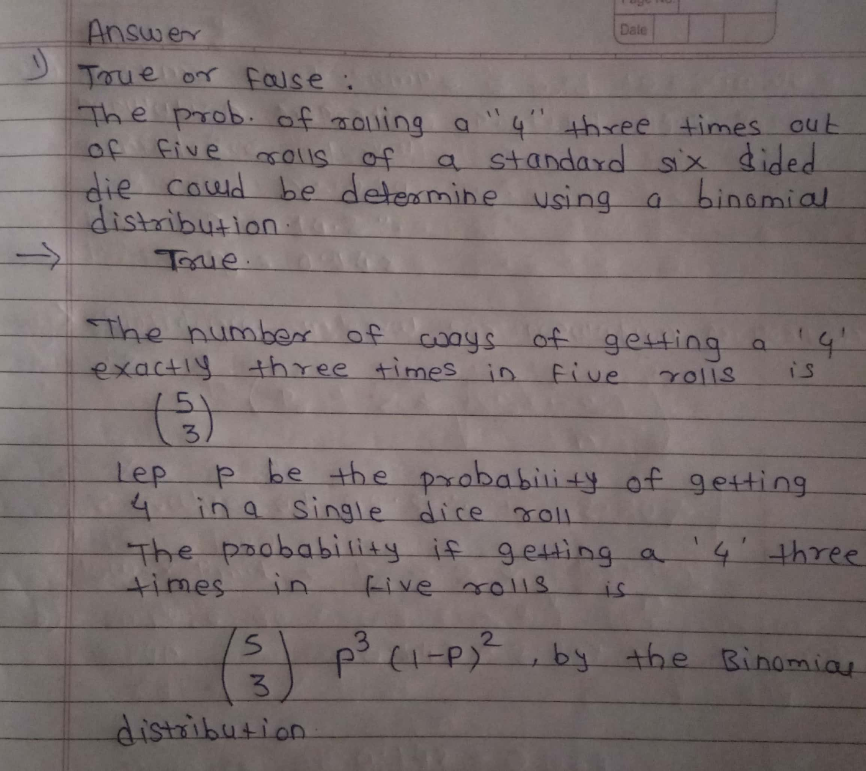This should be true, correct me if I am wrong. I mostly just need you to put an explanation into word for me when answering question A, below

* 1. Why did you answer the previous question the way that you did?

1. From what we have covered in the class so far, give me a specific example of how you think statistics might be applied to the business world in your field. For instance, if you are in marketing, give me a marketing example, if you are in accounting, an accounting example, etc.
2. What is the connection of Pan Am Flight 121 to modern science fiction?