***Research Paper Instructions***

Our research paper should be original work, based on general APA guidelines, 10 to 12 pages double spaced not including the cover page. Proofread for typos and other errors prior to submission.

Your title should be as focused as possible in order to achieve the goal of making a unique contribution to the existing body of knowledge on your subject. That means that you should try to limit the size of the population, demographic group or cohort being examined, their geographic region, their health issue, risk factors and outcomes.

Your title page should resemble the image below.

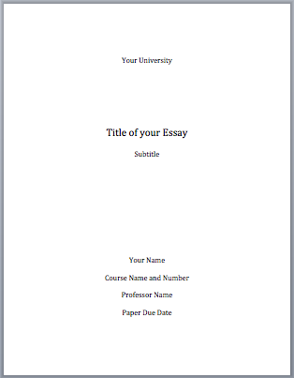

The first page should include the Table of Contents should resemble the following format. Obviously the actual headings will be different for us and follow the outline I posted named “Research Paper Format”.

Table of Contents

Table of Figures………………………………………………………………………………………………………………..…………….………………… 2

Abstract…………………………………………………………………………………………………………………………………………….…..…………. 3

Introduction……………………………………………………………………………………………………………………..………………….…………… 4

Methodology……………………………………………………………………………………………………………………………………..…….………. 5

Findings………………………………………………………………………………………………………………………..…………………………….……. 7

Discussion……………………………………………………………………………………………………………………………………..……………….… 9

Conclusions/Recommendations……………………………………………………………………………………………………….…………..… 11

List of References……………………………………………………………………………………………………………………………..…………….. 12

Your Table of Figures should resemble the Table of Contents. You will need at least 3 figures:

Table of Figures

Figure 1………………………………………………………………………………………………………………..……………………………… 8

Figure 2……………………………………………………………………………………………………………………………..………………… 9

Table 1………………………………………………………………………………………………………………………..……………………… 10

Your actual ***figures*** should be imbedded into the text, either in the Findings or Discussion sections and cover no more than 1/3 of the page. They should be adapted from research data, either by the researchers whom you are using as sources or by yourself. If you use your own original data to create a table, it should resemble the one below.

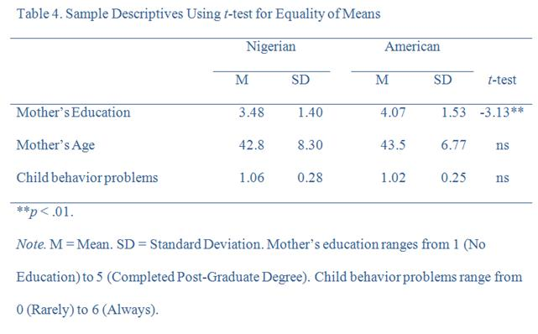

Your ***Abstract*** should focus on the historical context of your issue: How did we get here? What has the trend been for the last 25 years? Is this situation unique to this region or population? What is the current “talk of the town” regarding this? It should be limited to 100 to 250 words and should not be indented. Placing it on its own page, while not required, does look the most professional.

Next, your ***Introduction*** should start on the next page with the appropriate heading “Introduction”. It should be limited to a maximum of 2 pages and walk the reader through what they should expect in the following paper. Briefly discuss what they should expect in the Methodology, Findings, Discussion, and Conclusion sections.

In your ***Methodology***, you will discuss your reasons or motivations for pursue the topic or issue included in the paper. Why is it important? Why does it matter? How will your research add value to the body of existing knowledge on the subject? Then, discuss the steps you took to undertake your research. Did you begin with Google Scholar? The Rutgers library? Did someone assist you? What led you to pick the sources that you picked. Was your hunt fruitful? Did you get the answers you had anticipated from those sources? If you compiled original data, did it shed light on an issue that has been ignored until now? These are the general questions that should guide your methodology section. Remember it applies to YOUR research, not the research of your sources.

Your ***Findings*** should be a straightforward presentation of just that: your findings. Data, primary and secondary research, statistics and common theories should be mentioned here in a very basic and brief way. Your figures and tables will be imbedded in this section or the following discussion section.

In your ***Discussion*** section you will expand on the previous findings which you only very briefly mentioned in the last section. Here, you will elaborate on your findings. Are your findings consistent? Is there a lot of disagreement among the so-called experts in the field? Did any trends or patterns emerge?

Your ***Conclusion*** section will sum up the preceding paper. What have you just reported to the reader in the preceding several pages? Is it new or newly organized data? Have you emphasized in the preceding pages the urgency of a public health or related situation that requires immediate attention? Have you alerted the reader to a new and promising drug that might alleviate the current opioid epidemic? Have you discovered a new and promising trend on college campuses that seems to be lessening binge drinking through innovative peer pressure?

Your ***Recommendations*** should focus on either research recommendations and/or policy recommendations. Is further research required on a certain aspect of your issue? Is a broader sample needed to determine whether this promising trend on college campuses is actually a national/international trend? If not, is a federal policy of implementation needed to guide the affected population toward a particular and healthier lifestyle habit?

Your ***List of References*** page should be formatted according to the following example. You will need at least 10 sources, 5 of which will be academic and peer reviewed. If, for example you are writing about a pop celebrity experiencing harassment or sexual assault, those 5 scholarly sources will likely need to focus on the broader aspects that include the history of sexual discrimination, especially in the workplace.

