Question 1

Please compare and contrast these two images to discuss how art is used for didactic (teaching) purposes. You may bring in additional works we have studied to help illustrate your ideas.

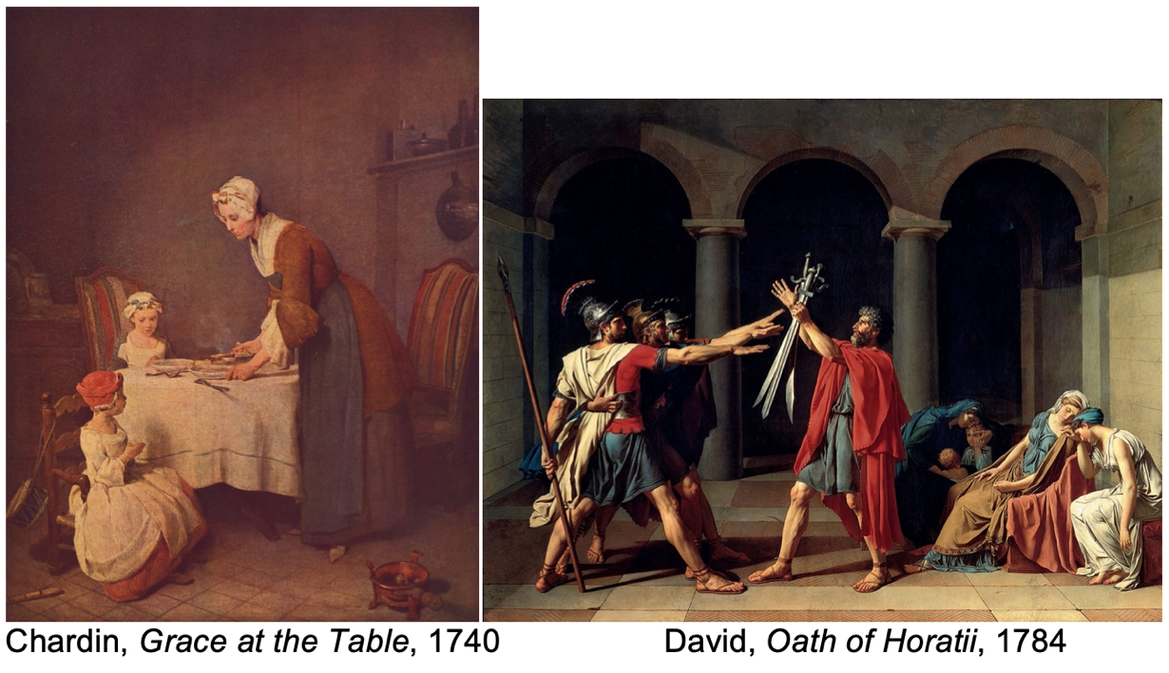

Question 2

New technologies and scientific advancement have always influenced the arts. Please compare and contrast two works of art that have been shaped by new technologies. Some things you may consider are if the science/technology affected the style and content of these works, if these artworks were considered “art” at the time or merely science, whether these works would have been possible without the new inventions.

Question 3

In your own words please define “hybridity” and select 2 works of art from different periods that show a form of hybridity. Please discuss each work and explain why the term “hybridity” can be used to discuss these works.

**Each answer** should be 1 page, 12-point font, 1.5 spacing, Times New Roman, 1- inch margins. All answers should be in full sentence, paragraph form and well edited.

No citations or outside sources are necessary.