|  |  |
| --- | --- |
| Name | Period |

Unit 4: The Great Depression & New Deal

US History

**Introduction to the Great Depression Notes**

**Part I: Stock Market Game**

**Welcome investors! You have $500 to invest.** **You must make a least one transaction per round**

Read the handout of [**prospectuses**](https://docs.google.com/document/d/11nzChrialVu9OouGyMO_3cBc_z1Up9zrP6bODj0d_yc/edit?usp=sharing) carefully and decide which stocks you wish to purchase. Most of these stock companies existed in the 1920s.

**You must purchase all stock in blocks of 10 shares.**

*You can buy on margin. Paying only 10%-20% of the actual stock price in hopes you’ll make a profit.*

|  |  |  |  |  |  |  |  |  |
| --- | --- | --- | --- | --- | --- | --- | --- | --- |
| **Stock** | **Opening Price** | **1920**  How many shares & how much money? | **1922**  How many shares & how much money? | **1923**  How many shares & how much money? | **1925**  How many shares & how much money? | **1927**  How many shares & how much money? | **1928**  How many shares & how much money? | **1929**  How many shares & how much money? |
| **Kroger** | $10x10 |  |  |  |  |  |  |  |
| **Radio Corporation** | $10x10 | 200,20 |  |  |  |  |  |  |
| **Mammoth Oil** | $10x10 | 100,10 |  | 480/30 |  |  |  |  |
| **Gotham Bank** | $10x10 |  |  |  |  |  |  |  |
| **Durant Motors** | $10x10 | 100.10 |  |  | 280/40 | 520/40 |  |  |
| **Midland Utilities** | $10x10 |  |  |  |  |  |  |  |
| **Kansas & Pacific RR** | $10x10 |  |  |  |  |  |  |  |
| **Tel-Tone** | $10x10 | 100.10 | 440/20 |  |  |  |  |  |
| **How much $ do you have?**  Deduct 10% for each amount you borrowed |  | 500 | 120 | 120 | 740 | 860 | 860 | 860 |

**Part II: Causes of the Great Depression**

|  |  |
| --- | --- |
|  | What was the [Stock Market Crash of 1929](https://www.youtube.com/watch?v=Yp7u328PKu4) and what was the result?   * Roaring 20s was * Black Tuesday (October 24/29) was: |

|  |  |
| --- | --- |
| Listen for:   * Agriculture * Speculation * Deflation * Federal Reserve * Gold standard | What caused the Great Depression? |

|  |  |
| --- | --- |
| [Migrant Mother](https://www.history.com/news/migrant-mother-new-deal-great-depression)  Great Depression | The Great Depression |

**Part III: Great Depression Statistics**

What can we earn about the economy and the Great Depression (1929-2939) from examining economic statistics?

**Data Table 1[1]**

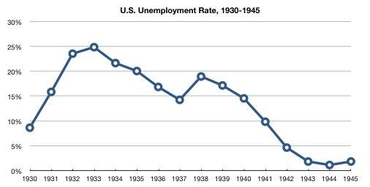

***Unemployment Rate:***The unemployment rate is the percentage of the labor force that is willing and able to work, does not currently have a job, and is actively looking for employment. The labor force consists of people ages 16 and over who are employed or actively seeking work.

In the space below, draft **one claim** about the impact of the Great Depression (1929 - 1939) on the United States. **Circle evidence** in the table that supports your claims.

**Data Table 2[2]**

|  |  |
| --- | --- |
| **Year** | **Number of Bank Suspensions** |
| 1929 | 659 |
| 1930 | 1352 |
| 1931 | 2294 |
| 1932 | 1456 |
| 1933 | 4004 |

***Bank Suspensions:*** Includes all banks closed to the public by supervising authorities or by the bank’s board of directors because the bank is having financial difficulties. Most bank suspensions were the result of consumer panic (consumers pull their money out of bank accounts because of fear of bank failure).

In the space below, draft **one claim** about the impact of the Great Depression (1929 - 1939) on the United States. **Circle evidence** in the table that supports your claims.

**Data Table 3[3]**

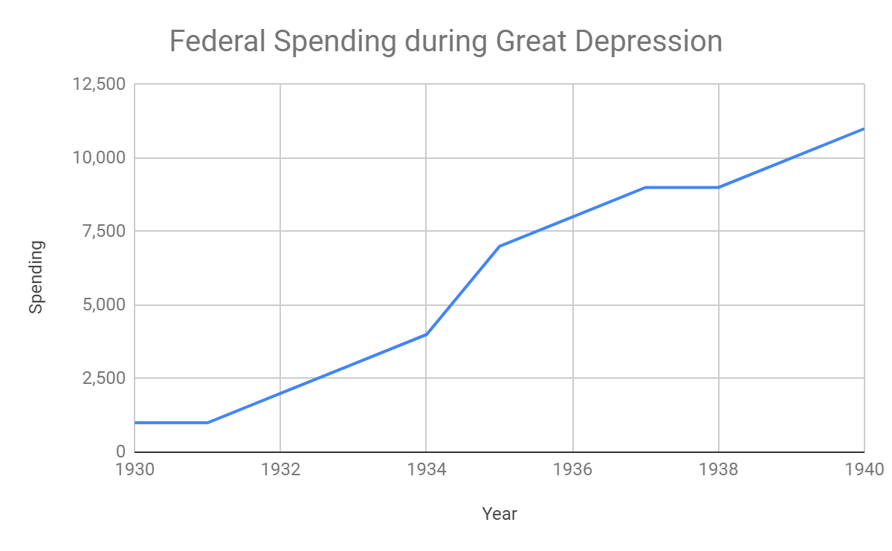

***Federal Spending:*** How much money the federal government spends.  *Note: President Roosevelt was elected in 1932, and took office in 1933.*

In the space below, draft **one claim** about the impact of the Great Depression (1929 - 1939) on the United States. **Circle evidence** in the table that supports your claims.

**Data Table 4[4]**



***Consumer Price Index:*** A measure of the average change over time in the prices paid by consumers for a market basket of consumer goods and services. It indicates the cost of living for a typical consumer. Negative CPI suggests that there is a steady decrease in the prices of goods and services, which suggests that unemployed Americans can’t buy any goods and services at any price.

In the space below, draft **one claim** about the impact of the Great Depression (1929 - 1939) on the United States. **Circle evidence** in the table that supports your claims.

**Data Table 5[5]**

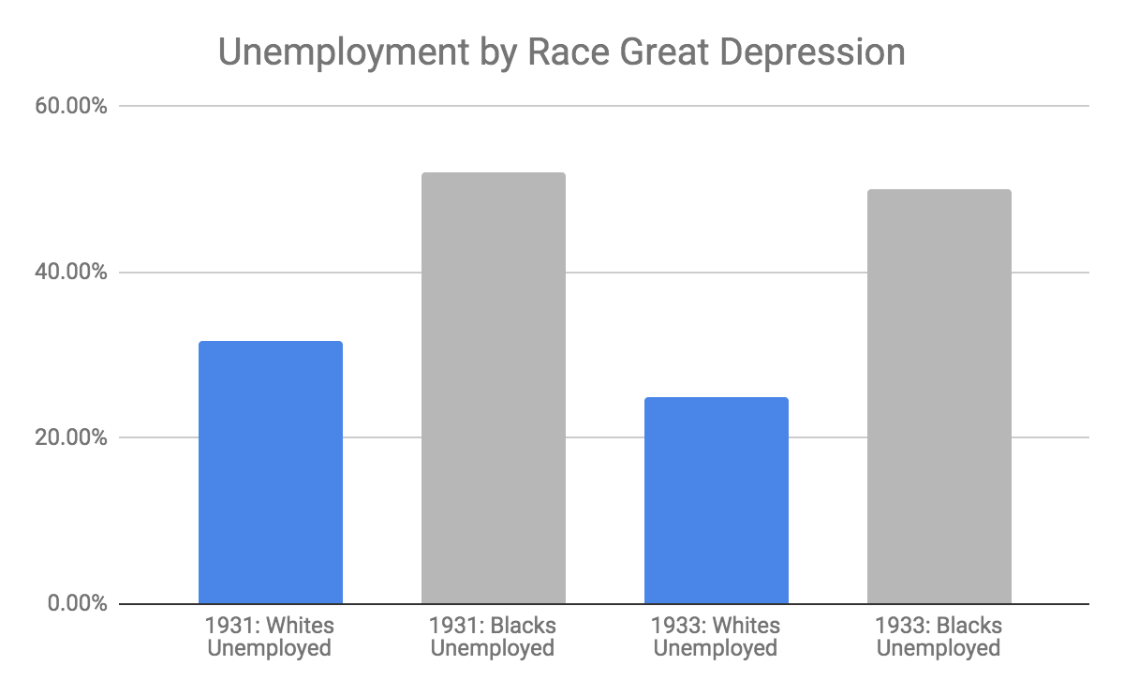

***Unemployment Rate:***The unemployment rate is the percentage of the labor force that is willing and able to work, does not currently have a job, and is actively looking for employment. The labor force consists of people ages 16 and over who are employed or actively seeking work.

In the space below, draft **one claim** about the impact of the Great Depression (1929 - 1939) on the United States. **Circle evidence** in the table that supports your claims.

**Data Table 6[6]**

|  |  |
| --- | --- |
| **Year** | **Real GDP (in millions of dollars)** |
| 1929 | $951.7 |
| 1930 | $862.1 |
| 1931 | $788.8 |
| 1932 | $682.9 |
| 1933 | $668.9 |

***Real GDP:*** Gross Domestic Product is the total market value of all final goods and services produced in an economy in a given year. A drop in GDP means less goods and services are being produced by the economy, in response to a lower demand for goods and services.

In the space below, draft **one claim** about the impact of the Great Depression (1929 - 1939) on the United States. **Circle evidence** in the table that supports your claims.

**Data Table 7**[7]

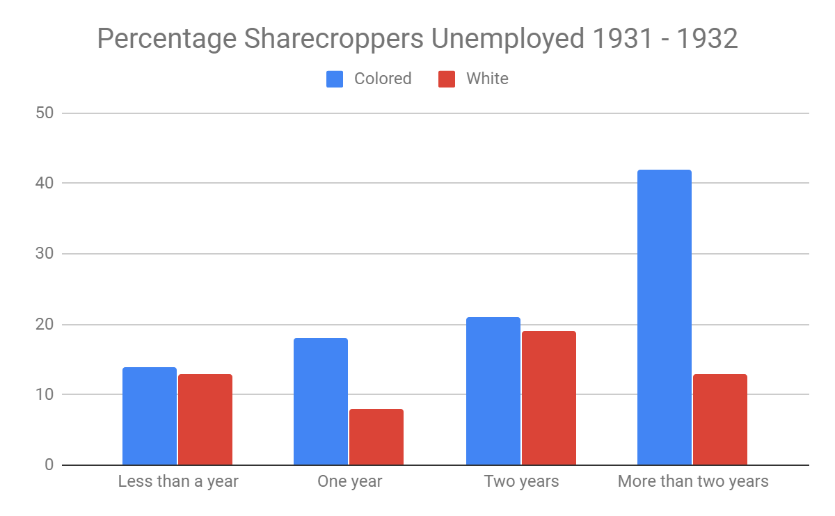

***Sharecroppers:*** Sharecroppers were amongst the poorest of farmers, they rented land from a larger land owner to farm. During the Great Depression, many sharecroppers lost their land. According to much of the data collected, race played a factor in whether or not farmers were unemployed.

In the space below, draft **one claim** about the impact of the Great Depression (1929 - 1939) on the United States. **Circle evidence** in the table that supports your claims.

**Part IV: Demonstrate your understanding of the causes of the Great Depression**

|  |
| --- |
| Answer the following questions using evidence from Parts I-III. Your answers should be a minimum 5 sentences with evidence.  [Introduction to the Great Depression Slide Deck link](https://docs.google.com/presentation/d/15CdjOBTqC5MH2zZN12-_QxWmIJy3wtttHRbUvOHnVRY/edit?usp=sharing) |
| 1. What were the causes of the Great Depression?  |  | | --- | | **Words & Phrases to connect cause & effect** | | as a result  for this reason  so  therefore  this led to...because | |
| 1. What were the impacts of the Great Depression on the economy? |
| 1. How did the Great Depression impact Americans of different races? What else was happening at the time in America that might have contributed to the Great Depression having a different impact on different races of Americans? Explain how African Americans and white Americans experienced the Great Depression differently. |

1. Bureau of Labor Statistics , “Graph of U.S. Unemployment Rate, 1930-1945,” *HERB: Resources for Teachers*, accessed August 2, 2019, <https://herb.ashp.cuny.edu/items/show/1510>.
2. Data; St Louis Federal Reserve Bank
3. Data: American Social History Project/Center for Media and Learning, “Graph of Federal Spending (in millions of dollars), 1929-1945,” *HERB: Resources for Teachers*, accessed August 2, 2019, <https://herb.ashp.cuny.edu/items/show/1509>.
4. Data: St. Louis Federal Reserve Bank
5. [Chart by NV - Data from To Ask for an Equal Chance by Cheryl Greenberg](https://www.amazon.com/Ask-Equal-Chance-Americans-Depression/dp/074255189X?_ga=2.223313307.1694903604.1564775445-1249227661.1553518058) 
6. Data; St Louis Federal Reserve Bank
7. Table and text from Robert C. Weaver, “The New Deal and the Negro: A Look at the Facts,” in Opportunity: Journal of Negro Life, July 1935, available from The New Deal Network