**From Cannabis Decriminalization to Cannabis Legalization in Massachusetts**

A Health Impact Assessment

Sarah Philbrick

February 2020

Clark University

MPA 3113-01

Table of Contents

1. Overview of policy examined
2. Stakeholder identification
3. Stakeholder interviews
   1. Member of Board of Selectmen
   2. Regional Public Health Planner
   3. Key Take-Aways
4. Data and statistics
   1. Adult Cannabis Use in Massachusetts
   2. Youth Cannabis Use in Massachusetts
   3. Dispensaries and Available Products
   4. Land Use Implications
   5. Enforcement
5. Community policies
   1. State policies
   2. Local policies
6. Impact
   1. The Creation of a “Big Marijuana” Industry
   2. Increase in Youth Use of Marijuana
   3. Increase in Adult Use of Marijuana
   4. Equity Impacts of Marijuana Legalization
   5. Available Tax Revenue for Public Health Programming
7. Recommendations
   1. Recommendations to limit marijuana usage in youth
   2. Recommendations to prevent the creation of a “Big Marijuana” industry
8. Next Steps
9. Overview of Policy Examined

In 2008, Massachusetts voters passed a ballot initiative that decriminalized the possession of small amounts of marijuana. The possession of less than one ounce went from up to six months in jail and a $500 fine to a $100 fine and no report of criminal activity. In 2016, voters passed another ballot initiative that ended marijuana prohibition for those 21 and older. As a result, marijuana first became legal in Massachusetts in December, 2016, yet the first official recreational sales did not begin until November, 2018. For more specific language about the change in laws that led to this change, please refer to section V. Community Policies.

This report examines the potential health impacts of the change from decriminalization to legalization of marijuana in Massachusetts. As stated, the first official recreational sales in the Commonwealth did not happen until the end of 2018. Because of its relative newness, it is too early to see all the impacts that legalization will bring to the Commonwealth, even though the policy change has already occurred. That is one of the reasons why it is important for stakeholders to understand the potential impacts of this policy change and prepare both responses and data collection standards to analyze and mitigate future impacts.

1. Stakeholder Identification

While this change in legislation has the potential to impact a number of residents, workers, business owners, and others in the Commonwealth, it is important to identify the key stakeholders that are critical to examining this policy change. This Health Impact Assessment calls out four stakeholders, but only two of these four stakeholders were interviewed.

1. **Health professionals** Health professionals can speak to the known benefits and risks of marijuana usage as well as the more specific expected outcomes (repertory issues, psychiatric impacts).
2. **Municipal CEOs** City and town managers, mayors and/or Boards of Selectmen should be able to provide perspective on the possibilities for local tax revenue that can come from marijuana sales.
3. **Public safety professionals** Public safety professionals can speak to the potential emergency preparedness measures needed after legalization (ex. ambulance needs, impaired driving impacts).
4. **Marijuana users** Communication with marijuana users can help us understand the difference in user experience and quality of product pre- and post- legalization. It is also important to make sure this group includes those who have had experience with the criminal justice system, as it relates to marijuana, to understand the change legalization may bring to their lives.
5. Stakeholder Interviews

In January, 2020 two 30 minute in-person interviews were conducted with stakeholders. These interviews served to provide a broader prospective on the potential health impacts of legalization in Massachusetts and get an insight into public sentiment on the policy. The two interviews are summarized below. In the next section, top concerns are identified through a combination of the interviews and news articles from the state.

**Interview 1: Member of the Board of Selectmen in a** [**Maturing Suburb of Metro Boston**](http://www.mapc.org/wp-content/uploads/2017/09/Massachusetts-Community-Types-Summary-July_2008.pdf)

*The member wished to have their name and town remain anonymous since they were not permitted to speak on behalf of the Selectmen. I identify this member of the Board of Selectmen as a “selectperson” throughout the write-up to avoid gendered language.*

This selectperson identified that from their perspective the change from decriminalization to legalization in Massachusetts was an exciting opportunity for communities to make a lot of money. The town they represent is currently looking at an operational override, and new income streams are important to keep the town functioning. The stakeholder was concerned, however, about the lack of certainty about how much money a dispensary would be able to bring in. They cited that Brookline has made lots of money, but as more dispensaries open across the state the opportunities to take in as much of the market will shrink. I asked if they had strong feelings about what the money should be used for, and the selectperson indicated that the money would be best in the general fund to pay for necessities like fixing potholes and funding schools.

I asked the selectperson what the main concerns from their constituents seemed to be and they listed two main concerns: parking and traffic issues associated with dispensaries and not wanting dispensaries or usage to happen near children. The selectperson has not heard their constituents concerned about marijuana from a personal health or moral issue.

The selectperson also brought up a concern about cultivation. There is a fear that if land values become high for cultivation, it may make agricultural uses and the protection of open space too expensive to pursue.

There was acknowledgement that usage has most likely gone up since legalization in this community. The selectperson told me they have had dozens of conversations with peers who are re-trying marijuana as adults (had not previously partaken since they were college students) because before legalization it didn’t feel as available or socially acceptable. The selectperson said even people running for office now joke about marijuana, which would have never been acceptable before, even with decriminalization. I asked if there were any concerns about public health with the increase of usage, and the selectperson indicated they really hadn’t thought much about public health concerns beyond the fact that more people may be smoking and inhaling things into their lungs which is bad. There are also some concerns about intoxicated driving, but the selectperson seemed to think that the culture around that has changed and less people are likely to feel ok driving when they are not sober than they were a few decades ago.

I asked the selectperson if and how the policy change had changed the way they parent their two young adult children around marijuana. The selectperson indicated that they were never truly against marijuana as a substance but were not comfortable having illegal substances in the house when both parents work as public servants. With the change to legalization, the feeling has changed because marijuana is not an illegal substance.

**Interview 2: Regional Public Health Planner**

*I will refer to this person as a “planner” throughout the course of the interview. The planner also has experience working at a Department of Public Health in California right before marijuana was legalized there, which she brings up throughout the interview*

The planner first made sure to tell me she has not personally done much work at the intersection of public health and cannabis. She feels like this is something public health planners and departments are still trying to figure out, and the change to legalization creates many challenges for public health workers.

This planner left California right before legalization but worked with the Public Health Department there trying to create strategies for post-legalization, knowing it was coming. This planner came from a farming county where the production and processing of cannabis was a big player in the local economy. The planner mentioned that the county previously had a large flower growing industry that left over time to South America, leaving many empty nurseries behind. Before marijuana even officially became legal all of these old nurseries had been bought as potential sites for new marijuana nurseries and there was an 23% increase in tax revenue within one year because of that change.

As a water rights advocate, this planner was excited about the prospect of legalization because it meant that marijuana growing operations would become more regulated and the risk of harmful pesticides or mismanagement of water use was lower. She cited there were many illegal operations happening before, and due to the legal medical operations happening at the same time it was difficult for the state to ‘crack down’ on illegal growing sites.

The planner mentioned Public Health Departments in California were worried about the new responsibilities they would have. They felt that since they were responsible for regulating health and safety facilities (similar to alcohol facilities) they would have a role in permitting and regulating cannabis industries as well. One of the main challenges seemed to be around dispensary sites and if the dosages advertised by retailers were real. The department of public health feared this would be particularly difficult. Was it their role to test the samples? How would they learn to do that? In addition to the dosage, how do they make sure products aren’t tainted with heavy metals/pesticides?

This planner, similar to the selectperson, mentioned that communities were eager to permit dispensaries to get tax revenue. There were multiple public processes to figure out what to do with the revenue, with re-investing in entrepreneurs of color and investing in formerly incarcerated individuals making the top of the list. However, in her community, the money from the first year of sales ultimately went to fill holes in the regular operating budget.

This planner and I also had a long discussion about the connection between cannabis, public health, and social justice. She noted that ideally communities most negatively impacted by the War on Drugs would reap the benefits of legalization. However, opening up a dispensary or a processing plant still involves a lot of capital investment and financing in this industry is even more difficult than other industries because it’s still illegal at the federal level. She felt conflicted as a public health professional because in theory she would want to impose more regulations on dispensaries and growing operations such as testing, quality, and safety assurances. However, she recognized that the more regulations that were imposed, the more expensive it would be to start a business, which might push more entrepreneurs of color out of the industry.

I asked the planner if she saw any cultural shifts around marijuana in California pre- and post- legalization. She noted that marijuana was always accepted and openly talked about in California (pre-legalization) by those who were affluent. Post-legalization more less-affluent people felt comfortable talking about it, but it was still somewhat taboo because of so many foundation and community funded programs, particularly in impoverished areas, that took the stance that drugs were bad and it was a personal responsibility not to get involved with them. She gave the DARE program and “just say no” campaigns as examples.

**Key Take-Aways**

* **One of the main motivators for communities to support the move from decriminalization to legalization is the opportunity to collect tax revenue from marijuana sales.** 
  + While some early advocates cited the money would be able to [produce new services](https://www.boston.com/news/local-news/2018/12/05/massachusetts-marijuana-tax), this money may produce less ‘new services’ than originally thought, and instead go to fill in holes in existing budgets. Like the selectperson interviewed, this [WBUR article](https://www.wbur.org/bostonomix/2019/07/08/recreational-marijuana-pot-taxes-massachusetts-spending) points out the need for services, such as filling potholes.
* **There are concerns the cultivation of marijuana will cause land values to rise, which makes using the land for other uses more expensive**
  + I was surprised that both people I interviewed talked about the increased value of land and cultivation space because of marijuana. While we don’t think of Massachusetts as a large agricultural state, the implications this may have on our food systems and ability to preserve open space should be examined. Massachusetts in particular is a state with high direct farm-to-consumer sales, so it is likely any land value changes related to agricultural land in Massachusetts would impact Massachusetts consumers the most. [This research](https://www.fs.fed.us/psw/publications/documents/psw_gtr258/psw_gtr258_395.pdf) on Humboldt County, CA finds that increased cannabis density is associated with increases in the price of undeveloped land. It is already difficult for communities in Massachusetts to purchase land set aside for recreational use due to the state’s small size and housing shortages, causing high land values. While there does appear to be [articles](https://massrealestatenews.com/marijuana-impact-home-values/) about how dispensaries may impact real estate values, I did not find news articles looking at this particular issue.
* **Marijuana legalization makes use more socially acceptable, and probably increases use, but this does not seem to be a primary concern of the people I spoke with**
  + I was also surprised through my interviews that marijuana use was essentially seem as harmless, or at least an uncontrollable action by individuals. Even this [MassLive article from 2016](https://www.masslive.com/news/2016/11/massachusetts_legalized_mariju.html) which talks about “what happens next” after legalization does not mention anything abut public health or a potential increase in personal use.
* **For many people, the move from decriminalization to legalization simply means dispensaries**
  + For many individuals, the concerns cited with ‘legalization’ are actually concerns about opening marijuana dispensaries. For example, the selectperson I spoke with mentioned parking and traffic as primary concerns, which are mostly associated with the opening of a dispensary. [The same has been true in my neighborhood of Jamaica Plain.](https://www.jamaicaplainnews.com/2019/02/21/recreational-marijuana-company-signs-city-host-agreement-to-open-in-jp/96497) I have asked town planners in the past what they are concerned about with the change in the legal status of marijuana. The response from over a half dozen planners was “We don’t need to think about that, we banned it here.” By “banning” these planners meant their municipalities have decided not to allow dispensaries to operate within their borders, but there was no acknowledgement of the potential for increased usage in the municipality. It is noted that because this sample was planners, and the response from public health or public safety officials may be different.
* **Legalization opens many hurdles for those in regulatory positions to have to figure out how to regulate a new product**
  + I was shocked at the amount of stress put on public health departments in California pre-and post-legalization to essentially “figure it out”. At the time of this [article in 2018](https://www.masslive.com/news/2018/10/testing_marijuana_for_potency.html), there were only three testing labs in Massachusetts. Not only is it important to test for the potency of THC, it’s imperative that we make sure products are free from heavy metals and toxins such as arsenic. Since marijuana is not legal at the federal level, departments such as the FDA cannot be put in charge of testing similar products. The need for these testing sites created a [large delay](https://www.analyticalcannabis.com/articles/a-look-inside-the-massachusetts-cannabis-testing-controversy-309454) between when marijuana officially became legal in Massachusetts and when recreational dispensaries could open, creating challenges for everyone involved.

1. Data and Statistics

**Cannabis Use In Massachusetts**

In order to evaluate the impact of legalization of marijuana in Massachusetts we must have a baseline of understanding the current rates of use in the Commonwealth. Due to the significant health impacts marijuana has on the developing brain, it is important to analyze adult and youth use in the Commonwealth separately. This report also highlights how those rates compare to the Northeast region of the United States as a whole (US Census). This section of the report primarily uses publicly available data modeled from the National Survey on Drug Use and Health.

1. **Adult Use**

Adult marijuana use in Massachusetts has increased significantly from 2008-2009 to 2016-2017. The percentage of adults who have used marijuana in the past year increased 41% from less than 15% of the population to over 20% of the population. Massachusetts rates remain higher than the Northeast region as a whole, and have increased faster than the Northeast region between the two survey points.

The trends are similar for adults who indicate they have used marijuana in the past month. Between 2008-2009 and 2016-2017 the rate of adult usage in the past month increased 58 percent to nearly 14% of the population, 3.7 percentage points higher than the Northeast region as a whole.

Source: SAMHSA, Center for Behavioral Health Statistics and Quality, National Survey on Drug Use and Health, 2008, 2009, 2016, and 2017 (2008 and 2009 Data – Revised March 2012)

1. **Youth Use**

Youth rates of marijuana usage in both the past year and the past month remain higher for Massachusetts than the Northeast region as a whole. While marijuana usage among those 12-17 has increased significantly between 2008-2009 and 2016-2017 for the Northeast Region as a whole, there has been no significant change in Massachusetts.

Source: SAMHSA, Center for Behavioral Health Statistics and Quality, National Survey on Drug Use and Health, 2008, 2009, 2016, and 2017 (2008 and 2009 Data – Revised March 2012)

Perhaps surprisingly, according to the High School Youth Risk Behavior Survey, the percent of High School Students that have ever used marijuana has actually decreased in recent years. The peak usage was in the late 1990s, hitting over 50% from 1997-2001. The trend for those who “Currently Use Marijuana” matches, indicating that the rate at which students continue to use marijuana after trying it may not be changing as much as the number of students who try marijuana in the first place.

The 2016-2017 National Survey on Drug Use and Health estimates over 40,000 people in Massachusetts started using marijuana between the age of 18 and 25. This estimate is not statistically different than the estimate of people first starting to use marijuana between the ages of 12-17. I would encourage the State of Massachusetts to conduct more research and surveys on this subject so that policy makers can have a larger sample size to see how this may change over time.

Source: [SAMHSA, Center for Behavioral Health Statistics and Quality, National Survey on Drug Use and Health, 2016 and 2017](https://www.samhsa.gov/data/report/2016-2017-nsduh-estimated-totals-state)

**Dispensaries and Available Product**

After marijuana became legalized in Massachusetts there was, and still remains, major barriers for consumers to obtain product. A [snapshot of the Commonwealth in July, 2018](https://www.wbur.org/news/2018/06/28/marijuana-moratorium-map) highlighted that more than 80 out of Massachusetts’ 351 municipalities had banned marijuana shops and another 101 had some sort of moratorium in place. As of December, 2019 [there were](https://www.boston.com/news/local-news/2018/12/19/marijuana-dispensaries-in-massachusetts) 35 recreational marijuana dispensaries in Massachusetts. There are still 0 recreational dispensaries between the cities of Boston, Cambridge, Quincy, Malden, Revere, and Somerville (these cities noted for their proximity to MBTA rapid transit). It is currently illegal to open a dispensary within 500 feet of a school, and each municipality is able to create their own zoning laws to regulate where and if dispensaries can operate within their borders.

While only 35 shops are currently open in Massachusetts, the Cannabis Control Commission has given licenses to many more. The map below is from the Commission, showing the total number licenses by county as of January, 2020.

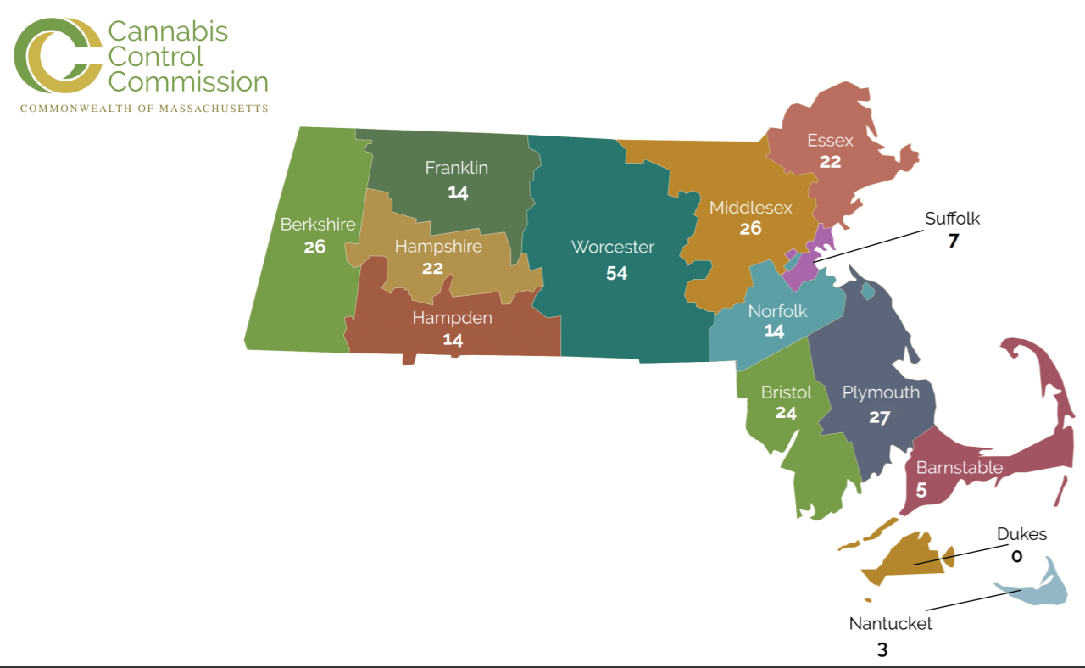

**Land Use**

One of the concerns that was highlighted in stakeholder interviews was the potential for the value of open space or agricultural land to rise with the shift from decriminalization to legalization. Higher land values make it difficult for communities to buy land to add to protected open space or for other agricultural workers to purchase land for crops that are less lucrative. According to the Massachusetts Land Parcel Database there are 1,472,000 acres of land classified as ‘Open Space.’ 1,334,000 of these acres are classified as ‘Permanently Protected Open Space.’ This leaves only .28% of the total 4,989,000 land acres in Massachusetts as non-protected open space. The map below highlights how little space that is compared to the total land area of Massachusetts. While it is possible that marijuana replaces (or displaces) other currently operating agricultural operations, these statistics show there is little space left in Massachusetts to expand its agricultural operations outdoors.

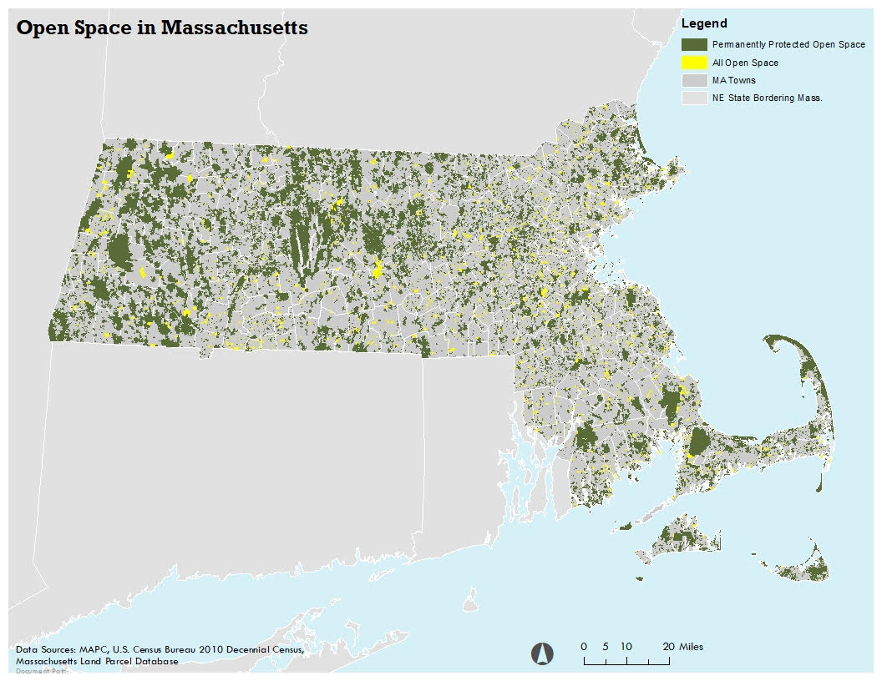

**Enforcement Statistics**

According to the [Massachusetts Crime Statistics](https://masscrime.chs.state.ma.us/tops/) database, drug case seizures for marijuana have declined by 68 percent between 2012 and 2018. This period only includes years post-decriminalization, which passed in 2008. We see one of the sharpest declines between 2016-2017, right after legalization passed in the Commonwealth.

The Massachusetts Cannabis Control Commission has released a few reports on the subject of enforcement as well. In their 2017 report, [*Impact of Drug and Marijuana Arrests on Local Communities in Massachusetts*](https://mass-cannabis-control.com/wp-content/uploads/2017/12/Impact-of-Drug-and-Marijuana-Arrests-on-Local-Communities-in-Massachusetts.pdf)*,* they highlight the impact of drug and marijuana arrests on local communities from 2006-2010. The ‘impact’ of arrests was measured by an index which gave 1/3 weight to economic conditions and 2/3 weight to arrest data. The following communities are deemed to be the ‘most impacted’ in the report. We see that the most severe impacts of marijuana arrests occurred in communities spread across the Commonwealth.

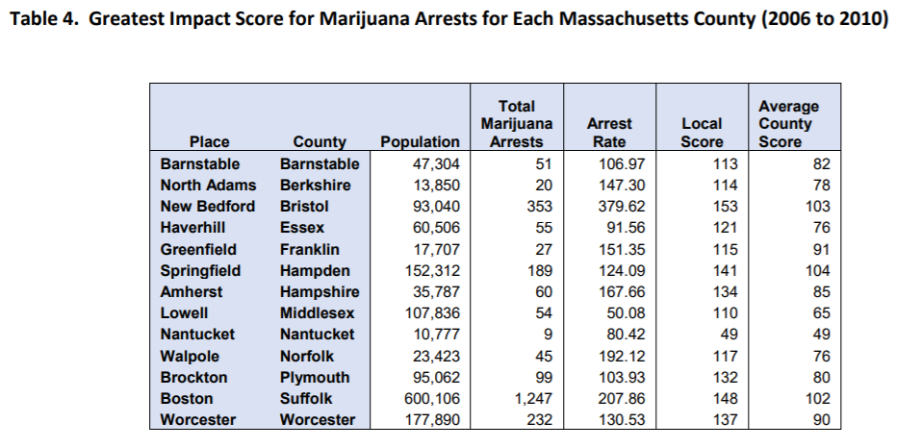

1. Community Policies

**State Policies**

A few of the key State Laws, Statues, and Regulations that set the context for the transition from decriminalization to legalization are highlighted and described below.

*Chapter 369 of the Acts of 2012* In 2012 “An Act for the Humanitarian Medical Use of Marijuana” was created. This law allowed “qualifying patients, physicians and helath care professionals, personal caregivers for patients, or medical marijuana treatment center agents” to be exempt from any state law punishment for the uses described in the law. This law defined who was able to be a medical “card holder” what conditions would apply for use, and the parameters in which medical marijuana was allowed.

*Chapter 334 of the Acts of 2016* In 2016 the “Regulation and Taxation of Marijuana Act” was put into place. This was enacted after a ballot initiative passed in the Commonwealth. The purpose of the act is to “control the production and distribution of marijuana under a system that licenses, regulates, and taxes the businesses involved in a manner similar to alcohol and to make marijuana legal for adults 21 years of age or older.” The purpose of the act was to make marijuana legal, and remove the “illicit market”.

*Chapter 55 of the Acts of 2017* “An Act to Ensure Safe Access to Marijuana” was created as an amendment to the 2016 act. This law set up the Cannabis Control Commission, a group of 5 commissioners, who are tasked with creating the systems under which marijuana sales will happen and be regulated.

*M.G.L. c. 94G: Regulation of the Use and Distribution of Marijuana Not Medically Prescribed* This chapter in Massachusetts General Laws outlines the context of local control, the role of the Cannabis Control Commission, and licensing of marijuana establishments.

*935 CMR 500.000: Adult Use of Marijuana* These regulations, created by the Cannabis Control Commission outline the adult use of marijuana in the Commonwealth including fees, registration of establishments, testing of products, inspections, regulation around edible products, and more.

**Local Policies**

As mentioned in the data section on “Dispensaries and Available Product”, there are many municipalities in Massachusetts that have banned the sale of marijuana outright. I would like to highlight specific rulings from two different municipalities to highlight how different local policies can be, even when marijuana is legal across the Commonwealth.

*Example 1: Stoneham, MA*

Stoneham is a northern suburb of Boston with a town meeting form of government. [In early 2018 17 speakers rose to share their opinion during a Special Town Meeting](https://patch.com/massachusetts/stoneham/stoneham-says-no-retail-marijuana) with one of the four topics being: Should the town ban the sale of recreational marijuana. Unlike other town meetings (which call for a show of hands), this discussion ended with secret ballots that were counted at the meeting. The chair of the Board of Selectmen at the time said “I think with the opioid crisis going on, I think the town sees that crisis going on and the last thing they want is to see this be part of another crisis.” Not only is the comparison of marijuana to opioids irresponsible, there was no acknowledgement that residents could use marijuana even if there is not a dispensary in the municipality.

*Example 2: Boston, MA*

Boston is the largest city in the Commonwealth of Massachusetts, and has step-by-step instructions [online](https://www.boston.gov/establishing-marijuana-business-boston) for how to establish a marijuana business in Boston. While the rules are clearly explained, the process is quite complex. First an applicant must complete an online form including details about the type of license and type of extractions the business may perform. The next step is to apply for a conditional use permit with the City’s Inspectional Services Department. If that is denied (and it most likely will be) the business owner must file an appeal with the zoning board of appeals and the Department of Neighborhood Services and Office of Emerging Industries will work with the owners to begin a community review process. After at least one public meeting, if the business is approved by the Boston Cannabis Board, the business will negotiate a Host Community Agreement and schedule a Zoning Board of Appeal date. Only after the zoning board of appeal approves the conditional use permit can the applicant start the state application process with the Cannabis Control Commission. If approved by the state, the owner can register as a business with the City of Boston. This quick overview of the process in Boston highlights how long this process can be and how many places in the process a business may fail.

1. Impact

The impact map below represents a theory of the impacts of the move from decriminalization to legalization in Massachusetts. While not all of these pathways are explored in this report, it is important to see the full scale of potential impacts due to a single policy. I will highlight only five of the many possible positive and negative effects of the move from decriminilzation to legalization in this section.

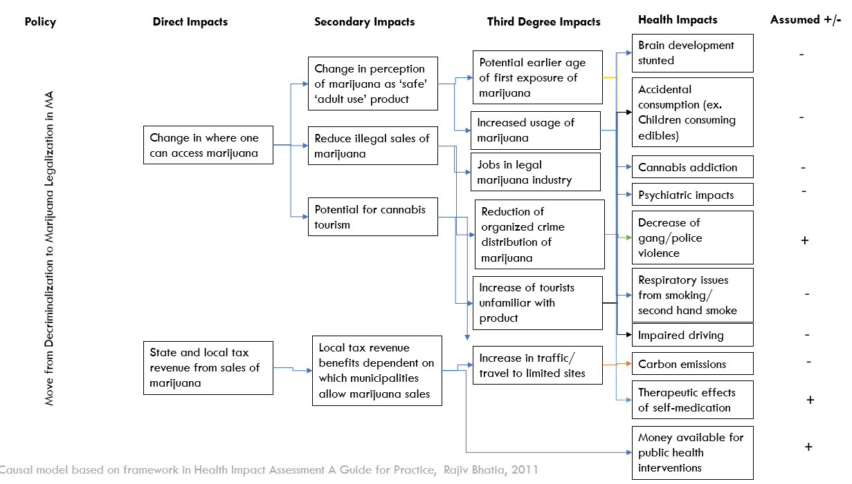

1. **The Creation of a ‘Big Marijuana’ Industry**

While the third degree impact of “jobs in legal marijuana industry” is potentially a positive impact of legalization, it can also be a potential challenge. One potential concern with the shift from decriminalization to legalization is the creation of “big marijuana” or large industries that control the market. Not only do large industries limit competition, take profits away from small business owners, and have the potential to create great lobbying power, large industries also usually encourage levels of unsafe use to increase their profits. In March 2019, because of concerns over extreme consolidation in the marijuana industry, the Boston Globe Spotlight team [published an exposé](https://www.bostonglobe.com/news/special-reports/2019/03/21/seahunter/okkkbXkh38kTkH9HDiiFXL/story.html?event=event12) that proved a corporation called Sea Hunter was getting around regulations that stated no company should own more than three marijuana shops in the state of Massachusetts by controlling many smaller companies. The CEO of one company, Acreage Holdings, was quoted in the article saying “The race to be the next Coca-Cola of cannabis is just beginning” The graphic below, from the Globe article, highlights how quickly one company can start to control multiple dispensaries.

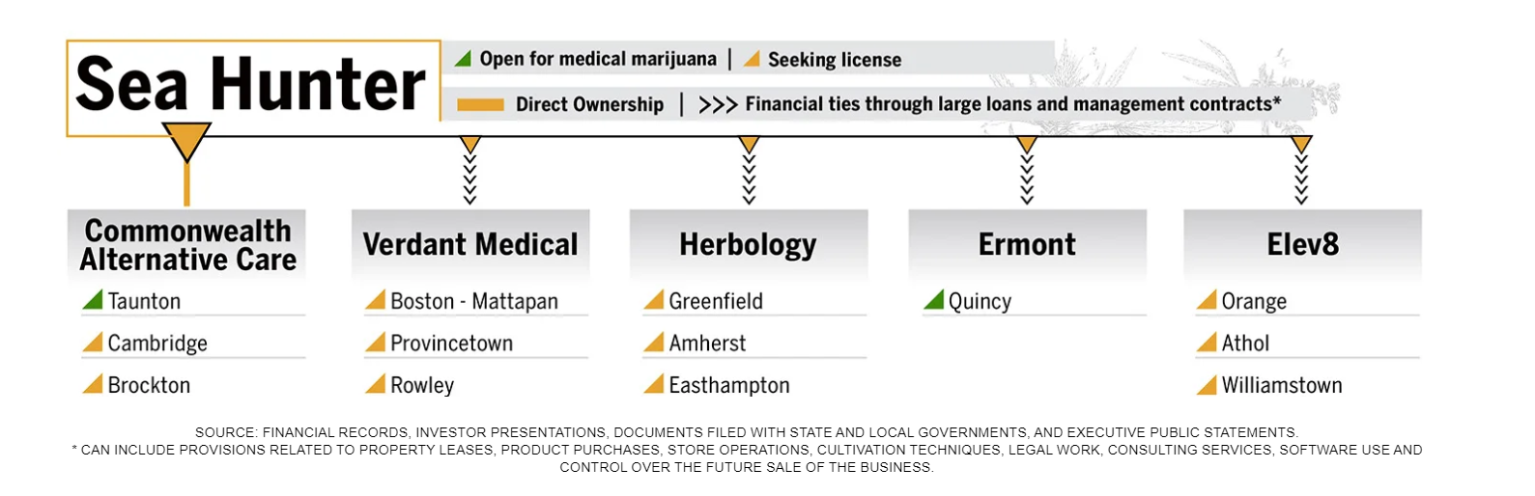

The legalization of marijuana has also created confusion about how a highly regulated, now commoditized, marijuana industry interacts with growers of hemp. In June 2019 the [Boston Business Journal reported](https://www.bizjournals.com/boston/news/2019/06/19/mass-cracks-down-on-cbd-roiling-the-emerging-hemp.html) Massachusetts outlawed the sale of products containing hemp-derived CBD, further regulating the industry. The next month products were forced offs shelves. There is currently [legislation proposed by State Rep. Marc Cusack](https://malegislature.gov/Bills/191/HD4339) which would undo that ruling by categorizing CBD as agriculture. The tension between marijuana as a controlled substance and final ‘product’ vs the plant material products can come from will be challenging as the marijuana industry becomes bigger and more corporate interests are involved.

1. **Increase usage of marijuana in youth**

Another major concern with the legalization of marijuana is the increased usage in marijuana in youth. Increased usage could happen both due to ease of availability, and general changes in attitudes towards marijuana. It has been proven that cannabis use among youth can have significant health impacts as well as social impacts. Youth use is more dangerous than adult use as young brains are still developing. The data section of this report highlights youth rates of marijuana usage in Massachusetts, and we find that Youth rates of marijuana usage in both the past year and the past month remain higher for Massachusetts than the Northeast region as a whole. It is still too early to see the impact of the move from decriminalization to legalization in the data, however we do know that [youth rates are actually declining](https://www.vice.com/en_us/article/wjzzj9/teens-are-smoking-less-weed-in-states-where-its-legal) in many states after legalization. It is unclear if this was due to increased public health campaigns and awareness, or other social reasons.

There are always challenges in communicating that a legal substance is harmful to youth and young adults. Teenagers especially like to test limits or think that once they reach a certain milestone (high school, 16, or 18) that they are then “adults”. One of the primary challenges is in convincing youth that the facts they are being told about cannabis research are true. The negative impacts of marijuana have been overstated for so long in American history, it may be hard to convince youth that we are, just now, telling the ‘real’ truth. In the DEA’s report, [*Preventing Marijuana Use Among Youth and Young Adults,*](https://www.dea.gov/sites/default/files/2018-07/DEA-Marijuana-Prevention-2017-ONLINE.PDF) national survey responses indicated that only 12% of 12th graders see experimenting with marijuana as entailing great risk and only 32% of 12th graders “perceive risk of harm from regular marijuana use.” It seems important to study and communicate to youth what the risks are in “experimenting” with marijuana at different ages and how these risks differ from long-term use.

1. **Increased usage of marijuana in adults**

Like increased usage in youth, increased usage in adults could occur due to a change in availability, or general changes in what is seen as “socially acceptable”. Adult marijuana use does not have the same public health impacts that youth use does, but all of the health impacts of long-term marijuana usage are not currently known. We do know that an increase in smoking marijuana can lead to breathing and lung issues, and marijuana usage can also lead to psychiatric impacts and a possibility of cannabis use disorder.

From the data section of this report we know adult marijuana use in Massachusetts has increased significantly from 2008-2009 to 2016-2017. This is before the first adult use dispensaries opened in Massachusetts, so we do not yet know the impact that legalization and ability to purchase at a dispensary will have on these numbers. The percentage of adults who have used marijuana in the past year also increased 41% over the same time period.

1. **Equity impacts of marijuana legalization**

The transition from decriminalization to legalization has been heralded by some advocates as another opportunity for the state to reverse some of the negative impacts the War on Drugs had on communities of color. Local policies, such as those in Cambridge and Boston, geared towards “equity applicants”, try to prioritize people of color for dispensary licenses and talk about how marijuana can be the next tool to achieve our racial equity goals. While this is an important start to a conversation, I think lawmakers, advocates, and other stakeholders need to be realistic about the impact one industry can have on society as a whole. Even if we only think about repairing the impact that the War on Drugs had on communities of color (ignoring all other racist policies), prioritizing applicants of color for marijuana dispensary licenses and expunging past records will not get us to what the world would’ve looked like without the War on Drugs.

The War on Drugs fractured the social fabric of communities, intensely added to the issue of generational trauma, and financially depressed communities and individuals by seizing assets, devaluing property, and taking away wealth generation opportunities. In the reading, [*Meet the Women Fighting to Ensure People of Color have a Stake in the Legal Marijuana Industry*](https://www.mic.com/articles/188622/meet-the-women-fighting-to-ensure-people-of-color-have-a-stake-in-the-legal-marijuana-industry), Mary Pryor was quoted saying “I honestly think that this is the last shot [at] generational wealth for people of color, given the way that the economy is about to shift and change.” While it is important to make sure that those who were involved in the illegal drug economy have a seat in this new industry and that other people of color who want a place at the table are given one, marijuana should not be the only option for entrepreneurs of color—particularly when marijuana is still illegal at the federal level.

1. **Available tax revenue for Public Health programming**

One of the ‘promises’ of marijuana legalization is the potential for large increases in local tax revenue. This potential benefit was certainly highlighted in my interview with a local Selectperson. It’s possible this tax revenue could be used for public health programming that goes above and beyond mitigating potential negative impacts of legalization. However, the Selectperson interviewed highlighted the need for this revenue to simply fill the gaps in current budgets, and pay for simple tasks such as “filling potholes”. Adult use marijuana in Massachusetts is subject to a 6.25% state sales tax, 10.75% state excise tax, and cities and towns can impose a local option of up to 3%. While 3% may not sound like a large amount, the potential for revenue is high. In the first two months of 2020 alone, [Massachusetts has sold $87.6M](https://opendata.mass-cannabis-control.com/stories/s/Sales-and-Product-Distribution/xwwk-y3zr) in legal cannabis sales. Since retailers opened in 2018, there has been $5.49M in total gross sales.

The article [Where does California’s Tax Revenue Go, You May be Surprised](https://www.mercurynews.com/2019/05/25/where-does-californias-cannabis-tax-money-go/), highlights the differences in the imagined and real uses of tax revenue from marijuana. Municipalities were promised drug abuse prevention, public safety, environmental protection, and economic to name a few. This article, which was written 1 ½ years after the start of legal sales, writes that most new tax revenues go into a general fund to pay for everyday needs. In addition to the use of funds, the amount of funds was severely overestimated in California, leading to disappointment among those who voted for legalization.

1. Recommendations

This report will focus on two of the identified impacts of legalization and propose recommendations for mitigating the negative impacts of legalization.

**Recommendations to limit usage of marijuana in youth**

1. **Invest in advertising campaigns and public health programming to communicate the known effects of marijuana**

To limit usage of marijuana in youth it’s imperative that communications are honest about the known harms of marijuana usage in youth bodies. The literature indicates when states legalize marijuana, the change around the potential risks of marijuana are real. Programs such as D.A.R.E. and other abstinence only and fear-based education policies are shown to be ineffective. It is necessary to reframe youth messaging about marijuana usage to be more about waiting until their brains are fully developed. The [Department of Justice report](https://www.dea.gov/sites/default/files/2018-07/DEA-Marijuana-Prevention-2017-ONLINE.PDF) on the issue highlights a myriad of impacts including physical and metal effects, impacts of school performance, and information about short and long term effects on the brain. Massachusetts should find effective ways to communicate this information to youths in school and through other public interest campaigns.

1. **Limit products that cater to youth**

It is important both to limit products that may be consumed by youth on accident, and products that are specifically marketed to youth. In terms of regulations this can mean altering the appearance, packaging, labeling, or flavors of products sold. Products such as marijuana infused candy and baked goods are most likely to be accidently ingested, and if they are allowed to be sold should have very clear, child-proof packaging and clear labeling about their effects and dosage of THC and/or CBD. There is precedent for these standards in the State of Massachusetts. In 2019 Massachusetts [also banned retail sales](https://www.wbur.org/commonhealth/2019/11/27/explainer-flavored-tobacco-vaping-law) of flavored tobacco including cigarettes and vape products. The law was put in place to restrict underage use of nicotine products, as we know youth are more drawn to sweet, candy-like flavors.

1. **Use tax policy to keep the price high**

Youth consumers have an extremely elastic demand for products given the constraints on their financial resources. Even though youth are not legally allowed to purchase marijuana, taxes in the legal market should reduce use among youth by increasing resale prices. A [report](https://pediatrics.aappublications.org/content/pediatrics/135/6/955.full.pdf) from the American Academy of Pediatrics also recommends this approach, citing that taxes on cigarettes and alcohol work in similar ways to reduce underage use of those products.

1. **Develop strict advertising standards for businesses**

The effects of advertising have been well documented. The tobacco industry has gone through a long series of limited advertising, including the [ban of television and radio in 1970 and](https://www.politico.com/story/2018/04/01/congress-bans-airing-cigarette-ads-april-1-1970-489882) a ban from paid cigarette product placement in 1991. Youth exposure to marketing around marijuana should also be limited. According to a [report](https://pediatrics.aappublications.org/content/pediatrics/135/6/955.full.pdf) from the American Academy of Pediatrics, advertising can lower the perception of risk and increased social desirability. Massachusetts should explore limiting the form of advertising of marijuana products. The first steps may be banning marijuana advertising on public transit, on TV shows targeted to youth, and by paid influencers on social media.

**Recommendations to prevent the creation of a “Big Marijuana” industry**

1. **Enforce regulations about how many businesses can be owned at a time and invest in tracking systems for business owners and investors**

The State of Massachusetts does currently have regulations trying to address the issue of “Big Marijuana.” Right now regulations state no company should own more than three marijuana shops in the state of Massachusetts. However, by controlling many smaller companies, some companies seem to be getting around this. The issue then, lies in tracking systems for owners and investors. I believe the best way to track this information may be through a collection of business filings as well as tax returns. Even if someone is a “silent investor” in multiple companies, it is still important for the State to track that information given the potential for big industry takeover.

It is also important to keep track of who related to the marijuana industry is involved in lobbying groups. According to a VOX article published in 2016, at the time at least five out of ten people on the board of directors for MPP, the Marijuana Policy Project, had direct ties to the industry. While it is not necessary wrong for industry leaders to be stakeholders in policy discussions, they should not be leading the conversation. Marijuana industry has a immediate motive to prioritize profits over public health interests. In fact, companies directly profit off of those abusing the substance.

1. **If Massachusetts would like to continue with privately owned businesses, promote worker owned co-ops and extend lines of credit to those without easy access to banking**

A shift towards worker owned co-ops would address two major impacts of marijuana legalization: an opportunity to create opportunity for communities most impacted by the War on Drugs and an opportunity to subvert ‘Big Business’ marijuana investors. Worker co-operatives are businesses where employees and workers own an equal part of the business, vote on how the business is run, and share in profits. Worker/owners are directly interacting with the community they serve and understand the impact their product has on users. While these workers may still have an incentive to promote over-use of marijuana, that is a function of creating a for-profit industry more than anything else.

Massachusetts already has legislation for cannabis “craft cooperatives”, but not a single one has been licensed. A large part of this may be due to access of capital. It is not enough for Massachusetts to allow cooperatives, they must also promote them and create funding sources for those who have a difficult time getting access to credit. Massachusetts should also reduce restrictions on who can enter the legal marijuana industry. Right now restrictions on those with previous arrest records prevent those most impacted by the War on Drugs from taking advantage of this new industry.

1. **Investigate the possibility of creating State run marijuana distribution network**

While current federal restrictions would make this difficult, Massachusetts should start investigating the possibility of State run marijuana distribution. A similar idea was [recently proposed in Mexico](https://mexiconewsdaily.com/news/state-owned-company-to-control-marijuana-sales/). The state would have the exclusive authority to purchase marijuana from legal producers and sell it to authorized retailers. Another possibility would be for Massachusetts to run the dispensaries themselves, similar to liquor stores in Virginia and New Hampshire. The benefit of this idea is that the cannabis market wouldn’t be left to autonomous regulation who have a profit incentive for over-consumption. It could also prevent large companies from dominating the market. Another [article from 2014](https://www.governing.com/topics/mgmt/gov-states-marijuana-sellers.html) points out the flaws in regulating marijuana like alcohol, similar to the way Massachusetts is functioning right now. The primary flaw is that profits depending on expanding consumption, which is not usually in the public health interest of the population.

1. Next Steps

The next step is to share these recommendations with stakeholders and identify points of action. One of the main stakeholders to discuss these recommendations with is the Cannabis Control Commission. The Commission has the ability to change regulations at the State level and can make sure these potential health impacts are an important part of the conversation. Another important set of stakeholders to engage with these recommendations are municipal leaders and CEOs who may be negotiating community host agreements with dispensaries.

Last, it is important to highlight the importance of engaging with local advocacy organizations and leaders in communities that were most impacted by the War on Drugs. As highlighted in the Impact section of this report, having “equity priority applicants” will not be enough to make up for historical wrongs. It’s important to ask communities what they hope to get out of this newly legal industry and start talking about what the money generated from this newly legal industry will be used for.