Naser Alawadhi

MGMT 445

Homework 2: Organizational Structure

January 24, 2021

Word Count: 1319

Portland State University is a public research institution located in Portland, Oregon. The institution began in 1946 as a post-secondary educational center for veterans returning from World War II. Over the next two decades, the institution grew to become a four-year college. It was later recognized and granted a university charter in 1969. Portland State University is the only Oregon Public University system located in an urban setting (Board of Trustees, Portland State University website, 2021). Portland State University creates its value by promoting access, inclusion, and equity in its pillars of excellence. The public institution is committed to curiosity, collaboration, stewardship as well as sustainability. The university strives for excellence and innovation to solve arising problems. Additionally, everyone in the university is treated with integrity and respect, transforming them through connections and real-world engagement.

The university consists of seven constituent colleges. In these colleges, the university offers undergraduate and postgraduate degree programs in "200+ degree and certificate programs" (Portland State University Website, 2021). The university is well-acknowledged for its spectacular University Studies curriculum, which ends with a final year dissertation that all undergraduates write to graduate. The capstone project integrates class work with community-based work and is completed with local community organizations' help.

The university is governed by a Board of Trustees, which is chosen by Oregon's Governor. The institution employs various academic staff. As of Fall 2019, PSU employed 1,796 employees in research and instructional faculty, 742 educational experts and managers, 91 in administration, 680 in staff, 680 graduate assistants, 2,019 student employees, and 355 employees classified as "other," which is a total of 6,338 employees (Portland State University website, 2021). The behavior and the expectations the university places on its employees are governed by Oregon Administrative Rules (OAR) and Oregon Revised Statutes (OAS). The employees have three unions; Service Employees International Union (SEIU) Local 503, American Association of University Professors (AAUP), and the American Federation of Teachers (AFT) Local 3571 (Current Employees, Portland State University website, 2021). The three unions represent classified workers, full-time faculty, and adjunct faculty, respectively.

Portland State University's location is in downtown Portland, Oregon, in the United States of America. The university's setting is urban, and the campus sits on 50 acres of land. It is located against the West Hills and bound by Clay Street, Fourth Avenue, Interstate 405, and 12th Avenue to the North, East, South, and West, respectively.

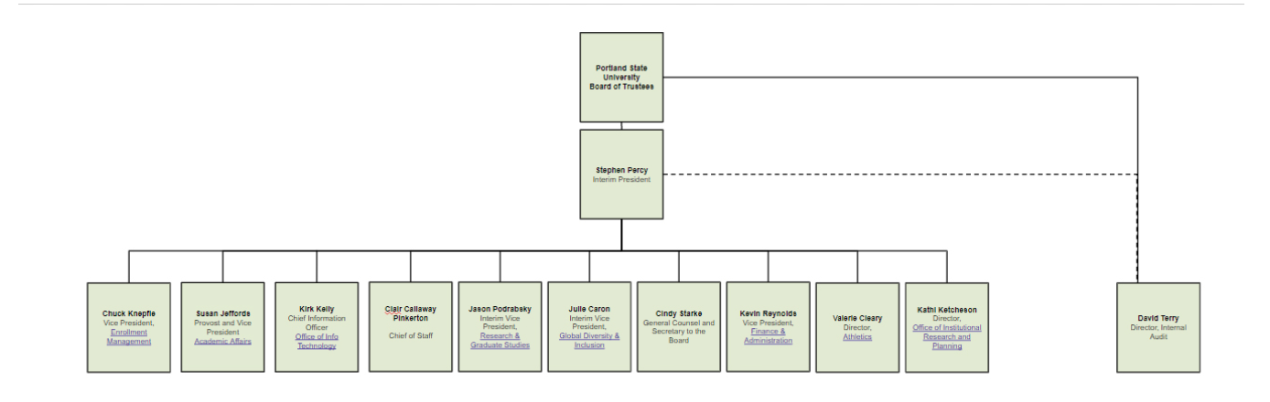*Figure 1*: Portland State University Organizational Chart, 2021.

According to the PSU organizational chart there are three levels within the organizational hierarchy. The institution is governed by a volunteer Board of Trustees composed of 15 members. The Board is mandated with the responsibilities of managing the university as required by state laws that establish the university. It is headed by the President, an ex-officio, and the only non-voting member on the Board. Additionally, the Board consists of one faculty member, a staff member, and one university student. All trustees of the Board earn their positions through the Governor of Oregon except the President. The chief of staff, general counsel, secretary to the Board, and internal audit director are amongst this Board's trustees. The other trustees lead various departments, including; enrolment management, academic affairs, the office of info technology, research and graduate studies, global diversity and inclusion, finance and administration, athletics, and office of institutional research and planning (Board of Trustees, Portland State University website, 2021).

The university's central role and function are to offer undergraduate and postgraduate students degrees. Its classification lies among "R2: Doctoral Universities undertaking high research activity" (Carnegie Classification of Institutions, 2019). Most of the Board of Trustees' work occurs through committees that meet continuously throughout the university's academic year to ensure that the institution is running smoothly. The Board's members elect their Chairs as well as Vice-Chair. They are also mandated to employ and evaluate University President and create its mission and strategic plan.

Additionally, they develop the tuition and fee rates, approve university's budget and debt's incursion, and undertake other works as necessary. All committees have members and are well-funded to undertake their duties effectively. Each college has different departments where employees have specific tasks to perform. The public institution has adequate employees, with 6,338 employees whose job is to perform organizational tasks and help the university achieve its goals (Portland State University Website, 2020). The Human Resource department ensures fair division and allocation of labor and resources, examines problems arising in different departments, and solves them effectively. The institution's divisions are established by product line because each college and department contains students taking related courses and workers performing similar tasks.

The organizational structure of Portland State University would be considered a tall one. The university consists of seven constituent colleges, and it is governed by a volunteer Board of Trustees composed of 15 members. There is various middle management between the President of the Board, staff, and university executives. The institution experiences multiple problems associated with vertical organizational structure. Trustees are entirely appointed by the Governor of Oregon except for the President. Additionally, they have to be confirmed by the Oregon Senate. This makes the appointment process of the members too much detailed and hierarchal. The faculty, staff as well as student members of the Board, serve for two-year terms, while the others are appointed to serve for four years (Board of Trustees, Portland State University website, 2021). This short period of appointment and vertical hierarchal nature of the institution make promotions too hard for the Board members. Communication problems also arise within the institution due to the barrier of a long chain of command (Jones, 2013, p.155). All these are problems that come along with a vertical organization structure.

Decision making at Portland State University is centralized. Centralized decisions are made by the people at the organization's top, which according to Jones, means that the power, authority, and ability to make significant decisions and influence the organization are held by people at the top of the hierarchy. For example, the board of trustees has more authority and influence than those who are lower in the organizational hierarchy (Jones, 2013, p.126). At PSU, the board members establish the university's mission and strategic plan, calculate tuition and fee rates, approve the budget and debt's incursion, and perform other managerial tasks.

Portland State University has standardized operations. There is a framework of agreements in the university where all relevant parties adhere to ensure that the university's processes run smoothly. This framework creates a sound performance of the university within set guidelines. The university's operations are standardized through its vision, mission, values, and code of ethics. The standardized functions enable the university employees to be committed and contribute to the highest level to support their mission. The standards also ensure a competitive rate of employee recruitment and retention.

The integrating mechanisms used at Portland State University include; a hierarchy of authority, direct contact, and team mechanisms (Jones, 2013, p.121). In the hierarchy of authority, Stephen Percy is the President of the University and deputized by a vice president. The President is ranked as the top employee, and there is a hierarchy that specifies who reports to whom. The direct contact mechanism is where managers meet face to face and coordinate activities. At Portland State University, the Board meets at least four times face-to-face every academic year to coordinate activities. In team integration mechanism, managers meet in permanent committees meet regularly to coordinate activities. There are various permanent committees at PSU that meet regularly throughout the year to coordinate activities mandated to them by the Board of Trustees.

Considering all of Portland State University's structural characteristics, their organizational structure can be considered a mechanistic one. This is because employees in different schools work and specialize in various defined tasks. The hierarchy of authority is well-defined and is the university's primary integrating mechanism (Jones, 2013, p.131). Additionally, the authority to control the university's operations is kept at the Board of Trustees, which is at the top of the President's organization.

**References**

Board of Trustees, Portland State University. (2021). Retrieved 21 January 2021, from <https://www.pdx.edu/board/>

Current Employees, Portland State University. (2021). Retrieved 21 January 2021, from <https://www.pdx.edu/human-resources/current-employees>

Doctoral Universities, The Carnegie Classification of Institutions (2019). Retrieved 22 January 2021, from

<https://carnegieclassifications.iu.edu/lookup/srp.php?clq=%7B%22basic2005_ids%22%3A%2216%22%7D&start_page=standard.php&backurl=standard.php&limit=0,50>

Homepage, Portland State University. (2021). Retrieved 21 January 2021, from <https://www.pdx.edu/>

Jones, G. R. (2013) *Organizational Theory, Design, and Change (7th ed.)*, Pearson College Division.

University Facts, Portland State University. (2021). Retrieved 21 January 2021, from

<https://www.pdx.edu/portland-state-university-facts>