**APA 7th Edition Basics**

* **Paper**: Your paper must be word-processed on unlined 8 ½″ x 11″ white paper.
* **Margins**: Use 1″ margins on all sides of the page.
* **Student APA papers must consist of a (1) cover page, (2) essay, and (3) reference page:** Each section of the paper must begin on a separate page.
  + **Abstracts** are only needed if an instructor specifically requests that you have one, and it would only be for a lengthy paper—such as a Capstone.
  + The title of the paper must appear on the third page, prior to the start of the body of the paper, centered and in bold.
* **Text:** accepted fonts are:
  + Times New Roman 12 pt.
  + Georgia 11 pt.
  + Calibri 11 pt.
  + Arial 11 pt.
  + Lucida Sans Unicode 10 pt.
* **Spacing**: Double space your entire paper, including: headings, long quotations, and references.
* **Page header**: In APA 7th edition student papers no longer requires a “running head,” only the page number in the upper right-hand corner is needed
* **Indentions**: Indent one-half inch from your left margin. (one tab), except for the abstract—this paragraph must start flush left.
* **References**: Your references should begin on a new page separate from the text of the essay; label this page "References," centered at the top of the page, bolded. References must be ordered alphabetically by the author(s) last name.
  + Double space the entire page—there should be no extra spaces between references.
  + All lines after the first line of each entry in your reference list should be indented one-half inch from the left margin. **This is called hanging indentation.**

**Any information, including ideas, theories, or research that is not your own, or has directly influenced your writing, must be cited within the body of your paper and have a corresponding reference on the reference list**.

**General Format:**

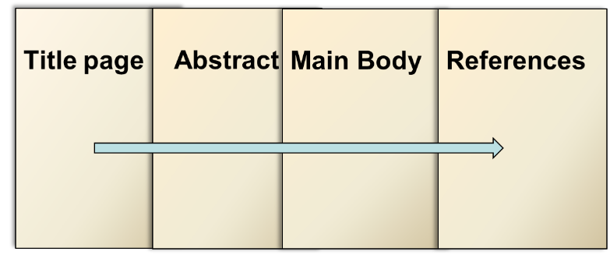

**Only if *specifically* requested!**

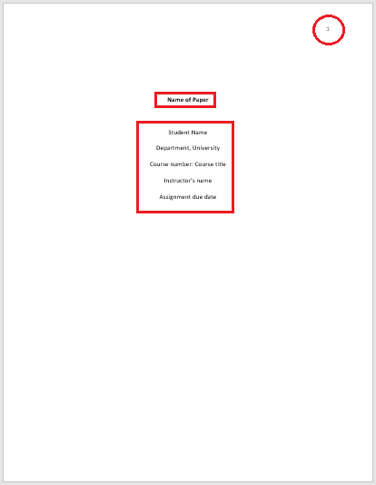**Title page format:**

* Page number in the right-hand corner of the page header
* Title of paper- Bold and center (beginning four lines down the page)
* Skip a line
* Student name(s)
* Department and University
* Course name and number
* Instructor of class
* Assignment due date

**Text (Body)**:

* The body of the paper should start on a new, separate page following the title page.
* **The title of the paper should appear on the first line on the first page of the text, bold and centered**
* 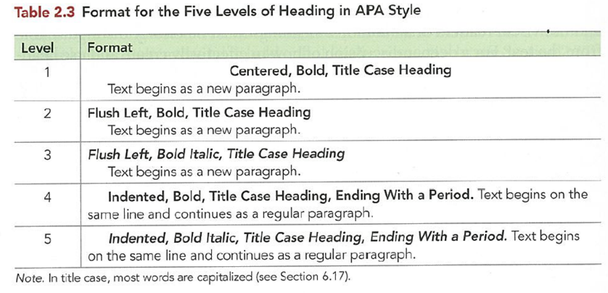A brief student paper may not have any headings, and if they do, they should follow the standard 5 level headings

**In-Text Citations**

**APA In-text citation basics**

* When using APA 7th ed. format, follow the author-date- (and page number when applicable) method of in-text citation.
* **All sources that are cited in the text must have a complete reference at the end of the paper and any source listed on the reference page must have a corresponding in-text citation.**
* The sentence punctuation always appears *after* the closed parenthesis. This is to show that the in-text citation belongs to that exact statement.
* If possible, cite an electronic document using the author-date style.
* **If a date cannot be found, use “n.d.” for no date.**
* **If the source does not have any page numbers, identify the location of the quoted material by paragraph (para), for example: (Jones, 1998, para. 3).**

**Direct Quotes:** When using word-for-word quoted material from an outside source, refer to the author(s), year of publication, and the page number (or paragraph number). For example:

* (Smith, 2018, p. 3).
* (Smith, 2018, para. 7).

Introduce direct quotations with a signal phrase:

* According to Jones (2018), “Students often had difficulty using APA style, especially when it was their first time” (p. 199).

If the author is not named in a signal phrase, place the author's last name, the year of publication, and the page number in parentheses after the quotation:

* She stated, "Students often had difficulty using APA style" (Jones, 1998, p. 199).

**Long direct quotations:** Use long quotations sparingly, and only if the language is so exact/perfect that it must be used within your work.Place direct quotations that are 40 words or longer in a free-standing block of typewritten lines and omit quotation marks, double space. Start the quotation on a new line, indented 1/2 inch from the left margin. The parenthetical citation should come after the closing punctuation mark.

**Indirect Quotes (summaries and paraphrases):** If you are referring to an idea from another work, but NOT directly quoting the material, you only must refer to the author and year of publication and not the page number in your in-text citation. For example:

* (Smith, 2018).

**Number of authors to include in the in-text citation:**

* The format of the author element of the in-text citation changes depending on the number of authors—it is abbreviated in some cases.
  + For a work with one or two authors, include the authors name(s) in every citation, using a & between the names, for example: (Jones & Smith, 2019).
  + For a work with three or more authors, include only the name of the first author plus “et al.” in every citation—including the first, for example: (Williams et al., 2019).
* In parenthetical citations, use an ampersand (&) between names
* In narrative citations, spell out the word “and”

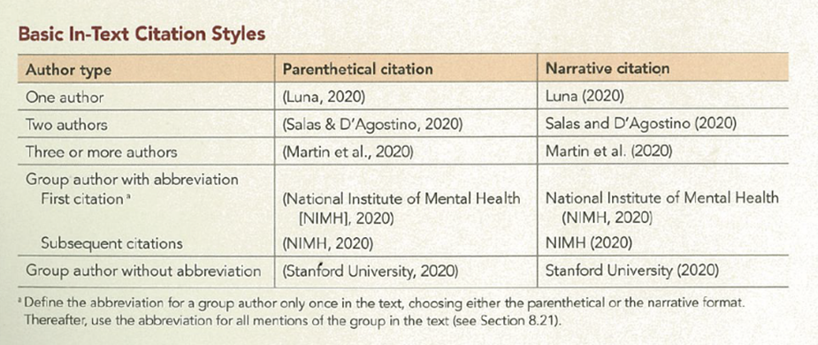

**Organization as an Author:** If the author is an organization or a government agency, mention the organization in the signal phrase or in the parenthetical citation the first time you cite the source. If the organization has a well-known abbreviation, include the abbreviation in brackets the first time the source is cited and then use only the abbreviation in later citations.

* First citation: (National Institutes of Health [NIH], 2020)
* Second citation: (NIH, 2020)

**Unknown or Anonymous Author**: For works with an unknown author, include the title and year of publication in the in-text citation (note that the title moves to the author [position in the reference list entry as well). For example:

* Magazine article with no author: (“Understanding Sensory Memory,” 2018)

**Personal Communication**: For interviews, letters, e-mails, and other person-to-person communication, cite the communicator's name, the fact that it was personal communication, and the date of the communication. Do not include personal communication in the reference list.

* (E. Robbins, personal communication, January 4, 2001).

**Citing Indirect Sources:** If you use a source that was cited in another source, name the original source in your signal phrase. List the secondary source in your reference list and include the secondary source in the parentheses.

* Johnson argued that ... (as cited in Smith, 2003, p. 102).

**References**

*It is important to note that if you were previously using APA 6th edition, there are a few format changes made to the 7th edition update, here is a brief list, and you will find examples of it being used below.

* Each reference can include the surnames and initials for up to 20 authors (instead of 7) on the reference list.
* Publisher location is no longer included in the reference for books.
* URLs are no longer preceded by “Retrieved from,” unless a retrieval date is needed. The website name is also included, unless it’s the same as the author.
* Websites should remain hyperlinks.
* DOIs are formatted the same as URLs. The label “DOI:” is no longer necessary.
* For ebooks, the format, platform, or device (e.g. Kindle) is no longer included in the reference.

**Two or More Authors:**

Last name, Initial, & Last name, Initial.

**Book:**

Last name, Initials. (date). *Book title*. Publisher.

* Pincus, M. (2005). *Managing difficult people*. Adams Media.

**Online book:**

Author, A. A. (Year). *Title of book.* Publisher. <https://doi.org/XXXXXX>

**Book Chapter:**

Last name, Initial. (date). Chapter title. In Initials, Last name (Ed.), *Book title* (pages). Publisher.

* Haybron, D. M. (2008). Philosophy and the science of subjective well-being. In M. Eid & R. J. Larsen (Eds.), *The science of subjective well-being* (pp. 17-43). Guilford Press.

**Book with an editor:**

Editor, A. A. (Ed.). (Year). *Title of book.* Publisher.

**Entries in Online Encyclopedias:**

*If the author is the same as the website, omit the website component.

Author, A. A. (Year). Title of entry. In A. Editor (Ed.), *Title of reference work* (xx ed.). Website. <http://xxxxx>

**Journal Article:**

Last name, Initials. (date). Title of the article. *Title of the Journal, volume*(issue), pages.

* Levey, T. (2010). The effect of level of college entry on midcareer occupational attainments. *Community College Review, 38*(1), 3-31. <https://eric.ed.gov/?id=EJ888966>

**Article from an Online Periodical with DOI Assigned**:

Author, A. A., & Author, B. B. (Date of publication). Title of article. Title of Journal, volume number, page range. <https://doi.org/10.0000/0000>

**Website:**

Last name, Initials. (date). *Title*. Website name. URL link

* Friedland, L. (2008). Top 10 natural and wildlife adventure travel tips. Adventure Travel. [http://adventuretravel.about.com/od/ecotourism/tp/Nature---WildlifeAdventures.htm#](http://adventuretravel.about.com/od/ecotourism/tp/Nature---WildlifeAdventures.htm)

**Organization as Author:**

*\*\*If the organization is the author, the name should take the place of the author—if the organization is the same name as the title of the website, do not repeat it following the title of the specific page, for example:*

Mayo Clinic. (2010). *Diabetes: Symptoms and Causes*.

<https://www.mayoclinic.org/diseases-conditions/diabetes/symptoms-causes/syc-20371444>

**Website, No author***:*

*\*When referring to a source that does not have a specific name, refer to the page title as an author. The corresponding in-text citation will be the page title in quotation marks. For example,* Reference:

*Appeal to authority*. (n.d.). Logical Fallacies. [https://www.logicalfallacies.org/appeal-to authority.html](https://www.logicalfallacies.org/appeal-to%09authority.html)

In-text citation:

(“Appeal to authority,” n.d.).

**Online Lecture Notes and Presentation Slides:**

*\*When citing online lecture notes, be sure to provide the file format in brackets after the lecture title (e.g. PowerPoint slides, Word document).*

Author, A. A. (year). *Title of Presentation in italics* [Lecture notes or Power Point]. URL

**Government Report:**

Author, A. A. (Year). *Title of report* (Report No. xxx). Website. <http://xxxxx>

**Press Release:**

Author, A. A. or Organization. (Year). *Title of press releas*e [Press release]. <http://xxxxx>

**Photograph:**

Photographer, A. A. (copyright year). *Title of photograph* [Photograph]. Website. <http://xxxxx>

**YouTube Video or Video Blog Entry:**

Online videos are cited similarly to the other types of digital media described above. However, because the creators of digital videos often go by pseudonymous screen names, this information is included after the author's name.

The general format is as follows:

* Author, A. A. [Screen name]. (year, month day). *Title of video* [Video]. <https://www.someaddress.com/full/url/>

If no author name is available, or if the author's name is identical to the username, leave it out. In this case, do not put the username in brackets.

* PBSoffbook. (2013, October 3). *How to be creative* [Video file]. <https://www.youtube.com/watch?v=weIQIthC3Ks>

**Films:**

Director, A. A. (Director). (Year). *Title of video*[Film]. Production Company.

If you have any questions, please don’t hesitate to contact your campus Writing Studio Coordinator, Dr. Brittain at [kbrittain@keiseruniversity.edu](mailto:kbrittain@keiseruniversity.edu) or 561-471-6000 (ext. 6160).

