Introduction draft: Protecting Individuals Accounts and Emails

Table of Contents
Abstract 3
Description of the Problem 4
Objectives of the Study 5
Purpose Statement 5
Research Questions 6
Literature Summary 6
Description of Audience 8
Definition of Terms 8
Conclusion 8
References 10

Abstract
In contemporary society, hackers have begun to innovate sophisticated ways to hack into personal emails, bank accounts, social media accounts, and other sensitive information. Many internet users are victims of phishing, social engineering, denial-of-service attacks (DoS), man-in-the-middle (MitM), password attack, eavesdropping, SQL injection, and drive-by attack. As cybercriminals continue to come up with various ways to impersonate legitimate users, there is a need to conduct intensive research on protecting individuals accounts and emails. This study describes the problem of hacking of individuals accounts and emails, purpose statement, a summary of past literature, and targeted audiences.

Description of the Problem
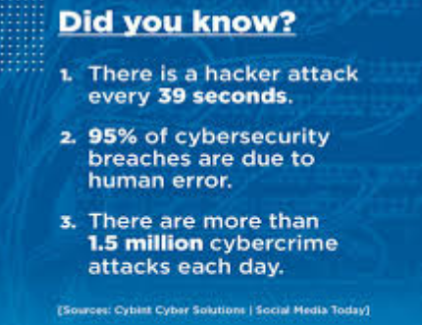
The problem of hacking of individual accounts and emails has been on the rise for the past decade. A report by Security Magazine indicated that in every 39 seconds, there is a hacker attack targeting accounts and emails. Breach Level Index report indicated that in every second, hackers steal 75 records, including individuals’ passwords, usernames, and other sensitive information. According to Fortune, approximately 66% of businesses that have been attacked by cybercriminals were not confident in recovering the stolen data. In 2017, research by Independent Magazine established that more than 25 million Yahoo and Gmail accounts were being sold on the dark web. According to HackRead, hackers were selling 21,800,969 Gmail accounts for just $450 on the dark web.
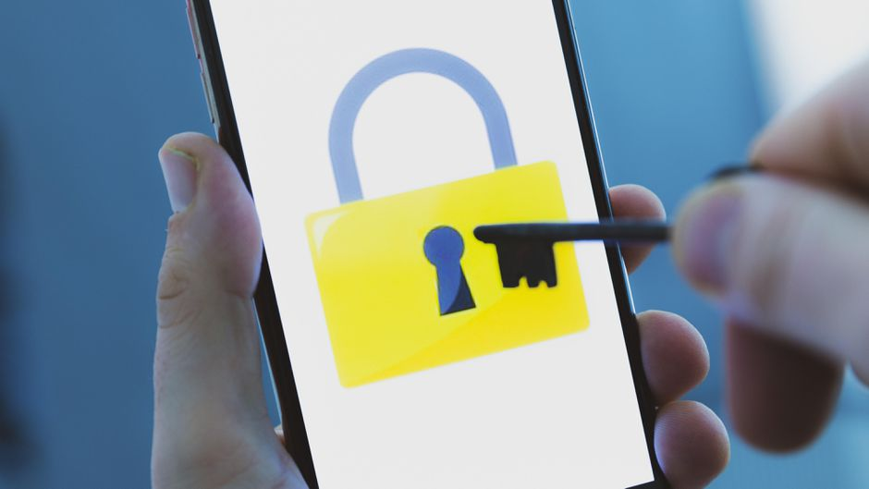
With the rising number of individuals accounts and emails being hacked by hackers, this study tries to address the loopholes or vulnerabilities leading to accounts and emails being compromised. The main issue in this study is that many individuals have not implemented strong passwords systems that can help to safeguard their accounts and emails from hackers . Although services providers such as Google, Yahoo, Facebook, PayPal, among others have tried to protect users’ accounts and emails, most of the users do not understand the importance of having strong passwords, data encryption, biometric authentication (fingerprint), two-factor authentication (2FA), strong anti-malware and antivirus software, and verification calls.
This study is relevant because it helps internet users to understand the best ways to safeguard their accounts and emails against cyberattacks. It informs internet users on the importance of being careful about who they share their accounts or emails with. It is important to understand that cybercriminals or hackers have started to masquerade as real web providers in order to steal accounts and emails from unsuspecting users. Also, the study assists internet users to be aware of ways cybercriminals are using to steal their emails and accounts. For example, hackers have started to use email phishing, where they send an email that appears to be from a legitimate user or company asking for sensitive information.

Objectives of the Study
The major objectives of this study are as follows: (1) analyzing the types of vulnerabilities that cause accounts and emails to be infiltrated by hackers, (2) identify the impacts of cyberattacks on individuals’ accounts and emails, (3) assess the best mechanisms to protect against cyberattacks, and (4) provide recommendations that can help individuals to protect their accounts and emails against cyberattacks.

Purpose Statement
The purpose of this study is to describe major vulnerabilities leading to individuals’ accounts and emails being compromised, highlight mechanisms used by hackers to compromise accounts and emails, and help internet users understand the best ways to protect their accounts and emails against cyberattacks. By the end of this study, the level of cyber awareness will have increased and internet users will be in a position to safeguard their accounts and emails against cyberattacks.

Research Questions
- How can individuals’ accounts and emails be protected from being infiltrated by cybercriminals?
- What vulnerabilities do hackers use to compromise individuals’ accounts and emails?
- How do strong security systems help to protect hackers from infiltrating individuals’ accounts and emails?

Literature Summary
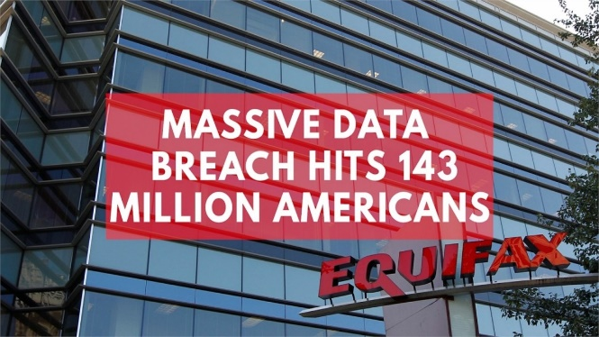
A journal article by Bloom, a senior editor of the St. John’s Law Review, to examine the case of Equifax where sensitive information of more than 143million Americans was allegedly compromised, established that cybercriminals steal sensitive data such as credit information, emails, passwords, and social security numbers to impersonate legitimate users with creditors and lenders (Bloom, 2018). Bloom noted that lack of proper security measures can lead to loss of sensitive information as was witnessed at Equifax. Although the study depicted clearly the severity of the situation at Equifax after the cyberattack, the research failed to provide solutions that can be used to avert such as kind of situation. Also, the study is narrowed to one entity and thus limited the scope of the study. Despite the research gap, the study by Bloom informs the current study (my study) because it provides multidimensional approaches to manage cyberattacks on individuals accounts and emails from hackers.
A scholar article by Kumar, Assistant Professor, Department of Computer Science, Sangam University, with Agarwal, co-author, to examine the methods used by ethical hackers to compromise users’ accounts and emails, established that hackers access sensitive information by cracking encryptions and passwords instruments using hacking tools such as NMAP, METASPLOIT, AIRCRACK-NG, BURP SUITE, among others. Although the study by Kumar& Agarwal (2018) shed light on the tools and methods used by hackers to compromise accounts, the study failed to suggest the best mechanism to protect against cyberattacks. Despite the limitation (research gap), this study contributes to the topic of research (my study) because it helps in highlighting the correlation between ethical hacking and the protection of individuals’ accounts and emails.
The article by Poole, a lecturer at Mississippi College with his colleagues Corkern and Hoffman from the same institution established that every internet user is susceptible to hacking, thus they should take measures to ensure that their data, including social security numbers, debit and credit cards, personal information, and passwords are protected. Poole, Corkern, & Hoffman (2018) suggest the importance of having strong passwords, fingerprint identification, and the use of antiviruses. In the study, the authors failed to validate how suggested security measures go about in protecting individuals accounts and emails from cybercriminals. this study contributes to the topic of research (my study) because it provides vital information that can be used to back up the claim on the importance of having strong passwords fingerprint identification.
In a longitudinal measurement report by Thomas, an IT expert at Google Inc. with co-author, established that approximately 12.4 people are potential victims of phishing kits, and more than 1.9billion passwords and usernames are exposed to data breaches. The conference report suggests the importance of hardening authentication mechanisms by including additional security and risk signals that provide a warning based on a user’s device profiles and historical geolocations. In this research, Thomas et al. (2017) data are only narrowed to Google accounts. Although the scope of the study is narrowed, it is important to my study because it helps to explain to readers on the severity of the problem.

Description of Audience
The target audiences of this study are internet users and specifically those who are using their accounts and emails to access e-commerce services, share information with credits and lenders, or seeking other internet services that could expose them to hackers. Companies, small businesses, and government agencies stand to benefit from this study because they would understand ways to protect customers’ accounts and emails.

Definition of Terms
Phishing is the act of sending emails that appear to be originating from a legitimate user or company soliciting for sensitive information. Eavesdropping occurs through the interception of network traffic of a website. A denial-of-service attack (DoS) occurs when a hacker bombards the website with a lot of data in order to stop it from responding to service requests. A man-in-the-middle (MitM) occurs when a hacker stays in the middle of communications between a server and a client. The password attack occurs when a hacker obtains passwords by gaining access to a password database “sniffing", or looking around the desk of a legitimate user. SQL injection occurs when a hacker executes a SQL query on the database. A drive-by attack occurs when a hacker plan ta malicious script into PHP or HTTP of unsecured websites.

Conclusion
Protection of individuals accounts and emails is critical in minimizing sensitive information from being acquired by cybercriminals or hackers. The literature summary reveals that using use strong password systems, encryption techniques, biometric authentication (fingerprints), two-factor authentication (2FA), strong anti-malware and antivirus software, and verification calls can protect individuals accounts and emails from being accessed by hackers. Therefore, internet users are encouraged to improve their password systems and be careful about people they share their sensitive information with.

References
Bloom, M. (2018). Protecting Personal Data: A Model Data Security and Breach Notification Statute. . John's L. Rev., 92, 977.
Kumar, S., & Agarwal, D. (2018). Hacking attacks, methods, techniques and their protection measures. Int. J. Adv. Res. Comput. Sci. Manage, 4(4), 2353-2358.
Poole, V. B., Corkern, S., & Hoffman, H. (2018). Prevention and Resolution for Identity Theft: Practical Advice for Individuals, Business Owners, and Tax Professionals. Business Education Innovation Journal, 10(1).
Thomas, K., Li, F., Zand, A., Barrett, J., Ranieri, J., Invernizzi, L., ... & Margolis, D. (2017, October). Data breaches, phishing, or malware? Understanding the risks of stolen credentials. In Proceedings of the 2017 ACM SIGSAC conference on computer and communications security (pp. 1421-1434).

